**Acoustic classification of Australian frogs for ecosystem surveys**

A THESIS SUBMITTED TO

THE SCIENCE AND ENGINEERING FACULTY

OF QUEENSLAND UNIVERSITY OF TECHNOLOGY

IN FULFILMENT OF THE REQUIREMENTS FOR THE DEGREE OF

DOCTOR OF PHILOSOPHY

**Jie Xie**

School of Electrical Engineering and Computer Science Science and Engineering Faculty

Queensland University of Technology April 2016

Copyright in Relation to This Thesis

c Copyright 2016 by Jie Xie. All rights reserved.

Statement of Original Authorship

The work contained in this thesis has not been previously submitted to meet requirements for an award at this or any other higher education institution. To the best of my knowledge and belief, the thesis contains no material previously published or written by another person except where due reference is made.

Signature:

**Date:**

i

ii

*To my family*

iii

iv

# Abstract

Rapid decreases in frog populations, which are regarded as one of the most critical threats to global biodiversity, have been spotted from locations around the world. Causes of these de- clines can be summarised as follows: disease, habitat destruction and modification, exploitation, pollution, pesticide use, introduced species, and ultraviolet-B radiation (UV-B). On the one hand, frogs play an important role in the whole ecosystem, but on the other, frog populations are declining globally. To assess frog populations and optimise the protection policy, monitoring frogs is becoming ever more necessary. Since frogs are much easier to be heard than seen, frog populations are often assessed by their vocalisations. In order to collect frog vocalisations, traditional manual methods require ecologists and volunteers to visit the field, which limits the scale for acoustic data collection. In contrast, recent advances in acoustic sensors provide a novel method to survey vocalising animals, such as frogs. After deploying acoustic sensors in the field, they can automatically collect acoustic data at large spatial and temporal scales. The large volumes of raw acoustic data collected must be analysed to gain insights about frogs and the environment from the data. It has become very important to enable automated species identification in acoustic data. Also, since the data is collected from the field, the acoustic data tend to be very noisy and very often the desired signal (frog call) is weak. Very often, there are also multiple signals overlapping the frog calls. These characteristics pose a big challenge to performing automatic classification of frog species in acoustic data.

The research presented in this dissertation aims to investigate methods to build a robust and accurate classification prototype system for frog species in acoustic data. Two important as- pects of a classification prototype system are investigated: feature extraction and classification, which consist of contributions towards three main objectives.

1. Develop an enhanced feature representation for frog call classification. Time-frequency information of frog calls can be effectively represented via the enhanced representation

v

of temporal, perceptual and cepstral features. The classification performance of various machine learning techniques is compared with different feature representations. Our proposed enhanced feature representation achieves the best classification accuracy, which outperforms most previous studies.

1. Propose a novel feature representation based on adaptive wavelet packet decomposition.

To better capture the frequency domain information of frog calls with a good anti-noise ability, a novel feature representation, namely, *adaptive frequency scaled wavelet packet decomposition sub-band cepstral coefficients*, is proposed. Compared with other cepstral coefficients, the proposed feature representation shows the best classification perfor- mance and a good anti-noise ability.

1. Design a robust classification system to study low signal-to-noise ratio (SNR) recordings with multiple simultaneously vocalising frog species. Two classification frameworks are employed to classify multiple simultaneously vocalising frog species.
   1. Multiple-instance Multiple-label (MIML) learning

To use MIML learning for classifying multiple simultaneously vocalising frog species, individual syllables are first segmented. Then, various features are calcu- lated from each segmented syllable. Next, a bag generator is applied to those ex- tracted features to construct a suitable bag-of-syllable representation. Finally, three MIML learning algorithms are employed for the classification of frog vocalisations: MIML-SVM, MIML-KNN, and MIML-RBF.

* 1. Multiple-label (ML) learning

For the ML learning, acoustic features are first calculated without segmentation. Then, ML learning is used to classify simultaneously vocalising frog species using extracted features. Three main ML learning methods are compared: Binary rele- vance, Classifier Chains, Random k-labelsets, where the base classifier is a decision tree. Furthermore, the frog abundance and species richness over three months are calculated based on the results of acoustic event detection and ML classification, respectively. Lastly, the correlation analysis between frog calling activity (frog abundance and species richness) and weather variables (mean temperature and rain- fall) are studied to demonstrate the application of our proposed ML classification framework.

vi

Our proposed approach achieves promising classification results compared with most previ- ous studies. Novel feature representations and classification learning frameworks have different contributions to the performance of the classification system of frog vocalisations. To cope with high SNR recordings, we construct a novel feature representation including temporal, percep- tual, and cepstral features. To improve the anti-noise ability of cepstral features, we develop a novel wavelet-based ceptral feature representation. To address low SNR recordings with multiple overlapping vocalising frog species, the classification frameworks of MIML learning and ML learning are proposed. To the best of this researcher’s knowledge, it is the first time that MIML learning and ML learning are employed for automatic classification of multiple simultaneously vocalising frog species. With this developed classification system, the ecosystem at large spatial and temporal scales can be surveyed, which can help ecologists better understand the ecosystem.

vii

viii

Bio-acoustic monitoring Environmental audio analysis Frog call classification Spectrogram analysis Acoustic feature extraction Wavelet packet decomposition

Multiple-instance multiple-label learning Multiple-label learning

ix

x

First, I would like to express my sincere gratitude and thanks to Dr Jinglan Zhang (principal supervisor), for giving me an opportunity to study in Australia. During the entirety of this PhD study, I have learnt so much from her about having passion for this work, combined with high motivation, which will benefit me throughout my life. I would also like to express my gratitude to Professor Paul Roe (associate supervisor), for his consistent instruction and support through the last three years.

I would also like to thank Dr Michael Towsey for his provision of consistent guidance, discussions, and encouragement during my PhD study. Michael’s attitude towards scientific research keeps motivating me go deeper into research.

I want to thank Professor Vinod Chandran for his support in writing my confirmation report and this thesis. Vinod’s strong background knowledge in signal processing greatly helps me improve my understanding of this research.

I would also like to express my gratitude to my family, especially my grandparents, parents and my wife. They have always supported my overseas study. Without their support, I could not give my full attention to PhD study and the completion of this thesis. My sincere thanks also go to all my friends for their love, attention and continuous support to my PhD study.

Finally, I extend my thanks to the China Scholarship Council (CSC), Queensland University of Tech- nology and the Wet Tropics Management Authority, for their financial support.

xi

xii

Abstract v

Keywords ix

Acknowledgements xi

List of Figures xx

List of Tables xxii

Abbreviations

1. Introduction 1

1.1 Motivation and background . . . . . . . . . . . . . . . . . . . . . . . . . . . . 1

1.2 Basic concepts . . . . . . . . . . . . . . . . . . . . . . . . . . . . . . . . . . 2

1.2.1 Environmental audio data . . . . . . . . . . . . . . . . . . . . . . . . 2

1.2.2 Audio data analysis . . . . . . . . . . . . . . . . . . . . . . . . . . . . 3

1.2.3 Frog call structure . . . . . . . . . . . . . . . . . . . . . . . . . . . . 4

1.2.4 Acoustic event and background noise . . . . . . . . . . . . . . . . . . 5

1.2.5 Frog call classification . . . . . . . . . . . . . . . . . . . . . . . . . . 6

1.3 Research Challenges . . . . . . . . . . . . . . . . . . . . . . . . . . . . . . . 6

1.4 Research questions . . . . . . . . . . . . . . . . . . . . . . . . . . . . . . . . 8

1.5 Aims and objectives . . . . . . . . . . . . . . . . . . . . . . . . . . . . . . . . 8

* 1. Significance and contributions . . . . . . . . . . . . . . . . . . . . . . . . . . 8

xiii

* 1. Thesis structure 11

1. Literature review 15
   1. Overview 15
   2. Signal pre-processing 17
      1. Signal processing 17
      2. Noise reduction 18
      3. Syllable segmentation 18
   3. Acoustic features for frog call classification 19
      1. Time domain and frequency domain features for frog call classification 19
      2. Time-frequency features for frog call classification 20
      3. Cepstral features for frog call classification 21
      4. Other features for frog call classification 21
   4. Classifiers 22
   5. MIML or ML learning for bioacoustic classification 23
   6. Experiment results with state-of-the-art methods 24
      1. Evaluation criteria 24
      2. Previous experimental results 25
   7. Research gap in current literature 25
      1. Database 25
      2. Signal pre-processing 27
      3. Acoustic features 28
      4. Classifiers 28
   8. Summary 28
2. Frog call classification based on enhanced features and machine learning algo- rithms 31
   1. Overview 31

xiv

* 1. Architecture of the classification system for frog calls 32
     1. Data description 32
     2. Syllable segmentation based on an adaptive end point detection 32
     3. Pre-processing 35
     4. Feature extraction 37
     5. Classifier description 41
  2. Experiment results 45
     1. Effects of different machine learning techniques 45
     2. Effects of different feature sets 46
     3. Effects of different window size for MFCCs and perceptual features . . 46 3.3.4 Effects of noise 47
  3. Discussion 49
  4. Summary and limitations 49

1. Adaptive frequency scaled wavelet packet decomposition for frog call classification 51
   1. Overview 51
   2. Method 52
      1. Sound recording and pre-processing 52
      2. Spectrogram analysis for validation set 53
      3. Syllable segmentation 54
      4. Spectral peak track extraction 56
      5. Syllable SPT features 58
      6. Wavelet packet decomposition 59
      7. WPD based on an adaptive frequency scale 60
      8. Feature extraction based on adaptive frequency scaled WPD 60
      9. Classification 64
   3. Experiment result and discussion 65
      1. Parameter tuning 65

xv

* + 1. Feature evaluation 66
    2. Comparison between different feature sets 66
    3. Comparison under different SNRs 70
    4. Feature evaluation using the real world recordings 71
  1. Summary and limitations 72

1. Multiple-instance multiple-label learning for the classification of frog calls with acoustic event detection 75
   1. Overview 75
   2. Materials and methods 76
      1. Materials 76
      2. Signal processing 77
      3. Acoustic event detection for syllable segmentation 77
      4. Feature extraction 80
      5. Multiple-instance multiple-label classifiers 81
   3. Experiment results 81
      1. Parameter tuning 81
      2. Classification 81
   4. Discussion 83
   5. Summary and limitations 83
2. Detecting frog calling activity based on acoustic event detection and multi-label learning 85
   1. Overview 85
   2. Materials and methods 86
      1. Acquisition of frog call recordings 86
      2. Frog abundance monitoring 87
      3. Wavelet-based feature extraction for species richness analysis 89

xvi

* + 1. Multi-label classification for species richness analysis 92
  1. Experiment results 92
     1. Experiment setup 92
     2. Frog abundance detection 93
     3. Frog species richness analysis 93
     4. Statistical analysis 94
  2. Summary and limitations 95

1. Conclusion and future work 97
   1. Summary of contributions 97
   2. Limitations and future work 99
2. Waveform, spectrogram and SNR of frog species from David Stewart’s CD 101
3. Waveform, spectrogram and SNR of six frog species from JCU recordings 103
4. Power spectral density (PSD) estimate of signal and noise (JCU recordings) 105
5. Confidence interval of signal and noise 107

References 117

xvii

xviii

# List of Figures

1.1 Photos of frogs . . . . . . . . . . . . . . . . . . . . . . . . . . . . . . . . . . 2

* 1. An example of spectrogram of environmental recording . . . . . . . . . . . . . 4
  2. Spectrogram of *Litoria caerulea* . . . . . . . . . . . . . . . . . . . . . . . . . 5
  3. Flowchart of a frog call classification system . . . . . . . . . . . . . . . . . . . 6
  4. An example of collected recording . . . . . . . . . . . . . . . . . . . . . . . . 7
  5. Structure of the four main chapters of this thesis 12
  6. Waveform, spectrum and spectrogram of one frog syllable 18
  7. Acoustic event detection 22
  8. Flowchart of frog call classification system using enhanced features 32
  9. H*a*¨rm*a*¨’s segmentation algorithm 34
  10. Syllable segmentation results 35
  11. Distribution of syllable number for all frog species 36
  12. Results of different classifiers 46
  13. Classification results with different feature sets 47
  14. Classification results of MFCCs with different window size 47
  15. Classification results of TemPer with different window size 48
  16. Sensitivity for different features for different levels of noise contamination . . . 48
  17. Block diagram of the frog call classification system for wavelet-based feature extraction 52
  18. Distribution of number of syllables for all frog species 55

xix

* 1. Segmentation results based on bandpass filtering 56
  2. Spectral peak track extraction results 58
  3. Adaptive wavelet packet tree for classifying twenty frog species 62
  4. Description of three feature extraction methods including MFCCs, MWSCCs,

and different statistical types of AWSCCs. 62

* 1. The feature vectors for 31 syllables of the single species, *Assa darlingtoni* . . . 68
  2. Wavelet packet tree based on adaptive frequency scale for classifying ten and fifteen frog species. 70
  3. Mel-scaled wavelet packet tree for frog call classification. 70
  4. Sensitivity of five features for different levels of noise contamination. 71
  5. Flowchart of a frog call classification system using MIML learning 76
  6. Acoustic event detection results before (Left) and after (Right) event filtering

based on dominant frequency 80

* 1. Acoustic event detection results after region growing 80
  2. Flowchart of a frog call classification system using multi-label learning 86
  3. Acoustic event detection for frog abundance monitoring using different methods 90
  4. Frog abundance detection of different sites 93
  5. Frog species richness distribution of three selected sites 94
  6. Averaged frog species richness of different sites. 95

xx

# List of Tables

* 1. Summary of related work 19
  2. A brief summary of classifiers used in previous studies. 23
  3. Overview of frog call classification performance 26
  4. Summary of scientific name, common name, and corresponding code 33
  5. Comparison with previous used feature representations 49
  6. Parameters of 18 frog species averaged of three randomly selected syllable samples in the commercial recording 53
  7. Parameters of eight frog species obtained by averaging three randomly selected syllable samples from recordings of James Cook University 54
  8. Parameters used for spectral peak extraction 57
  9. Parameter setting for calculating spectral peak track. 66
  10. Weighted classification accuracy (mean and standard deviation) comparison for

five feature sets with two classifiers. 67

* 1. Classification accuracy of five features for the classification of twenty-four frog species using the SVM classifier 69
  2. Paired statistical analysis of the results in Table 4.6 69
  3. Classification accuracy (%) for classifying different number of frog species with

four feature sets. 70

* 1. Classification accuracy using the JCU recordings. 72
  2. Accuracy measure for MIML classifiers with different feature representations . 83
  3. Example predictions with MIML-RBF 83

xxi

|  |  |  |
| --- | --- | --- |
| 6.1 | Acoustic parameters of eight frog species averaged for ten randomly selected syllables . . . . . . . . . . . . . . . . . . . . . . . . . . . . . . . . . . . . . . | 87 |
| 6.2 | Classification results based on four feature sets and four multi-label learning algorithms. . . . . . . . . . . . . . . . . . . . . . . . . . . . . . . . . . . . . | 94 |
| A.1 | Waveform, spectrogram, and SNR of CD . . . . . . . . . . . . . . . . . . . . | 101 |
| B.1 | Waveform, spectrogram, and SNR of JCU recordings . . . . . . . . . . . . . . | 103 |
| C.1 | PSD of JCU recordings . . . . . . . . . . . . . . . . . . . . . . . . . . . . . . | 105 |
| D.1 | Confidence interval for CD recordings . . . . . . . . . . . . . . . . . . . . . . | 107 |
| D.2 | Confidence interval for JCU recordings . . . . . . . . . . . . . . . . . . . . . | 107 |

xxii

**DFT** Discrete Fourier Transform **DCT** Discrete Cosine Transform **STFT** Short-Time Fourier Transform **LPCs** Linear Predictive Coding

**MFCCs** Mel-Frequency Cepstral Coefficients

**LDA** Linear Discriminant Analysis

**K-NN** K-Nearest Neighbour **SVM** Support Vector Machine **ANN** Artificial Neural Network **RF** Random Forest

**AED** Acoustic Event Detection

**WPD** Wavelet Packet Decomposition **MIML** Multiple-Instance Multiple-Label **ML** Multiple-Label

**Introduction**

## Motivation and background

During the past decades, rapid decreases in frog populations, which are regarded as one of the most critical threats to the global biodiversity, have been spotted from locations around the world. Many environment problems are regarded as the reasons for these declines: disease, habitat destruction and modification, exploitation, pollution, pesticide use, introduced species, and ultraviolet-B radiation (UV-B). On one hand, frog populations are declining rapidly worldwide, and on the other, frogs are greatly important to the global ecosystem.

* + 1. Frogs are an integral part of the food web
    2. Frogs are often used as environment indicators
    3. Frogs are important in medical research that benefits humans

For those aforementioned reasons, increasing frog populations and optimising protection policy necessitates monitoring of frogs. Frogs are often much easier to be heard than to be seen (Figure. 1.1). Also frog vocalisations are often employed for most communication; this offers a possible way to study and evaluate frog populations by detecting species-specific calls [Dorcas](#_bookmark196) [et al., 2009]. Therefore, frogs are often monitored via their vocalisations. Traditional manual monitoring methods require ecologists and volunteers to spend extensive time in the field for acoustic data collection. Although traditional methods can provide an accurate measure of daytime species and richness, it has a scale limitation in both spatial and temporal domains for this measurement. To address this limitation, recent advances in acoustic sensors provide a

1

way to automatically survey vocal animals (such as frogs). Deploying acoustic sensors in the field, frog vocalisations can then be automatically collected. Compared with the manual point- counting method, sensors can greatly extend the survey into larger spatial and temporal scales, and generate large volumes of acoustic data that needs to be analysed. Consequently, enabling automatic species identification in acoustic data has become important. However, since the recordings are automatically collected from the field, the audio data tends to be very noisy. Very often the desired signal (frog call) is weak, and there are multiple overlapping signals over the frog call. Furthermore, different frog species tend to call together to make a chorus. All those characteristics pose a big challenge in monitoring frog vocalisations automatically.

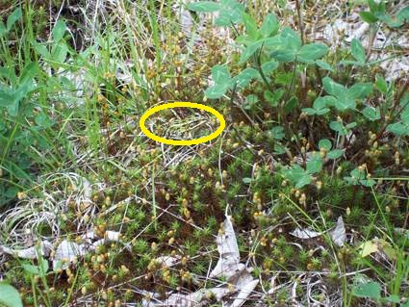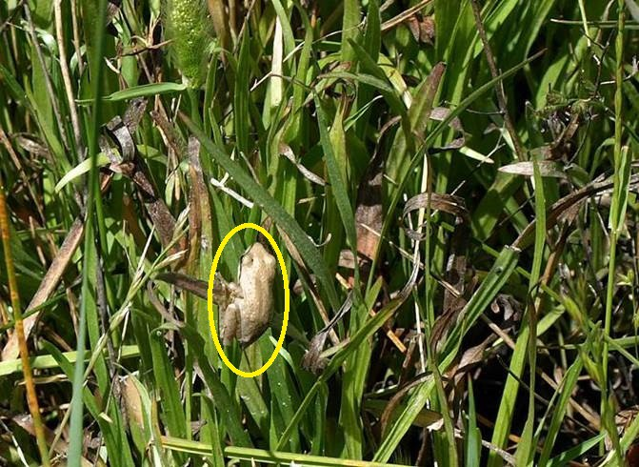

**Figure 1.1**: Photos of frogs to indicate that frogs are difficult to be seen in the field

## Basic concepts

In this section, some basic concepts are given to better describe the research problem and questions, aims and objectives, significance and contributions that are presented in the thesis.

* + 1. Environmental audio data

The audio data used in this study is mainly derived from two sources: David Stewart’s CD [Stewart, 1999] and recordings collected by James Cook University (JCU) 1. David Stewart’s CD is employed for the preliminary testing, and used for the experiments in Chapters 3 and 4. Recordings collected by JCU are used for Chapters 5 and 6. The reasons for using those two datasets are listed as follows.

1All the recordings can be obtained from our group website: [https://www.ecosounds.or](http://www.ecosounds.org/)g/

* + - * Almost all prior work studied frog recordings with an assumption that only one frog

species exists in each individual recording; first, those previous methods are reviewed and a frog call classification system is developed to outperform the state-of-the-art, whereas the CD recordings are used for testing. In this thesis, CD recordings are used in Chapters 3 and 4.

* + - * Compared with the CD recordings, most JCU recordings have multiple simultaneously vocalising frog species, which is in accord with the real environment. Chapters 5 and 6 focus on the investigation of JCU recordings, which is the real situation for most environmental recordings.

Compared with audio data collected in the laboratories and quiet places (such as on David Stewart’s CD), environmental recordings are normally collected under unconstrained noisy con- ditions (such as JCU recordings). Consequently, the noise and variability issues need to be considered when coping with environmental audio data. In terms of the background noise, there are a wide variety of non-biological noises and a variety of animal sounds in the environmental recordings. These non-biological noises often come from different sources: rain, wind, human activities (e.g. traffic noise). Besides non-biological noises, many competitive animal sounds

(e.g. birds when we are interested in frogs) are also recorded in the environmental recordings. The signal-to-noise ratio (SNR) of CD recordings and JCU recordings are listed in Table A.1 and Table B.1.

Since the power of signal and background noise in this study varies from recording to recording and call to call within the recording, Table D.1 and Table D.2 (Appendix D) show the confidence intervals of high and low SNR recordings for the power of signal and noise.

In the case of variability, it is produced in many aspects: call structure between species, population of one specific species, time and season changes. All those noises and variabilities make it challenging to develop a robust frog call classification system.

* + 1. Audio data analysis

Audio data is usually considered as a mono-dimensional signal. To ease the tasks of under- standing, comparison, modification, and resynthesisation of signals [Rocchesso, 2003], audio data analysis is often developed to find the major features representing the time-varying audio data.

Many application areas of audio data analysis have been identified: speech processing, me- chanical signal processing, bioacoustics analysis, etc. The two most important audio data analysis techniques are Short-time Fourier Transform (STFT) and Linear Predictive Coding (LPC). STFT is a Fourier-related transform, which determines the sinusoidal frequency and phase content of local sections of a signal as it changes over time [Allen, 1997]. LPC is mostly used to represent the spectral envelope of audio data based on the information of a linear predictive model [Deng and O’Shaughnessy, 2003]. After STFT, the audio data is transformed into its two dimensional representation (spectrogram), which is widely used for most bioacoustics analysis for its flexible implementation and good applicability. An example of a spectrogram of frog calls derived from a field recording is shown in Figure 1.2.

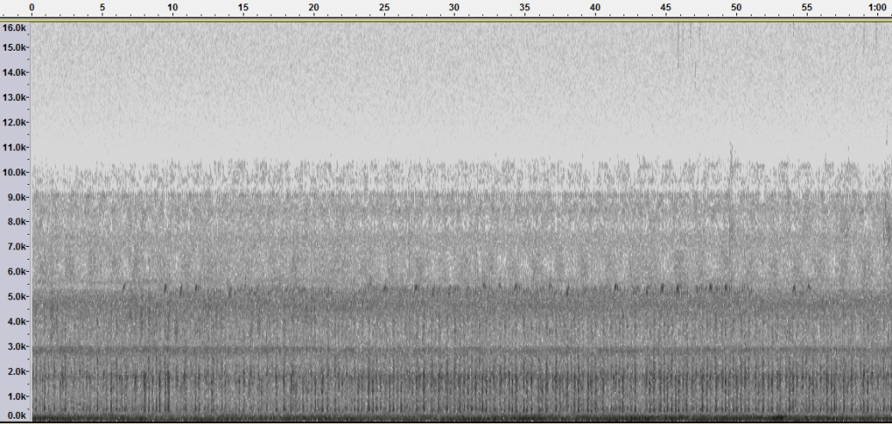

**Figure 1.2**: An example of a spectrogram of environmental recording. The x-axis is time (seconds); the y-axis is frequency (kHz). The spectrogram is generated from a one-minute recording collected in Townsville, Queensland, on around 11.50 pm February 03 2013; the frog species in this recording is *Litoria caerulea.*

* + 1. Frog call structure

In contrast to the hierarchical structure of bird calls, frog calls have a relatively simple call structure [Somervuo et al., 2006]. The frog vocalisation structure mainly has two ingredients: call and syllable. A frog call is normally made up of several frog syllables (Figure. 1.3).

One syllable is basically a sound that a frog produces with a single blow of air from the lungs [Huang et al., 2009]. For frog call classification, an elementary unit is one syllable. To

**Figure 1.3**: Spectrogram of *Litoria caerulea*, three syllable of *Litoria caerulea* are annotated with one black rectangle, respectively.

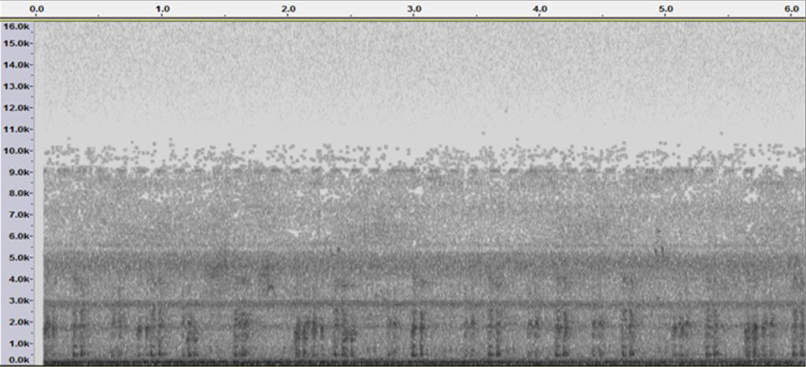

get an intuitive sense of the frog call structure, examples of different frog species in both waveform and spectrogram are shown in Table A.1 and Table B.1. For the waveform, x-axis and y-axis represent time and amplitude scales, respectively. The x-axis and y-axis of the spectrogram represent the time and frequency scales, respectively. The grey scale represents the acoustic intensity.

* + 1. Acoustic event and background noise

An acoustic event is a localised region of high intensity in a spectrogram. As can be seen from Figure 1.5, there are lots of acoustic events in a one-minute recording. This study focuses on the frog vocalisations, and frog calls are regarded as signals. Consequently, all the other events are called background noise. In this study, both high and low SNR recordings are investigated to build a robust frog call classification system. Most previous studies present the frog call classification system using high SNR recordings. The high SNR recordings often assume that there is only one frog species in each individual recording with few background noises (*SN R ≥* 15*dB*). In contrast, most low SNR recordings consist of more than one frog species in an individual recording with lots of background noises (*SN R ≤* 15*dB*). For the low SNR recordings, Table C.1 shows the power spectral density of signal and noise. It can be seen that the noise in low SNR recordings is often generated by several sources and broadband, which covers different frequency bands and leads to the frequency overlapping between the

signal and noise.

* + 1. Frog call classification

A frog call classification system often consists of four parts (Figure. 1.4) : (1)signal pre- processing, which includes signal processing and noise reduction; (2) syllable segmentation, which is used to generate a basic classification unit for frog calls; (3) feature extraction; and (4) classification.

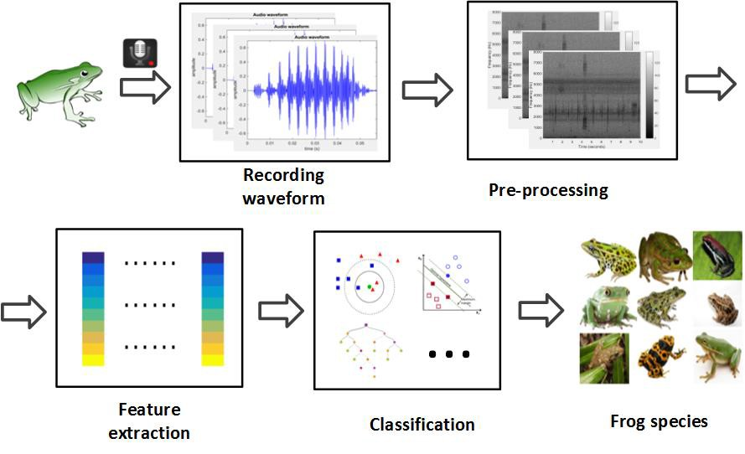

**Figure 1.4**: Flowchart of a frog call classification system

## Research Challenges

Most datasets used in previous frog call classification studies assume that there is only one frog species in each individual recording. However, these resulting frog calls cannot reflect the characteristics of frog vocalisations in real-world situations, such as background noise, frog chorus, and other vocalising animals. To develop a robust frog call classification system for environmental recordings, two main challenges have been identified.

**Challenge 1**: Most previous work studied frog call classification using high SNR recordings,

but the classification performance of different studies varied a lot with a relatively low classifi- cation accuracy. The first challenge of this thesis is to build an enhanced feature representation to further improve the classification performance using high SNR recordings.

**Challenge 2**: Since our work finally aims to classify frog calls in low SNR recordings, most features that can successfully classify high SNR recordings cannot perform well for low SNR recordings. Consequently, it is still a big challenge to develop robust acoustic features to classify frog species in low SNR recordings.

**Challenge 3**: Since most previous work assumed that each individual recording consists of only one frog species, a single-instance single-label (SISL) framework is suitable for classifying frog calls in those high SNR recordings Figure. 1.5. However, as low SNR recordings often have different characteristics containing more than one frog species, the SISL framework is no longer suitable. Therefore, the last challenge of this thesis is to design a novel classification framework for studying frog vocalisations in low SNR recordings with overlapping vocalising frog species.

*Litoria fallax*

*Litoria nasuta*

*Cyclorana novaehollandiae*

*Litoria rubella*

*Litoria rothii*

**Figure 1.5**: An example of collected recording with multiple simultaneously vocalising frog species. Five frog species exist in this 10-second recording: *Cyclorana novaehollandiae*, *Litoria rubella*, *Litoria nasuta*, *Litoria rothii*, and *Litoria fallax*.

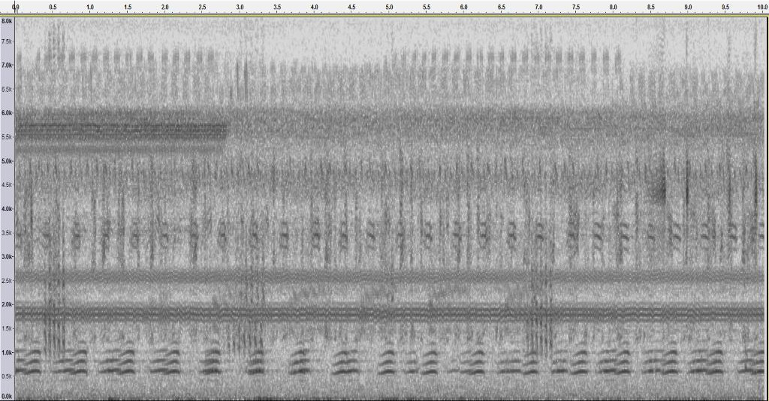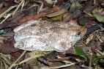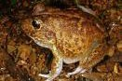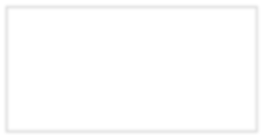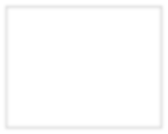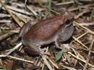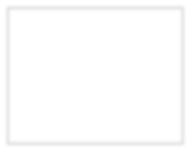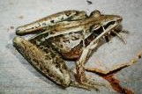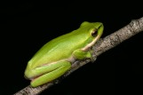

## Research questions

The research questions are developed in order to solve the aforementioned challenges, which can be categorised into three parts.

* + 1. How to improve the classification performance when addressing high SNR recordings?
    2. How to develop robust acoustic features to classify frog calls in low SNR recordings?
    3. How to employ suitable classification frameworks to classify multiple simultaneous vo- calising frog species in low SNR recordings?

## Aims and objectives

This thesis aims to investigate techniques for robust and effective classification of frog species in acoustic data for environmental monitoring. For high SNR recordings, we need to improve the classification performance. As for the low SNR recordings, we plan to design novel frameworks to classify multiple simultaneously vocalising frog species. With our classification results, ecologists can then make decisions on how to protect and improve the health of frog populations. The specific research objectives are listed below.

* + 1. To improve the current representation schemes for modelling frog calls in high SNR recordings
    2. To develop robust feature extraction methods for frog call classification in low SNR recordings
    3. To investigate machine learning techniques (MIML learning and ML learning) to tackle the frog call classification problem in low SNR recordings

## Significance and contributions

Due to the development of sensor techniques, acoustic sensors have been widely deployed in the field for surveying vocalising animals. Different from recordings collected in the constrained

environment, recordings collected in the field often have low SNR and consist of multiple simul- taneous vocalising frog species. In this dissertation, firstly the high SNR recordings are investigated to further improve the classification performance of frog recordings with high SNR. Then, those features that can be used for studying frog calls in high SNR recordings are developed or adapted for analysing low SNR recordings for further analysis. Since field recordings often consist of multiple simultaneous vocalising frog species, both MIML and ML learning are used for the classification of those low SNR field recordings. Meanwhile, the frog calling activity can also be monitored based on the MIML and ML classification results. With the frog call classification framework developed, ecologists can then monitor frogs by collecting audio data. This will enable frog monitoring over large areas and long periods of time, and significantly reduce the expert labour cost for monitoring frog calling activity of a particular area. The monitoring result can also help reveal the importance of environmental protection, which can be achieved via studying the correlation between the frog calling activity and weather variables.

Below is a list of the publications arising from this PhD research.

Journal Articles

* + 1. **Xie, Jie**, Towsey, Michael, Zhang, Jinglan, and Roe, Paul (2016) Adaptive frequency scaled wavelet packet decomposition for frog call classification. Ecological Informatics, 32, pp. 134-144.

This work corresponds to Chapter 4 in this thesis, which developed a novel spectral feature for frog call classification.

* + 1. Zhang Liang, Towsey Michael, **Xie Jie**, Zhang Jinglan, Roe Paul, Using multi-label classification for acoustic pattern detection and assisting bird species surveys, Applied Acoustics, Volume 110, September 2016, Pages 91-98.
    2. **Xie, Jie**, Towsey, Michael, Zhang, Jinglan, and Roe, Paul, Frog call classification: a survey, Artificial Intelligence Review (**Under review**)

This work corresponds to Chapter 2 in this thesis, which reviewed the extant literature on frog call classification.

* + 1. **Xie, Jie**, Towsey, Michael, Zhang, Jinglan, and Roe, Paul, Frog call classification based on enhanced features and machine learning algorithms, Applied Acoustics (**Under re- view**)

This work corresponds to Chapter 3 in this thesis, which presented an enhanced feature representation for frog call classification using various machine learning algorithms.

Conference Papers

1. **Xie, Jie**, Towsey, Michael, Zhang, Jinglan, and Roe, Paul, Detecting frog calling activity based on acoustic event detection and multi-label learning, International Conference on Computational Science (Accepted)

This work corresponds to Chapter 5 in this thesis, which applied multiple-label learning for frog call classification.

1. **Xie, Jie**, Towsey, Michael, Zhang, Liang, Zhang, Jinglan, and Roe, Paul, Multiple- Instance Multiple-Label Learning for the Classification of Frog Calls With Acoustic Event Detection, International Conference on Image and Signal Processing (Accepted)

This work corresponds to Chapter 6 in this thesis, which applied multiple-instance multiple- label learning for frog call classification.

1. **Xie, Jie**, Towsey, Michael, Zhang, Liang, Zhang, Jinglan, and Roe, Paul, Feature Extrac- tion Based on Bandpass Filtering for Frog Call Classification, International Conference on Image and Signal Processing (Accepted)
2. **Xie, Jie**, Towsey, Michael, Truskinger, Anthony, Eichinski, Philip, Zhang, Jinglan, and Roe, Paul (2015) Acoustic classification of Australian anurans using syllable features. In 2015 IEEE Tenth International Conference on Intelligent Sensors, Sensor Networks and Information Processing (ISSNIP), IEEE, Singapore, pp. 1-6.
3. **Xie, Jie**, Towsey, Michael, Yasumiba, Kiyomi, Zhang, Jinglan, and Roe, Paul (2015) Detection of anuran calling activity in long field recordings for bio-acoustic monitoring. In 2015 IEEE Tenth International Conference on Intelligent Sensors, Sensor Networks and Information Processing (ISSNIP), IEEE, Singapore, pp. 1-6.
4. **Xie, Jie**, Towsey, Michael, Zhang, Jinglan, and Roe, Paul (2015) Image processing and classification procedure for the analysis of Australian frog vocalisations. InProceedings of the 2nd International Workshop on Environmental Multimedia Retrieval, ACM, Shang- hai, China, pp. 15-20.
5. **Xie, Jie**, Towsey, Michael, Zhang, Jinglan, Dong, Xueyan, and Roe, Paul (2015)Ap- plication of image processing techniques for frog call classification. In IEEE Interna- tional Conference on Image Processing (ICIP 2015), 27-30 September 2015, Quebec City, Canada.
6. **Xie, Jie**, Towsey, Michael, Eichinski, Philip, Zhang, Jinglan, and Roe, Paul (2015)Acous- tic feature extraction using perceptual wavelet packet decomposition for frog call classi- fication. In 2015 IEEE 11th International Conference on e-Science (e-Science), IEEE, Munich, Germany, pp. 237-242.
7. **Xie, Jie**, Zhang, Jinglan and Roe, Paul, Discovering acoustic feature extraction and selection algorithms for frog vocalization monitoring with machine learning techniques, 2015 Annual Conference of the Ecological Society of Australia. (Abstract accepted for poster presentation)
8. **Xie, Jie**, Zhang, Jinglan, and Roe, Paul (2015) Acoustic features for hierarchical clas- sification of Australian frog calls. In 10th International Conference on Information, Communications and Signal Processing, 2-4 December 2015, Singapore.
9. Dong, Xueyan, **Xie, Jie**, Towsey, Michael, Zhang, Jinglan, and Roe, Paul (2015)Gener- alised features for bird vocalisation retrieval in acoustic recordings. In IEEE International Workshop on Multimedia Signal Processing, 19-21 October 2015, Xiamen, China.

## Thesis structure

This thesis is organised in the manner outlined in Figure 1.6.Detailed description of each chapter is shown below.

* Chapter 1 provides a brief introduction to the problem of ”Acoustic classification of Australian frogs for ecosystem surveys”. The background and motivation are first dis- cussed. Then five basic concepts related to frog call classification are presented, to lay the foundation for this research: environmental audio data, audio data analysis, frog call structure, acoustic event and background noise, and frog call classification system. Next, research problems and questions, aims and objectives, significance and contributions

##### Goal Outcome

Chapter 3



High SNR

recordings

* + 1. Review previous work
    2. Develop a novel feature representation to improve current classification performance
       1. The proposed enhanced feature representation can achieve a better classification performance compared with most previous studies.
       2. Cepstral features are effective for classifying frog calls, but very sensitive to the background noise

##### Motivation

|  |  |  |
| --- | --- | --- |
|  | Design a novel cepstral feature  representation with both good classification performance and excellent anti-noise ability? | |
|  | |  |
| Outcome | | |

Chapter 4

High and low

SNR

recordings

##### Goal

Use wavelet packet decomposition to design a novel feature representation

1. Wavelet-based cepstral features are effective for

classifying frog calls, and robust to background noise

1. These features can be used for both low SNR and high recordings

##### Motivation

So far almost all recordings used are high SNR. Low SNR recordings have multiple simultaneously vocalising frog species, so how to design a suitable classification framework?

Chapter 5

Low SNR recordings

##### Goal

Use multiple-instance multiple-label (MIML) learning to classify frog calls in low SNR recordings

##### Outcome

MIML learning can effectively classify frog calls in low SNR recordings. However, the classification performance is highly affected by the event detection results

##### Motivation

To improve the classification performance, we can do

1. use supervised learning to perform event detection. But we do not have much annotated acoustic data, (2) use multiple-label learning.

Chapter 6

Low SNR

recordings

##### Goal

Use multiple-label (ML) learning to classify

frog calls

##### Outcome

ML learning can improve the classification performance of MIML learning, and frog calling activity of three months are monitored

**Figure 1.6**: Structure of the four main chapters of this thesis

are presented, based on those five basic concepts. To be specific, there are three main objectives in this thesis. The remaining chapters are organised in the order of addressing those three objectives.

* + Chapter 2 reviews the significant and latest literature in the field. The discussion divides

the frog call classification system into three parts: signal pre-processing, feature extrac- tion and classification. In addition, there are reviews for evaluation methods and previous experimental results. This chapter intends to provide the reader with a foundation for the research problem and necessary information about the state-of-the-art developments in the field. Furthermore, the research gap in current literature is identified, leading to the direction for the following research.

* + Chapter 3 presents an enhanced feature representation for frog call classification in high SNR recordings. An enhanced feature representation is constructed via the combination of temporal, perceptual, and cepstral features. Five machine learning algorithms are evaluated with our proposed feature representation. This chapter aims to (1) review previous features used for frog call classification and develop a better feature representa- tion; (2) explore those previous features and study which can be adapted from high SNR recordings to low SNR recordings.
  + Chapter 4 discusses wavelet analysis for frog call classification. According to the con- clusion from Chapter 3, it is found that a ceptral feature can achieve higher classification accuracy compared with temporal and perceptual features but it is very sensitive to the background noise. Consequently, in this research, a novel cepstral feature representation has been designed with wavelet packet decomposition that has both high classification performance and a good anti-noise ability. It is because this research will move to low SNR recordings from high SNR recordings, rather than only focusing on the low SNR recordings.
  + Chapter 5 discusses the use of multiple-instance, multiple-label framework for frog call classification. To cope with low SNR recordings with multiple simultaneously vocalis- ing frog species, the traditional single-instance, single-label classification framework is no longer suitable. Therefore, this research tries to adopt other classification frameworks such as MIML learning and ML learning. MIML learning is presented in this chapter. A MIML classification framework is adopted for studying frogs. Frog syllables are detected using a supervised learning algorithm, which needs lots of annotated data. However, in this study there is a lack of those annotated frog recordings. An unsupervised learning method is developed to segment syllables, which is named *acoustic event detection (AED)*. Then, three MIML learning classifiers are evaluated with extracted features from each syllable, after applying a bagging algorithm. The classification performance is highly affected by

the results of AED. Although our AED methods achieve better results compared with previous AED methods, the results still need to be further improved.

* + Chapter 6 discusses the multiple-label learning method for frog call classification. Since Chapter 5 shows that classification performance is highly affected by the AED results, the AED results still need to be improved. This chapter uses ML learning to study low SNR recordings with multiple simultaneously vocalising frog species, where AED is not necessary for the classification. In contrast, AED is used to predict the frog abundance. The cepstral feature representation proposed in Chapter 4 is used, where a simple but effective method is used to modify it. Both the results of AED and ML classification are applied to field recordings over three months.
  + Chapter 7 summarises and concludes the thesis, and claims the achievements.

# Chapter 2 Literature review

This chapter reviews the extant literature on frog call classification. It aims to give a quantitative and detailed analysis of related techniques used in frog call classification. To the best of our knowledge, previous studies have not used multiple-instance multiple-label (MIML) learning or multiple-label (ML) learning for frog call classification, therefore we focus on the studies of single-instance single-label (SISL) classification of frog calls. For MIML and ML learning, some papers that have studied birds are reviewed.

## Overview

Over the past decade, frog biodiversity has rapidly declined because of frogs’ sensitivity to habitat loss and degradation, introduced invasive species, and environmental pollution [Dud-](#_bookmark197) [geon et al., 2006]. On the one hand, frog biodiversity is rapidly declining, and on the other hand, frogs are greatly valuable to the environment. Firstly, frogs are an integral part of the food web, and the decline of their population can result in negative impacts through the whole ecosystem. Secondly, frogs are famous indicator species for environment health. Finally, frogs are very useful in medical research that benefits humans 1. The rapid biodiversity decline and great importance of frogs make it necessary for frog biodiversity monitoring to increase.

To monitor the change of frog biodiversity and optimise the protection policy, many re- searchers have shown interest in studying frogs. Compared to counting frogs by visual obser- vation, hearing the vocalisations of frogs is much easier. Consequently, frog vocalisations are

1<http://www.savethefrogs.com/why-frogs>

15

often used for monitoring frogs. There are two approaches for acoustic frog monitoring. The traditional field survey methods require ecologists to physically visit sites to collect acoustic data, which is both time-consuming and costly. In contrast, recent advances in acoustic sensor techniques have greatly extended the spatio-temporal scale for acoustic monitoring of frog biodiversity [Wimmer et al., 2013]. The large volumes of acoustic data collected this way make it essential to develop new automated methods of analysis.

Over the last few years, many researchers have described automated methods for detecting and classifying frog calls [Camacho et al., 2011,](#_bookmark182) [Chen et al., 2012,](#_bookmark185) [Gingras and Fitch, 2013,](#_bookmark202) [Han et al., 2011,](#_bookmark205) [Huang et al., 2014,](#_bookmark210) [2009,](#_bookmark211) [2008]. However, there is no paper that summarises those methods. In this work, we present a comprehensive survey of frog call classification to provide acoustic signal researchers with basic information, current methods and trends in this field.

Three parts play important roles in the performance and precision of frog call classification: signal pre-processing, feature extraction, and classification. In this survey, these three important parts of frog call classification are presented as shown in Fig. 1.4.

Signal pre-processing consists of signal processing, noise reduction and syllable segmenta- tion. Signal processing here denotes changing a signal from one-dimension (audio data) into two-dimensional representation (image). Noise reduction is essential to improve the classifica- tion performance. Since the elementary acoustic unit for frog call classification is the syllable, which is a continuous vocalisation emitted by an individual, segmenting continuous recordings of frog calls into individual syllables is necessary.

Previous studies have developed various methods for feature extraction [Camacho et al.,](#_bookmark182) [2011,](#_bookmark182) [Chen et al., 2012,](#_bookmark185) [Gingras and Fitch, 2013,](#_bookmark202) [Han et al., 2011,](#_bookmark205) [Huang et al., 2014,](#_bookmark210) [2009,](#_bookmark211) [2008]. Here we review and analyse all the used features: time domain and frequency domain features, time-frequency features, cepstral features, and other features. After feature extraction, numerous classifiers have been proposed for frog call classification. A summary of those classifiers is given in section 2.4.

It is worth noting that most previous researchers used different databases for their exper- iments, because frog call research is often related to geographical regions [Jang et al., 2011]. Consequently, there is still a lack of uniformity in the way classification methods are evaluated and assessed. This survey is not meant to compare all previous frog call classification methods

and find the best one, but to assemble all the methods in order to provide a direction for the classification of frog calls. To be specific, this research mainly surveyed different features used for frog call classification because most studies focus on new features rather than new signal processing techniques, syllable segmentation methods, or classifiers.

The remainder of this survey is organised as follows: In section 2.2, signal pre-processing is presented in its three parts: signal processing, noise reduction, and syllable segmentation. In section 2.3, different acoustic features are investigated for frog call classification. In section 2.4, numerous classifiers are studied for frog call classification. In section 2.6, experimental results of state-of-the-art research are discussed. Finally, section 2.7 discusses research gaps and 2.8 sums up this chapter.

## Signal pre-processing

Frog call recordings are often collected using a battery-powered acoustic sensor (stored in a weatherproof metal box) with an external microphone. After signal acquisition, signal pre- processing is the first step for a frog call classification system. It often consists of signal processing, noise reduction, and syllable segmentation. The research gap in each part of signal pre-processing is described below.

* + 1. Signal processing

Signal processing often denotes the transformation of frog calls from one-dimension (recording waveform) to two dimensions (time-frequency representation). Two main techniques used for frog signal processing are short-time Fourier transform (STFT) [Colonna et al., 2015,](#_bookmark189) [Huang](#_bookmark210) [et al., 2014,](#_bookmark210) [2009,](#_bookmark211) [Noda et al., 2016], wavelet packet decomposition [Yen and Fu, 2002], and discrete wavelet transform [Colonna et al., 2012b]. STFT is the most widely used technique among them for its flexible implementation and better applicability. Given one frog call *x*(*n*), its fast Fourier transform can be expressed as

*L−*1

*X*(*k*) = X *x*(*n*)*w*(*n*)*e−j*2*πkn/L,* 0 *≤ k ≤ L −* 1 (2.1)

*n*=0

where *X*(*k*) is the frequency domain signal (spectrum) and denotes each frame of the spec- trogram, and *w*(*n*) is the window function. The waveform, spectrum and spectrogram of one individual syllable for *Mixophyes fasciolatus* is illustrated in Fig. 2.1. Here, three representations are consistent with features in three domains: the time domain, frequency domain and time- frequency domain.

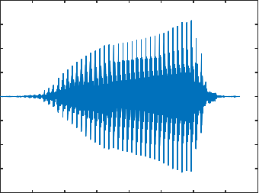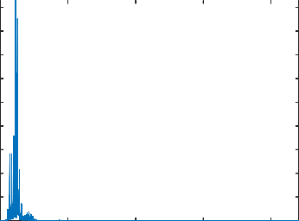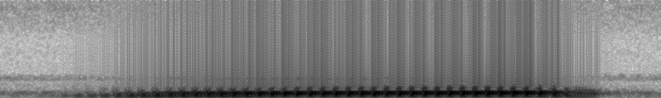

0.8

0.6

0.4

0.2

Magnitude

0

-0.2

-0.4

-0.6

-0.8

0 0.05 0.1 0.15 0.2 0.25 0.3 0.35 0.4

Time (s)

450

400

350

300

Magnitude

250

200

150

100

50

0 0.5 1 1.5 2

Frequency (Hz) ×104

2.2

2

1.8

1.6

1.4

Frequency (Hz)

1.2

1

0.8

0.6

0.4

0.2

×104

0 0.05 0.1 0.15 0.2 0.25 0.3 0.35

Time (s)

**Figure 2.1**: Waveform, spectrum and spectrogram of one frog syllable for *Mixophyes fasciolatus*. The window function, size and overlap are Hamming window, 128 samples and 85%, respectively.

* + 1. Noise reduction

Noise reduction is an optional process for frog call classification. Huang et al. [2014] applied a de-noise filter for noise reduction. The wavelet threshold function in the one-dimensional signal was used as the filter kernel function. Bedoya et al. [2014] introduced a spectral noise gating method for noise reduction. Specifically, the selected frequency band spectrum of the frogs’ call to be detected was estimated and suppressed. While the aforementioned noise reduction methods can remove some background noise, some of the desired signals will be suppressed. Noise reduction methods are therefore selectively used based on signal-to-noise ratio of the acoustic data and the research problem.

* + 1. Syllable segmentation

For frog calls, the basic elementary acoustic unit is a syllable, which is a continuous frog vocalisation emitted by an individual frog [Huang et al., 2009]. The precision of syllable segmentation will directly affect the classification performance, since features used for frog call classification are calculated based on each syllable. Frog syllable segmentation methods in previous studies are summarised and listed in Table 2.1. All previous methods cannot address

recordings with simultaneous vocalising frog calls. Meanwhile, those methods that used the time domain feature for segmentation, cannot address recordings with low signal-to-noise ratio.

**Table 2.1**: Summary of related work for frog syllable segmentation. Here, E denotes energy, ZCR denotes zero-crossing rate.

|  |  |  |
| --- | --- | --- |
| **Authors** | **Features for segmentation** | **Procedure** |
| Han et al. [2011] | Spectral entropy | Manual |
| Jaafar and Ramli [2013a] | E and ZCR | Sequential |
| Huang et al. [2009] | Amplitude | Non-sequential |
| Chen et al. [2012] | Spectrogram | Non-sequential |
| Colonna et al. [2015] | Incremental E and Incremental ZCR | Sequential and real time |

## Acoustic features for frog call classification

Developing effective acoustic features that show greater variation between rather than within species is important for achieving robust classification results F[ox, 2008]. For frog call clas- sification, acoustic features can be classified into four categories: time domain and frequency domain features, time-frequency domain features, cepstral features, and other features.

* + 1. Time domain and frequency domain features for frog call classification

Time domain features for frog call classification have been explored for a long time [Camacho](#_bookmark182) [et al., 2011,](#_bookmark182) [Chen et al., 2012,](#_bookmark185) [Dayou et al., 2011,](#_bookmark194) [Huang et al., 2014,](#_bookmark210) [2009,](#_bookmark211) [2008]. Time domain features are often combined with frequency domain features for frog call classification.

Huang et al. [2009] used spectral centroid, signal bandwidth, and threshold-crossing rate for frog call classification with a k-nearest neighbour classifier (K-NN) and support vector machines (SVM). In another work, Huang et al. [2014] combined spectral centroid, signal bandwidth, spectral roll-off, threshold-crossing rate, spectral flatness, and average energy to classify frog calls using neural networks. Another paper published by Huang et al.  [2008] used spectral centroid, signal bandwidth, spectral roll-off, and threshold-crossing rate for frog call classification. Dayou et al. [2011] combined Shannon entropy, R*e*´nyi entropy and Tsallis entropy for frog call classification. Based on this work, Han et al. [2011] improved the classi- fication accuracy by replacing Tsallis entropy with spectral centroid. To classify anurans into

four genera, a three-parameter model was proposed, based on advertisement calls, 1 which used mean values for dominant frequency, coefficients of variation of root-mean square energy, and spectral flux [Gingras and Fitch, 2013]. With this model, three classifiers were employed for classification: K-NN, a multivariate Gaussian distribution model and a Gaussian Mixture Model (GMM) [Gingras and Fitch, 2013]. Chen et al. [2012] proposed a method based on syllable duration and a multi-stage average spectrum for frog call recognition. Their recognition stage was completed by the Euclidean distance-based similarity measure. Camacho et al. [2011] used the loudness, timbre and pitch to detect frogs with a multivariate ANOVA test.

* + 1. Time-frequency features for frog call classification

For frog call classification, we often transform the one-dimensional signal into its two-dimensional time-frequency representation. Then, features based on the time-frequency representation can be calculated for classification. Acevedo et al. [2009] developed two feature sets for automated animal classification. The first was minimum and maximum frequencies, call duration, and maximum power; the second was minimum and maximum frequencies, call duration, and frequency of maximum power in eight segments of duration. With two feature sets, three classifiers were used for the classification: linear discriminant analysis(LDA), decision tree and SVM. Brandes [2008] proposed a method for classifying animals using duration, maximum frequency, and frequency bandwidth, and with Hidden Markov Model (HMM) used as the classifier. Yen and Fu [2002] combined wavelet packet feature extraction and two different dimensionality reduction algorithms to produce the final feature vectors. Then, they adopted a neural network classifier for classification. Grigg et al. [1996] developed a system to monitor the effect of the introduced cane toad on the frog population of Queensland. The classification was based on the local peaks in the spectrogram using Quinlan’s machine learning system, C4.5. Brandes et al. [2006] proposed a method to classify frogs using central frequency, duration, and bandwidth with a Bayesian classifier. Croker and Kottege [2012] introduced a feature vector for detecting frogs with a similarity measure based on Euclidean distance. The feature vector consisted of dominant frequency, frequency difference between the lowest and dominant frequencies, frequency difference between the highest and dominant frequencies, time from the start of the sound to the peak volume, and time from the peak volume to the end of the sound.

1an advertisement call is produced by a male frog in order to attract females during the breeding season and to warn other rival males of his presence.

* + 1. Cepstral features for frog call classification

Cepstral features are also popular for frog call classification. These features include Linear Prediction Coefficients (LPCs) and Mel-frequency cepstral coefficients (MFCCs). Colombia and del Cauca [2009] introduced LPCs for frog call classification with a modified K-Means classifier. Jaafar et al. [2013a] introduced MFCCs and LPCs as features, and K-NN and SVM as classifiers for frog call identification. Yuan and Ramli [2012] also used MFCCs and LPCs as features, and K-NN as the classifier for frog sound identification. Lee et al. [2006] used the averaged MFCCs and LDA for the automatic recognition of animal sounds. Bedoya et al. [2014] combined MFCCs and a learning algorithm for multivariate data analysis (LAMDA) for frog call recognition. Vaca-Castano and Rodriguez [2010] proposed a method to identify animal species, which consisted of MFCCs, principal component analysis (PCA) and K-NN. Jaafar and Ramli [2013a], Jaafar et al. [2013b], Tan et al. [2014] published three papers about frog call classification with MFCCs, ∆ MFCC and ∆∆ MFCC calculated as features, and K-NN and SVM used as classifiers. Colonna et al. [2012a] introduced MFCCs for classifying anurans with a K-NN classifier. Noda et al. [2016] fused time domain features with cepstral features for frog call classification, which achieved a better classification performance than using only cepstral features. Three classifiers were investigated for the classification: HMM, random forest, and SVM.

* + 1. Other features for frog call classification

Besides time domain features, frequency domain features, time-frequency domain features and cepstral features, other features are also introduced to classify frog calls. Wei et al. [2012] proposed a distributed sparse approximation method based on *`*1 minimization for frog call classification. Dang et al. [2008] extracted the vocalisation waveform envelope as features, then classified calls by matching the extracted envelope with the original signal envelope. Kular et al. [2015] treated the sound signal of a frog call as a texture image. Then, texture visual words and MFCCs were calculated as the features for frog call classification.

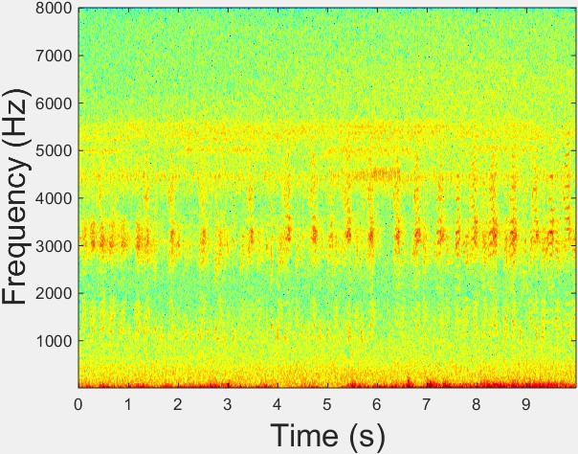

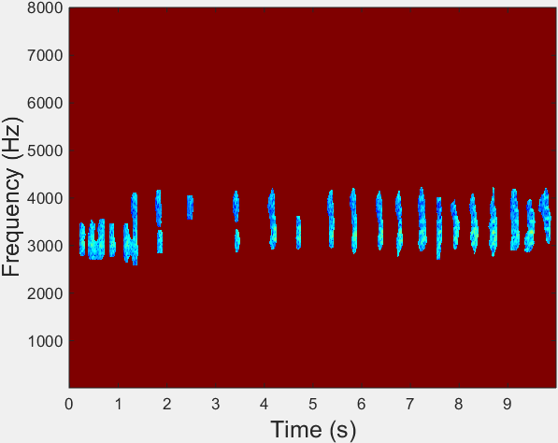**Figure 2.2**: Original spectrogram and segmented events after applying acoustic event detection to the original spectrogram image.

## Classifiers

For frog call classification, numerous pattern recognition methods have been used to construct the classifier, such as the Bayesian classifier [Brandes et al., 2006], k-nearest neighbour clas- sifier (K-NN) [Colonna et al., 2012a,](#_bookmark188) [Dayou et al., 2011,](#_bookmark194) [Gingras and Fitch, 2013,](#_bookmark202) [Han et al.,](#_bookmark205) [2011,](#_bookmark205) [Huang et al., 2009,](#_bookmark211) [2008,](#_bookmark212) [Jaafar and Ramli, 2013a,](#_bookmark213) [Jaafar et al.,](#_bookmark215) [2013a,b,](#_bookmark216) [Vaca-Castano](#_bookmark247) [and Rodriguez, 2010,](#_bookmark247) [Yuan and Ramli, 2012], support vector machine (SVM) [Acevedo et al.,](#_bookmark173) [2009,](#_bookmark173) [Gingras and Fitch, 2013,](#_bookmark202) [Huang et al., 2009,](#_bookmark211) [2008,](#_bookmark212) [Jaafar et al., 2013a,](#_bookmark215) [Tan et al., 2014], hidden Markov model (HMM) [Brandes, 2008], Gaussian mixture model (GMM) [Gingras and Fitch, 2013, Huang et al., 2008], neural networks (NN) [Huang et al., 2014,](#_bookmark210) [Yen and Fu, 2002], decision tree (DT) [Acevedo et al., 2009,](#_bookmark173) [Grigg et al](#_bookmark204)., [1996], one-way multivariate ANOVA [Camacho et al., 2011], and linear discriminant analysis (LDA) [Acevedo et al., 2009,](#_bookmark173) [Lee](#_bookmark222) [et al., 2006]. Besides classifiers, other methods for classifying frog species include those based on the similarity measure [Chen et al., 2012,](#_bookmark185) [Croker and Kottege, 2012,](#_bookmark192) [Dang et al., 2008] and those based on the clustering technique [Bedoya et al., 2014,](#_bookmark177) [Colombia and del Cauca,](#_bookmark187) [2009,](#_bookmark187) [Wei et al., 2012]. The summary of those classifiers used in frog call classification is listed in Table 2.2. K-NN is the most commonly used classifier for its simplicity and easy application. However, the K-NN classifier is sensitive to the local structure of the data, as well as to the initial cluster centroids. Therefore, the K-NN classifier is often run multiple times based on different initial points. SVM is another classifier that is widely used for its good generalisation ability. However, the performance of SVM can be quite sensitive to the selection of the regularisation and kernel parameters, and it is possible to over-fit when tuning these

hyper-parameters. Therefore, selecting suitable parameters for SVM is very important and is realised by grid search in most previous studies [Hsu et al., 2003].

**Table 2.2**: A brief summary of classifiers used in previous studies.

|  |  |  |  |
| --- | --- | --- | --- |
| Reference | Classifier | Reference | Classifier |
| Brandes et al. [2006] | Bayesian classifier | Acevedo et al. [2009] | Support vector machine |
| Huang et al. [2008] | K-nearest neighbour | Huang et al. [2009] | Support vector machine |
| Huang et al. [2009] | K-nearest neighbour | Tan et al. [2014] | Support vector machine |
| Han et al. [2011] | K-nearest neighbour | Gingras and Fitch [2013] | Support vector machine |
| Dayou et al. [2011] | K-nearest neighbour | Jaafar et al. [2013a] | Support vector machine |
| Jaafar and Ramli [2013a] | K-nearest neighbour | Gingras and Fitch [2013] | K-nearest neighbour |
| Brandes [2008] | Hidden Markov model | Jaafar et al. [2013b] | K-nearest neighbour |
| Huang et al. [2008] | Gaussian mixture model | Jaafar et al. [2013a] | K-nearest neighbour |
| Gingras and Fitch [2013] | Gaussian mixture model | Yuan and Ramli [2012] | K-nearest neighbour |
| Huang et al. [2014] | Neural networks | Vaca-Castano and Rodriguez [2010] | K-nearest neighbour |
| Yen and Fu [2002] | Neural networks | Grigg et al. [1996] | Decision tree |
| Acevedo et al. [2009] | Decision tree | Camacho et al. [2011] | One-way multivariate ANOVA |
| Colonna et al. [2012a] | K-nearest neighbour | Acevedo et al. [2009] | Linear discriminant analysis |
| Huang et al. [2008] | Support vector machine | Lee et al. [2006] | Linear discriminant analysis |

## MIML or ML learning for bioacoustic classification

To the best of our knowledge, there is still no paper that uses MIML or ML learning to focus on frog call classification. In contrast, some previous research has applied MIML or ML learning to study bird calls.

For MIML learning, [Briggs et al., 2012] introduced the MIML classifiers for acoustic classification of multiple simultaneous bird species. In their method, a supervised learning classifier (random forest) was first employed for segmenting acoustic events. Then, features were extracted from each segmented acoustic event. Before putting features into classifiers, a bag generator was used to construct a bag-level feature. Lastly, three MIML classifiers were experimentally evaluated: MIML-SVM (support vector machines Based Multi-Instance Multi-Label Learning Algorithm), MIML-RBF(MIML Radial Basis Function), and MIML- kNN (k-Nearest Neighbor Based Multi-Instance Multi-Label Learning Algorithm). Dufour et al.  [2013] used Mel-filter cepstral coefficients and three MIML classifiers to classify birds. To be specific, Mel-filter cepstral coefficients were first calculated for each frame. Then, two new feature vectors were computed to represent longer segments. Lastly, three MIML classifiers were experimentally evaluated: MIML-RBF, MIML-kNN, and M3MIML (Maximum Margin Method for Multi-instance Multi-label Learning).

For ML learning, several papers have been published in the Neural Information Processing Scaled for Bioacoustics (NIPS4B challenge), which classified birds, insects, and amphibians recordings, followed by pre-processing and segmentation, feature extraction, feature selection, and classification [Chen et al., 2013,](#_bookmark184) [Lasseck, 2013,](#_bookmark221) [Massaron, 2013,](#_bookmark226) [Mencıa et al., 2013,](#_bookmark229) [Stowell and Plumbley, 2013]. Lasseck  [2013] first pre-processed the recordings via the application of short-time Fourier transform, noise reduction and segmentation. Then, file-Statistics, segment- Statistics and segment-Probabilities are calculated as the features. Finally, for each sound class, an ensemble of randomised decision trees is applied for the classification. [Stowell and](#_bookmark241) [Plumbley, 2013] used either MFCC statistics (52 dimensions), chirplet histograms (up to 20,000 dimensions), or both, as the features. Then, Random Forests was applied for multi-label classi- fication. Mencıa et al.  [2013] proposed an new feature extraction method via an unsupervised generation of an aleatory number of features, which included random patching, a Denoising Autoencoder unit and subsequent convolution. For the classification, a pairwise ensemble of SVMs, random decision trees and a single layer neural network were used. [Massaron, 2013] described an approach that involved building an ensemble of generalised linear models and a classi- fication model by hinge loss and a program based on stochastic gradient descent optimisation, and boosted tree ensembles. Chen et al.  [2013] first calculated prominent features from windowing MFCCs with overlap, and leveraged them to build an ensemble classifier, which was a blend of different classifiers (Gradient Boosting Tree models, Random Forest models, Lasso and elastic- net regularized generalised linear model etc).

## Experiment results with state-of-the-art methods

* + 1. Evaluation criteria

Accuracy is the most widely used statistical criterion for evaluating frog call classification. Other evaluation criteria, such as precision, recall, sensitivity, specificity, F-measure, and ROC curves are also used. Before defining these evaluation criteria, we first define true positives (TP), true negatives (TN), false negatives (FN), and false positives (FP) as described by [Gordon et al.,](#_bookmark203) [2003] (1) TP: correctly recognised positives; (2) TN: correctly recognised negatives; (3) FN: positives recognised as negatives; (4) FP: negatives recognised as positives. Then, accuracy, precision, recall (sensitivity), and specificity can be defined as follows.

*Accuracy* =

*T P* + *T N*

*T P* + *T N* + *F P* + *F N*

(2.2)

*P recision* =

*T P T P* + *F P*

(2.3)

*Recall* =

*T P T P* + *F N*

(2.4)

*Specif icity* =

*T N F P* + *T N*

(2.5)

* + 1. Previous experimental results

Table 2.3 shows the list of summarised frog call classification methods, together with the database they used and corresponding performance. From Table 2.3, we can find that few studies explored frog vocalisations using signal processing and machine learning techniques before 2010. Due to the decrease of frog biodiversity, advances in signal processing, machine learning techniques and acoustic sensors, the research in frogs has been increased in the last five years. In addition, few datasets used are publicly shared with researchers. The classification performance of different studies varies a lot. One of the main reasons is the use of different datasets.

## Research gap in current literature

In this section, the research gap of each part of a frog call classification system is discussed to give a direction for future work.

* + 1. Database

One major problem for frog call classification is the lack of a universal database. The databases used are often related to geographical regions, since researchers from different countries focus

**Database Performance Reference Data source**

on particular frog species in their specific area (Table 2.3).

3 frog species with 635 calls Precision of 99%, recall of 92% Camacho et al. [2011] Collected from Costa Rica (unavailable)

Sensitivity of 0.85 with specificity of 0.92

when distinguishing *Mixophyes iteratus* calls from

1 frog species with 100 samples

17 animal types

other species’ call. Sensitivity of 0.88 with specificity of 0.82 against background noise 50% true positive accuracy,

over 50 false-negative for 4 animal types

Croker and Kottege [2012] Recorded next to a running stream (unavailable)

Brandes et al. [2006] Collected from NE Costa Rica (unavailable)

22 frog species NA Grigg et al. [1996] Collected from Queensland, Australia (unavailable) Best performance with averaged classification

4 frog species with 66 samples

10 frog species, 9 bird species,

Accuracy of 72.18% and 0.76% for standard deviation.

Yen and Fu [2002] Unknown

and 8 cricket species

9 frog species and 3 bird species

Accuracy of 88% for frogs Brandes [2008]* Collected from NE Costa Rica (unavailable)

Best true positive rate of 94.95% and

with 10061 samples

0.94% for false positive rate

Acevedo et al. [2009]* Collected from 14 montane sites in Puerto Rico

9 frog species with 90 syllables Averaged classification accuracy of 90.00% Dayou et al. [2011] Obtained from http://www.Frogsaustralia. net.au/frogs 9 frog species with 54 syllables Averaged classification accuracy of 98.00% Han et al. [2011] Obtained from http://www.Frogsaustralia. net.au/frogs 5 frog species with 727 syllables Averaged classification accuracy of 95.86% Huang et al. [2008] Unknown

142 species belonging to four genera Genus classification accuracy above 70% Gingras and Fitch [2013] obtained from commercially available compact discs (CDs) (available)

Recorded in a wild field located in

18 frog species with 960 syllables Classification accuracy of 94.3% Chen et al. [2012]

the Shan-Ping forest ecological garden in Kaohsiung city, Taiwan (unavailable)

13 frog species with 1514 samples Averaged recognition rate of 93.4% Huang et al. [2014] Unknown 5 frog species with 959 samples Averaged classification accuracy of 90.03% Huang et al. [2009] Unknown

15 frog species with 286 samples Averaged classification accuracy of 95.67% Tan et al. [2014] recorded at Sungai Sedim, in Kulim, Kedah, Malaysia

8 frog species with 160 samples averaged classification accuracy of 98.1% Yuan and Ramli [2012] Obtained from AmphibiaWeb [(http://amphibiaweb.org/)(a](http://amphibiaweb.org/)(available))v[ailable)](http://amphibiaweb.org/)(available))

Internet database [(http://learning.froghome.org/)](http://learning.froghome.org/))

10 frog species with 250 syllables Averaged classification accuracy of 98.8% Jaafar et al. [2013a]

and IBM,USM [(http://www.frogwatch.org.au/?action=animal.list)](http://www.frogwatch.org.au/?action=animal.list)) (available)

15 frog species with 386 syllables Averaged classification accuracy of 85.78% Jaafar et al. [2013b] Recorded from locations around Baling and Kulim, Kedah, Malaysia (unavailable) 12 frog species with 291 syllables Averaged classification accuracy of 97% Jaafar and Ramli [2013a] Recorded from locations around Baling and Kulim, Kedah, Malaysia (unavailable) 12 frog species with 379 samples,

10 bird species with 193 samples Averaged classification accuracy of 86.6% Vaca-Castano and Rodriguez [2010]

Therefore, it is difficult for re-

Averaged classification accuracy of 100%,

Recorded in Puerto Rico [(http://www.amazon.com/Los](http://www.amazon.com/Los)

-Anfibios-Reptiles-Puerto-Rico/dp/084770243X) (available) Provided by the Smithsonian Tropical Research Institute (STRI)

13 frog species with 916 calls

and 99.61% respectively for two database Averaged classification accuracy of 96.8%

Bedoya et al. [2014]

and the Grupo Herpetolgico de Antioquia (GHA) (unavailable)

30 frog species and 19 cricket calls

and 98.1%

Lee et al. [2006] Derived from compact disk (unavailable)

15 frog species with 896 syllables Precision of 99.00% Colonna et al. [2015] Obtained from Internet(http:// bit.ly/1b8bvyE) (available)

10 frog species with 516 syllables Averaged classification accuracy of 97.45% Xie et al. [2015a] Collected from compact disk [(http://www.naturesound.com.au/)](http://www.naturesound.com.au/)) (available) 15 frog species with 436 syllables Averaged classification accuracy of 74.73% Xie et al. [2015c] Collected from compact disk [(http://www.naturesound.com.au/)](http://www.naturesound.com.au/)) (available)

Collected on the campus of the Federal University of Amazonas in

9 frog species with 49 samples Averaged classification accuracy of 97.60% Colonna et al. [2012a]

Manaus, Brazil (unavailable)

3 frog species with 50 samples Averaged classification accuracy of 90% Dang et al. [2008] Unknown 1564 syllables of 41 anurans,

5201 syllables of 58 frogs,

26

*CHAPTER 2. LITERATURE REVIEW*

**Table 2.3**: A brief overview of frog call classification performance.

frog species are not the only animal species to be studied.

The asterisk denotes that

searchers to compare their particular classification methods. Current studies often focus on the

study of limited number of frog species (less than 100), but the number of known amphibian species is above 7000. To reach a high quality resolution, there still is a long way to go.

10905 syllables of 100 anurans,

and 17671 syllables of 199 anurans

98.8%, 96.9%, 95.48%, and 95.38% respectively Noda et al. [2016]

AmphibiaWeb(41 anurans), 58 frogs from Cuba,

100 anurans from Brizil-Uruguay,

and 199 anurans from all datasets [(http://www.nhbs.com/)](http://www.nhbs.com/)) (available)

* + 1. Signal pre-processing

Currently, short-time Fourier transform (STFT) is the most widely used technique for frog call classification. However, STFT has a trade-off between time and frequency resolution, which restricts the discriminability of features extracted from the spectrogram. In contrast, wavelet packet decomposition (WPD) has a better frequency domain resolution than STFT. The main disadvantage of WPD is the time dependence.

Noise reduction is an optional processing step in frog call classification. For some databases of studies shown in Table 2.3, frog calls have a high signal-to-noise ratio (SNR), where noise reduction is unnecessary. However, when studying recordings of low SNR, noise reduction is essential for improving the classification performance [Bedoya et al., 2014,](#_bookmark177) [Huang et al., 2014]. After noise reduction, both the accuracy of syllable segmentation and feature extraction can be relatively improved.

Frog syllable segmentation based on energy and zero-crossing rate cannot address record- ings with low SNR. Meanwhile, this method cannot segment recordings with overlapping frog calls. Recent use of unsupervised learning algorithms opens a path for segmenting overlapping frog syllables with image processing techniques. However, like other unsupervised algorithms, this method has the disadvantage that not all segmented syllables are frog vocalisations [Potami-](#_bookmark232) [tis, 2015]. Briggs et al. used a supervised learning algorithm (Random Forest) for bird call segmentation. However, this method required lots of tagged acoustic data to train the classifier [Tjahja et al., 2015].

For syllable segmentation, time domain features are more sensitive to background noise than frequency domain features, because different frequency components can be separated by transforming the signal from time domain to frequency domain. But time domain features cannot segment those overlapping frog syllables, since time domain features have no ability to separate different frequency components. Compared to time domain features, the use of amplitude-frequency information provides a robust method to segment low SNR recordings. To address those overlapping frog syllables, image processing techniques can be a possible solution.

* + 1. Acoustic features

Most previous studies directly transplant features developed for speech recognition, to analyse frog calls, which might not be suitable. For example, MFCCs, which are based on the calculation of a non-linear Mel-scale, are designed for studying speech. However, the Mel-scale is designed for the perceptual scale of pitches judged by listeners rather than frogs. The direct use of speech features will therefore restrict classification performance.

Most frequency domain features are calculated by directly calculating the statistics over frames, which leads to the loss of temporal information. To add the temporal information of the feature set, time domain features can be combined with frequency domain features to achieve higher classification accuracy. Transforming audio data into its two dimensional representation (such as a spectrogram) for quick visual analysis, has led to increasing attention being given to image processing techniques for automatically analysing animal calls. Image features are worth investigating for frog call classification.

* + 1. Classifiers

Almost all previous studies assume that each recording has only one frog species, and then an SISL classification framework is adopted to classify frog calls. However, recent advances in acoustic sensor techniques have collected large volumes of acoustic data that have multiple simultaneously vocalising frog species, because different frog species tend to call together to make a frog chorus (Figure 1.5). Based on this characteristic of frog call recordings, the classification problem can be naturally framed as an MIML classification or an ML classification problem rather than an SISL classification. In previous studies, MIML learning and ML learning have been used to solve bioacoustic problems, but mainly focus on birds. In this thesis, MIML and ML learning will be investigated to study frog vocalisations.

## 2.8 Summary

The main objective of this survey is to provide a research direction for analysing acoustic sig- nals, especially frog calls. With the use of signal processing and machine learning techniques, different frog species can be classified based on their vocalisations. To achieve this goal, three

main parts of a frog call classification system are explained: signal pre-processing, feature extraction, and classification. For each part, current techniques used by different researchers are explored. For signal pre-processing, signal processing, noise reduction and syllable seg- mentation are studied respectively. For feature extraction, acoustic features in different domains are explored. For classification, different single-instance, single-label classifiers are investigated.

In general, frog call classification is still in its infancy as a field of study, and potential applications and unsolved problems are extending every day. For future work, it is worth further improving the accuracy and efficiency of noise reduction and syllable segmentation, because they are critical processes for frog call classification. Since collected frog calls in the field often contain many background noises (birds, insects, rain, wind, human voices, etc.), it is necessary to design new noise reduction methods based on different environments. It is also necessary to develop accurate and efficient methods for syllable segmentation for its great influence in the frog call classification system performance. Currently, studies have focused on frequency domain features for classification. In the future, time domain features can be more incorporated for increasing the accuracy of frog call classification. For the classification frameworks, using MIML learning or ML learning for studying environmental recordings may be a productive research direction because of the characteristic of collected acoustic data. It is also worth making a uniform dataset that covers different frog species from different areas, since there is still no available uniform dataset of frog calls. Then researchers can evaluate their particular methods on a uniform platform.

30 *CHAPTER 2. LITERATURE REVIEW*

# Chapter 3

**Frog call classification based on enhanced features and machine learning algorithms**

## Overview

This chapter presents an enhanced feature representation for frog call classification using vari- ous machine learning algorithms and explores whether a combination of three types of features discriminate a wider variety of species that may share similar characteristics in either temporal, perceptual or cepstral information, but not all. In the literature, various feature representations have been developed for frog call classification. However, most features used in the prior work are based on either temporal features such as averaged energy and zero-crossing rate, perceptual features such spectral centroid and spectral flux, or cepstral features such as MFCCs.

This chapter aims to compare various feature representations with different machine learn- ing techniques. Based on the classification performance, suggested features can then be adapted to study low-SNR recordings. This chapter directly addresses sub-research question (1): How to improve the classification performance when addressing high SNR recordings, and which of those features can be adapted from high SNR recordings to low SNR recordings?

The performance of the proposed method is evaluated based on twenty-four frog species, which are geographically well distributed through Queensland, Australia. Five feature represen- tations are compared via five machine learning algorithms. Classification results demonstrate that a combination of temporal, spectral and cepstral features can achieve the best performance.

31

Compared with temporal and spectral features, cepstral features can achieve a robust classifica- tion accuracy, but are sensitive to the background noise. Therefore, in the next chapter, we aim to develop robust cepstral features that are not sensitive to the background noise.

## Architecture of the classification system for frog calls

Our frog call classification system consists of six steps (Figure. 3.1): data description, syllable segmentation, pre-processing, feature extraction, feature fusion, and classification. Detailed information of each step is shown in following subsections. Different from [Huang et al., 2009], pre-processing is directly applied to the segmented syllables rather than continuous recordings.

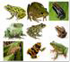

Data

description

Syllable

segmentation

Pre-processing

Feature extraction and

fusion

|  |  |
| --- | --- |
|  |  |
| Classifier  model | |

|  |  |
| --- | --- |
|  |  |
| Pre-emphasise  windowing | |

|  |  |
| --- | --- |
|  |  |
| Temporal  Perceptual  Cepstral | |

Classification

|  |  |
| --- | --- |
|  |  |
| Acoustic  sensor | |

Training Testing



**Figure 3.1**: Flowchart of frog call classification system using enhanced features

* + 1. Data description

In this study, twenty-four frog species, which are widespread in Queensland, Australia, are selected for experiments (Table 3.1). All the recordings are obtained from David Stewart’s CD with a sample rate of 44.10 kHz and saved in MP3 format [Stewart, 1999]. Each recording includes one frog species with the duration ranging from eight to fifty-five seconds.

* + 1. Syllable segmentation based on an adaptive end point detection

Each recording is made up of multiple continuous calls of one frog species. For frogs, one syllable is an elementary acoustic unit for classification, which is a continuous frog vocalisation emitted from an individual [Huang et al., 2009]. In this chapter, one method built on the H*a*¨rm*a*¨’s method is used to perform syllable segmentation for frog calls [Harma, 2003]. The syllable segmentation process is based on the spectrogram, which is generated by applying short-time

**Table 3.1**: Summary of scientific name, common name, and corresponding code. Frog species name with asterisk means that it needs to be smoothed before segmentation.

|  |  |  |  |
| --- | --- | --- | --- |
| **No.** | **Scientific-name** | **Common-name** | **Code** |
| 1 | *Assa darlingtoni* | Pouched frog | ADI |
| 2 | *Crinia parinsignifera* | Eastern Sign-bearing Froglet | CPA |
| 3 | *Crinia signifera* | Common eastern froglet | CSA |
| 4 | *Limnodynastes convexiusculus* | Marbled frog | LCS |
| 5 | *Limnodynastes ornatus* | Ornate burrowing frog | LOS |
| 6 | *Limnodynastes tasmaniensis*\* | Spotted grass frog | LTS |
| 7 | *Limnodynastes terraereginae* | Northern banjo frog | LTE |
| 8 | *Litoria caerulea* | Australian green tree frog | LCA |
| 9 | *Litoria chloris* | Red-eyed tree frog | LCS |
| 10 | *Litoria latopalmata* | Broad-palmed frog | LLA |
| 11 | *Litoria nasuta* | Striped rocket frog | LNA |
| 12 | *Litoria revelata* | Revealed tree frog | LEA |
| 13 | *Litoria rubella* | Desert tree frog | LRA |
| 14 | *Litoria tyleri* | Southern laughing tree frog | LTI |
| 15 | *Litoria verreauxii verreauxii* | Whistling tree frog | LVI |
| 16 | *Mixophyes fasciolatus* | Great barred frog | MFS |
| 17 | *Mixophyes fleayi* | Fleay’s barred Frog | MFI |
| 18 | *Neobatrachus sudelli*\* | Painted burrowing frog | NSI |
| 19 | *Philoria kundagungan* | Mountain frog | PKN |
| 20 | *Philoria sphagnicolus*\* | Sphagnum frog | PSS |
| 21 | *Pseudophryne coriacea* | Red-backed toadlet | PCA |
| 22 | *Pseudophryne raveni*\* | Copper-backed brood frog | PRI |
| 23 | *Uperoleia fusca*\* | Dusky toadlet | UFA |
| 24 | *Uperoleia laevigata* | Smooth toadlet | ULA |

Fourier transform (STFT) to each recording. For STFT, the window function used is Hamming window, with the size and overlap being 512 samples and 25%, respectively. The detail of the segmentation method is described in Figure 3.2, which is based on the iterative frequency- amplitude information of the spectrogram. This chapter focuses on the evaluation of fused features, but the accuracy of segmentation results can greatly affect the classification performance. To reduce the bias introduced by syllable segmentation, the segmented syllables are further filtered. First, those syllables whose length are smaller than 300 samples are removed. Then, those syllables whose averaged energy are smaller than 15% of the maximum energy and larger than

* 1. times the averaged energy are removed for each frog species experimentally [Gingras and

[Fitch, 2013].](#_bookmark202)

Continuous frog calls



|  |  |
| --- | --- |
| Compute  spectrogram | |
|  |  |

Smooth spectrogram

Find maximum amplitude of spectrogram: A

A(1)-A >D

No END

Bidirectional search of the amplitude

Yes

No

A-B(t) >D

Yes

Remove detected syllable

Syllable set

**Figure 3.2**: Segmentation method based on H*a*¨rm*a*¨’s algorithm. Here, *D* is the amplitude threshold for stopping criteria which is set at 20 dB experimentally, and the segmentation result is sensitive with this value. *A* is the maximum amplitude value of the spectrogram and we save the first maximum amplitude as *A*(1), *B*(*t*) is the amplitude of frame *t*. An asterisk denotes the optional processing step.

In this study, smoothing spectrogram is optionally applied to the spectrogram before the H*a*¨rm*a*¨’s algorithm, because some frog species have a large temporal gap within one syllable (see in Figure. 3.3). As for the smoothing, a Gaussian filter (7*×*7) is applied to the spectrogram, where the size is set, taking into account a trade-off between connecting gaps within one syllable and separating adjacent syllables. The segmentation result after smoothing is shown in Figure. 3.3. The distribution of syllable numbers after segmentation for all frog species is shown in Fig- ure. 3.4.

syllable gap

* + 1. Before smoothing

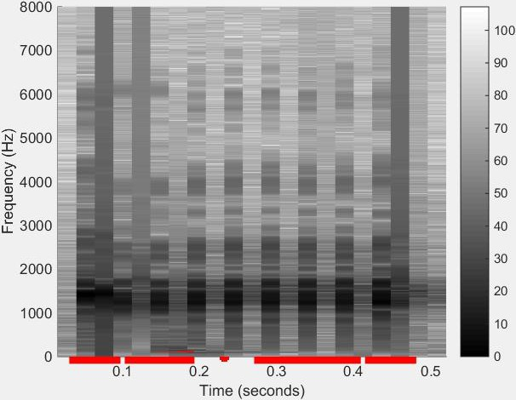

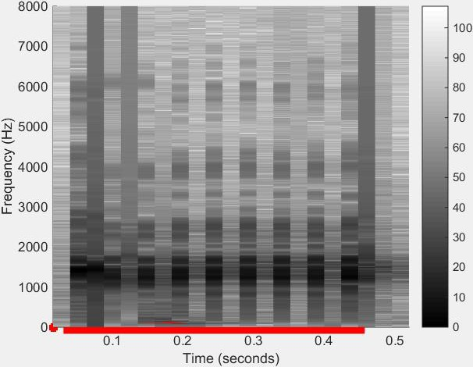

* + 1. After smoothing

**Figure 3.3**: Syllable segmentation results are marked with a red line for *Neobatrachus sudelli*

(one syllable).

* + 1. Pre-processing

Since features play an important role in the classification performance, pre-processing is applied to each syllable to improve the accuracy of feature extraction. The pre-processing of each syllable consists of the following steps:

160

Number of syllables for each frog species

140

120

100

80

60

40

20

0

ADI

CPA CSA LCS LOS LTS LTE LCA LCS LLA LNA LEA LRA LTI LVI MFS MFI NSI PKN PSS PCA PRI UFA ULA

Abbreviation of each frog species

**Figure 3.4**: Distribution of syllable number for all frog species. The x-axis is the abbreviation of each frog species, and the corresponding scientific name can be found in Table 3.1.

Pre-emphasise

Some collected frog calls have low amplitude but in the high frequency, which will have an effect on feature extraction of the spectrum at the high frequency end. To enhance those high- frequency components and reduce the low-frequency components, a first-order high-pass filter with finite impulse response (FIR) is introduced and defined as follows:

*y*(*n*) = *s*(*n*) *− αs*(*n −* 1) (3.1) where *s*(*n*) is a syllable of frog call, *y*(*n*) is the output of the high-pass filter, *α* denotes

the cut-off frequency of the high-pass filter and is set at 0.97 here, *n* is the n-th sample of the syllable.

Windowing

After pre-emphasising, each syllable is segmented into overlapping frames with fixed length. A Hamming widow is used to minimise the maximum side-lobe in the frequency domain and get side-lobe suppression, which is defined as

2*nπ*

*w*(*n*) = 0*.*54 *−* 0*.*46*cos*( *L −* 1 )*,* 0 *≤ n ≤ L −* 1

(3.2)

where *L* is the length of the frame. Because window sizes have an effect on the classification results, different window sizes are optimised for different features in this study. The signal after windowing process is expressed as

*x*(*n*) = *w*(*n*)*y*(*n*) (3.3)

* + 1. Feature extraction

After pre-processing of each syllable, various parametric representations are used to represent the syllable. In the literature, a variety of parametric representations of frog calls can be found, such as LPC and MFCCs [Bedoya et al., 2014,](#_bookmark177) [Jaafar and Ramli, 2013b,](#_bookmark214) [Yuan and Ramli, 2012]. MFCCs achieved a better performance than LPC [Yuan and Ramli, 2012]. Different from the hybrid features used [Gingras and Fitch, 2013,](#_bookmark202) [Han et al., 2011,](#_bookmark205) [Huang et al., 2009], our enhanced feature consists of more features, such as oscillation rate [Xie et al., 2015b], to further improve the classification accuracy. In this study, temporal features include syllable duration, Shannon entropy, r*e*´nyi entropy, zero-crossing rate, averaged energy, and oscillation rate. Perceptual features contain spectral centroid, spectral flatness, spectral roll-off, signal bandwidth, spectral flux, and fundamental frequency. The MFCCs feature is used as a cepstral feature. The description of each feature is listed below.

1. Syllable duration (*Dr*): Syllable duration [Xie et al., 2015b] is directly obtained from the bounds (time domain) of the segmentation results,

*Dr* = *x*(*ne*) *− x*(*ns*) (3.4)

where *ne* and *ns* are the end and start location of one segmented syllable.

1. Shannon entropy (*Se*): Shannon entropy is the expected information content of a sequence of a signal. It is often used to describe the average of all the information contents weighted by their probabilities *pi*

*L*

*Se* = *−* X *pilog*2(*pi*) (3.5)

*i*=1

where *L* is the length of a frog syllable.

1. R*e*´nyi entropy (*Re*): r*e*´nyi entropy is calculated to obtain the different averaging of proba- bilities via the parameter *α*, and defined as

*Re* =

*n*

*log*2(X *pα*) (3.6)

*i*

1

1 *− α i*

where *pi* is the probabilities of the occurence x(n) in the signal.

1. Zero-crossing rate (*Zcr*): zero-crossing rate denotes the rate of signal change along a signal. When adjacent signals have different signs, a zero-crossing occurs. The mathematical expression of *ZCR* can be defined as

*Zcr* =

1 *L−*1

X *−*

[*sgn*(*x*(*n*)) *sgn*(*x*(*n* + 1))] (3.7)

2

*n*=0

1. Averaged energy (Ae): Averaged energy is defined as the sum of intensity of signal.

*Ae* =

*L−*1

X *x*(*n*)2 (3.8)

1

*L*

*n*=0

1. Oscillation rate (*Or*): Oscillation rate is calculated in the frequency boundary around the fundamental frequency. First, the power within the frequency boundary is calculated. After normalising the power, the first and last 20% part of the power vector is discarded due to the uncertainty. Next, the autocorrelation is performed by the length of the vector. Furthermore, a discrete cosine transform is employed to the vector after mean subtraction, and the position of the highest frequency is achieved to calculate the oscillation rate.
2. Spectral centroid (*Sc*): spectral centroid is the centre point of spectrum distribution. In terms of human audio perception, it is often associated with the brightness of the sound. With the magnitudes as the weight, it is calculated as the weighted mean of the frequencies,

*Sc* =

*k*=0 *fk X*(*k*)

P*N −*1

*k*=0 *X*(*k*)

P*N −*1

(3.9)

where *X*(*k*) is the discrete Fourier transform (DFT) of the syllable signal of the k-th frame, N is the half size of DFT.

1. Spectral flatness (*Sf* ): spectral flatness provides a way to quantify the tonality of a sound. A higher spectral flatness indicates a similar amount of power of the spectrum in all spectral bands. Spectral flatness is measured by the ratio between the geometric mean and the arithmetic mean of the power spectrum and defined as

q 1 P*N −*1

*N k*=0 *InX*(*k*)

*Sf* = P*N −*1

1

*X*(*k*)

(3.10)

*N k*=0

1. Spectral roll-off (*Sr*): spectral roll-off is often used to measure the spectral shape, and defined as the frequency *H*. Here *H* is the value below which the *θ* of the magnitude distribution is concentrated,

*H N −*1

X *X*(*k*) = *θ* X *X*(*k*) (3.11)

where *θ* is set at 0.85.

*k k*=1

1. Signal bandwidth (*Bw*): signal bandwidth can be used to represent the difference between the upper and lower cut-off frequencies.

s P*N −*1 2

*Bw* =

*k*=0 (*k − Sc*) *|x*(*n*)*|*

*k*=0 *X*(*k*)

P*N −*1

(3.12)

1. Spectral flux (*Sf* ): spectral flux is used to measure how quickly the power spectrum of a signal is changing. The spectral flux can be obtained via the power spectrum comparison between one frame and its previous one. The calculation of spectral flux is denoted as

*Sf* =

*k*= *N*

2

X

*k*=*− N*

2

*H*[*|X*(*n, k*)*| − |X*(*n −* 1*, k*)*|*] (3.13)

where *H*(*x*) = (*x* + *|x|*)*/*2 is a half-wave rectifier function.

1. Fundamental frequency: fundamental frequency is calculated via averaging peak intensity of all frames within one frog syllable. If the peak intensity value is higher than an empirically chosen or specified threshold, the frequency of that peak will be selected to calculate the fundamental frequency.
2. Mel-frequency cepstral coefficients (MFCCs): MFCCs, which are obtained by applying cosine transform to a sub-band Mel-frequency spectrum within a short time, have been widely used in bird classification [Lee et al., 2006], speech/speaker recognition [Han et al., 2006], and frog identification [Bedoya et al., 2014]. In this study, MFCCs are calculated based on the method of Lee et al.  [2006].

**Step 1**: Band-pass filtering: The amplitude spectrum is then filtered using a set of triangular band-pass filters,

*Ej* =

*N/*2*−*1

X

*k*=0

*φj* (*k*)*Ak ,* 0 *≤ j ≤ J −* 1 (3.14)

where J is the number of filters, *φj* is the *jth* filter, and *Ak* is the amplitude of *X*(*k*).

*Ak* = *|X*[*k*]*|*2*,* 0 *≤ k ≤ N/*2 (3.15)

**Step 2**: Discrete cosine transform: MFCCs for the *ith* frame are computed by performing DCT on the logarithm of *Ej*

*J −*1

X

*m* =

*Cj*

*j*=0

*π*

cos(*m* (*j* + 0*.*5))*log*10(*Ej* )*,* 0 *≤ m ≤ L −* 1 (3.16)

*J*

where *L* is the number of MFCCs.

In this study, the filter bank consists of 40 triangular filters, that is *J* = 40. The length of MFCCs of each frame is 12 (L=12). After calculating MFCCs from each frame, the averaged MFCCs of all frames within one syllable are calculated.

*fm* =

*m*

P*K*

*i*=1

(*Cl* )

*,* 0 *≤ m ≤ L −* 1 (3.17)

*K*

where *fm* is the *mth* MFCCs, *K* is the number of frames within the syllable.

For all perceptual features and *Zcr*, the mean values are calculated to characterise the frog

syllable. Then, the L-dimensional MFCC vectors are fused with the other 11 feature vectors to form the enhanced temporal, perceptual and cepstral (TemPerCep) features.

After the formulation of feature vectors, normalisation is conducted as follows,

*vi* =

*vi −µi*

*σi*

(3.18)

where *µi* and *σi* are the mean and standard deviation computed for each feature vector *i*.

Let *F*1 represent temporal features with length *L*1, *F*2 and *F*3 represent perceptual features and cepstral features with length *L*2 and *L*3, respectively. The enhanced procedure is performed as

*FH* = *w*1*F*1 *⊕ w*2*F*2 *⊕ w*3*F*3 (3.19)

where *w*1, *w*2, and *w*3 are the weights, *⊕* is the concatenation operation.

* + 1. Classifier description

In this chapter, the results for five classification algorithms are reported: 1) Linear discriminant analysis (LDA), 2) K-nearest neighbour, 3) Support vector machines, 4) Random forest, 5) Artificial neural network. Five feature vectors, linear predictive coding, MFCCs, enhanced temporal feature and MFCC (*TemCep*), enhanced temporal and perceptual features (*TemPer*), enhanced temporal, perceptual features, and MFCC (*TemCepPer*), are fed into each classifier respectively to test their classification performance.

Linear discriminant analysis

After transforming the feature vector into low-dimensional space, the classification accuracy can be improved for linear discriminant analysis (LDA). In LDA, the goal is to find an optimal transformation matrix to transform the feature vector from an n-dimensional space to a d- dimensional space. A linear mapping, which maximises the Fisher criterion *JF* , is used to obtain the transformation matrix as follows.

*JF* (*A*) = *tr*((*AT Sw A*)*−*1(*AT SB A*)) (3.20)

where *Sw* and *SB* are the within-class scatter matrix and between-class scatter matrix, respec- tively. The within-class scatter matrix and between-class scatter matrix are respectively defined as

*C Nj*

*SW* = X X(*F j − µj* )(*F j − µj* )*T* (3.21)

*j*=1

*i i*

*i*=1

*C*

*SB* = X(*µi − µ*)(*µi − µ*)*T* (3.22)

*j*=1

where *F j* is the i-th feature vector of frog species *j*, *µj* is the mean vector of species *j*, *C* is the number of frog species, and *Nj* is the number of feature vectors in species *j*, *µ* is the mean vector of all frog species.

*i*

The optimisation of the transform matrix can be determined via finding the eigenvectors of

*W SB* .

*S−*1

*tr*(*AT SB A*)

*Aopt* = *argmax*

*AT SW*

(3.23)

*A*

In the recognition stage, the feature vector is first transformed into a lower-dimensional space via *Aopt* derived by LDA. Then, the distance between the feature vector of the test syllable and the feature vector representing this species is calculated. The one with minimum distance is regarded as the identified species.

K-nearest neighbour

For the K-NN classifier, the distance between an input frog feature vector and all stored feature vectors is first calculated. Then *K* closest vectors are selected to determine the species of the input feature vector by majority voting. For example, the Euclidean distance between an input instance *i* (frog feature vector) and one stored instance *j* is calculated as

v

u *n*

*d*(*i, j*) = uX(*Fi,c − Fj,c*)2

t

*c*=1

(3.24)

Then the species of this input instance *i* can be predicted from the selected *k* nearest neighbours,

If

1 X *d*(*i, j*(*S* )) *≤* 2

1 *k*

*k*1 *j S*1 2

X *d*(*i, j*(*S*2)) (3.25)

*j S*2

where *k* = *k*1 + *k*2, *k*1 is the number of frog species *S*1, *k*2 is the number of frog species *S*2. Here the input instance *i* will be classified as frog species *S*2. Following prior work ([Han et al.,](#_bookmark205) [2011,](#_bookmark205) [Xie et al., 2015b]), the distance function used for K-NN is the Euclidean function, and *k* is set at 1.

Support vector machines

Due to the high accuracy and superior generalisation properties, support vector machines (SVM) have been widely used for classifying animal sounds [Huang et al., 2009] [Acevedo et al.,](#_bookmark173) [2009]. In this study, the feature set obtained is first selected as training data. Then, the pairs (*F n, Ln*)*, l* = 1*,* 2*, ..., Cl* are constructed using the selected training data, where *Cl* is the number

*l l*

of frog instances in the training data, *F n* is the feature vector obtained from the *l*-*th* frog instance in the training data, *Ln* is the frog species label. Furthermore, the decision function for the classification problem based on SVM [Cortes and Vapnik, 1995] is defined by the training data

*l*

*l*

as follows,

*f* (*v*) = *sgn*(X *αnLnK*(*v, vn*) + *bn*) (3.26)

*l l l l*

*sv*

where *K*(*., .*) is the kernel function, *αn* is the Lagrange multiplier, and *bn* is the constant

*l l*

value. In this work, the Gaussian kernel is selected as the kernel function. Parameters *α* and *v* are selected independently for each feature vector by grid search using cross-validation [Hsu](#_bookmark209) [et al., 2003].

Random forest

Random forest (RF) is a tree-based algorithm, which builds a specified number of classification trees without pruning. The nodes are split on a random drawing of *m* features from the entire feature set *M* . A bootstrapped random sample from the training set is used to build each tree. The advantage of RF is its ability to generate a metric to rank predictors based on their relative contribution to the model’s predictive accuracy [Bao and Cui, 2005]. The prediction is defined

as follows.

*P red* =

*K*

1

X *Ti* (3.27)

*K*

*n*=1

where *Ti* is the n-th tree response of the RF. In this work, the number of trees *K* is set at 300 trees to characterise frog calls. As for the predictor variables *m*, it is set at *√N* , where *N* is the

feature dimension in a syllable.

Artificial neural network

Artificial neural network (ANN) is a non-linear, adaptive, machine learning tool with great capabilities for learning, generalisation, non-linear approximation, and classification. An ANN architecture often consists of many interconnected neurons organised in successive layers: pat- tern layer, summation layer, and decision layer. The neuron in class is often computed by a Gaussian function. Then, the summation layer uses summation units to memorise the class conditional probability density functions of each class through a combination of Gaussian densities. Lastly, the decision layer unit classifies the pattern in accordance with the Bayesian decision rule based on the output of all summation layer neurons as follows,

*D*(*F* ) = *argmaxpi*(*F* )*, i* = 1*, ..., N* (3.28)

where *i* is the species index, *N* is the total number of frog species.

*mi*

*pi*(*F* ) = X *βij φij* (*F* ) (3.29)

*j*=1

where *mi* is the number of Gaussian components, *βij* and *φij* (*F* ) can be represented as follows.

*mi*

X *βij* = 1 (3.30)

*j*=1

1

*φij* (*F* ) = (2*π*)(*d/*2)*σd exp*[*−*

(*F − µij* )*T* (*F − µij* )

2*σ*2 ] (3.31)

where *i* = 1*, ..., N* , *j* = 1*, ..., mi*, *d* denotes the dimension of the input vector *F* , *σ* is the smoothing parameter, *µij* is the mean vector and the central of the classification. In this study, one ANN classifier named multiple perception layer (MLP) is used to classify frog calls.

## Experiment results

In this experiment, all the datasets have been divided as 50% of the training set and 50% the testing set. For the testing phase, each machine learning algorithm is used to learn a model to classify frog calls with 5-fold cross validation. The performance of the proposed frog call classification system is evaluated by quantitatively expressed detection metrics, such as average accuracy, precision, and specificity. The definition of accuracy, precision, and specificity can be defined as

*Sensitivity* =

*T P T P* + *F N*

(3.32)

*Specif icity* =

*T N T N* + *F P*

(3.33)

*Accuracy* =

*T P* + *T N*

*T P* + *T N* + *F P* + *F N*

(3.34)

where *T P* is true positive, *F P* is true positive, *T N* is true negative, and *F N* is false negative.

* + 1. Effects of different machine learning techniques

Figure 3.5 shows the frog call classification performance with different machine learning tech- niques. The high classification results in term of the accuracy, sensitivity and specificity mea- sure of different classifiers indicate good classification performance. It can be observed that RF achieves the best classification performance, while the classification performance of LDA is the lowest. Meanwhile, the classification performances of SVM and MLP are very good, which might be that the features and classifiers are quite suitable. It can be seen from Figure 3.5 that frog call classification with different machine learning techniques can achieve good perfor- mance with our enhanced feature representation, because the classification accuracy is very high. It can also be noted that RF can be highly recommended for classification of frog calls due to the highest classification accuracy.

1

0.98

Classification performance

0.96

0.94

Accuracy Sensitivity Specificity

0.92

0.9

LDA K-NN SVM RF MLP

Machine learning techniques

**Figure 3.5**: Results of different classifiers

* + 1. Effects of different feature sets

Figure. 3.6 illustrates the classification accuracy with different feature sets: LPC feature, MFCCs (*Cep*), temporal features and MFCCs (*TempCep*), temporal features and perceptual features (*TemPer*), and temporal features, perceptual features and MFCCs (*TemPerCep*). It can be seen that cepstral features (*Cep*, *TempCep*, *TemPerCep*) have a more stable performance than LPC and perceptual features. It is evident that our proposed enhanced feature (*TemPerCep*) shows outstanding performance of all proposed feature representations of all the machine learning techniques. The reason for the high classification accuracy is that frog calls are of short dura- tion and cover a small spectral band. Our proposed enhanced feature, *TemPerCep*, can better characterise the content of frog calls. Although the classification performance of *TemPerCep* is not significantly higher than other feature representations, the difference does show that our proposed feature set is suitable and effective for the classification of frog calls.

* + 1. Effects of different window size for MFCCs and perceptual features

As we know, the window size has an effect on the MFCCs and perceptual features. There- fore, a different window size will lead to a different classification performance (Figure. 3.7 and Figure. 3.8). The window size used for the test is 32, 64, 128, 256, because the syllable length of some frog species is less than 512 samples. It is found that the best classification performance for MFCCs is achieved with window size of 64 samples. For *TemPer*, the window size of 64 obtains the best classification performance. It also can be observed that SVM and RF achieve the best classification performance. Moreover, different window sizes of MFCCs have a larger

1

0.8

Classification accuracy

0.6

0.4

0.2

LPC

Cep TemCep TemPer TemPerCep

0

LDA K-NN SVM RF MLP

Machine learning techniques

**Figure 3.6**: Classification results with different feature sets

variation than *TemPer* features, which might be because temporal features have a high weight in

*TemPer* for the classification task.

1

0.95

0.9

Classification accuracy

0.85

0.8

0.75

0.7

0.65

LDA K-NN SVM RF MLP

0.6

32 64 128 256

Window size

**Figure 3.7**: Classification results of MFCCs with different window size

* + 1. Effects of noise

To further evaluate the robustness of our proposed feature set, white noise with different signal- to-noise (SNR) of 40 dB, 30 dB, 20 dB, 10 dB, 0dB, and -10 dB is added to the frog calls. Because this chapter focuses on the evaluation of features rather than the segmentation method, the artificial noise is added after syllable segmentation. Since SVM has shown a good per- formance for frog call classification in 3.3.1, we only use SVM to test the effects of different levels of artificial noise. The classification results of different levels of noise contamination

1

0.95

0.9

Classification accuracy

0.85

0.8

0.75

0.7

LDA K-NN SVM RF MLP

0.65

0.6

32 64 128 256

Window size

**Figure 3.8**: Classification results of TemPer with different window size

are shown in Figure. 3.9. It is found from Figure 3.9, that MFCCs (Cep) are very sensitive to background noise, compared with other feature representations. Comparing *TemCep* with *TemPer*, it can be observed that perceptual features have a better anti-noise ability than the cepstral feature. It is also found that LPC has a good anti-noise ability when SNR is larger than 10, but the classification accuracy quickly decreases when SNR is smaller than 10.

1

0.9

0.8

LPC

Cep TemCep TemPer TemPerCep

0.7

Classification accuracy

0.6

0.5

0.4

0.3

0.2

0.1

40 30 20 10 0 -10

Different signal to noise ratio

**Figure 3.9**: Sensitivity for different features for different levels of noise contamination.

## Discussion

Table 3.2 shows the classification performance of previous methods. Since previous studies often used different datasets to perform the classification task, this research implemented all those features and applied them to the used dataset with the same classifier (SVM). Compared with those previous methods, this proposed enhanced feature representation significantly outperforms other methods. Therefore, it can be concluded that the results of this research stand above the current classification performance. From the table, we can also observe that MFCCs is the most popular feature that has been used for frog call classification. Among all used machine learning techniques, SVM shows the superior performance and is widely used for the classification task. It can be found that the classification accuracy of *TemPerCep* does not show significant improvement when compared with MFCCs. However, combining temporal and perceptual features with cepstral features greatly improves the anti-noise ability of MFCCs.

**Table 3.2**: Comparision with previous used feature representations

Ref. Feature Accuracy

[Juan Mayor, 2009,](#_bookmark219) [Yuan and Ramli, 2012] LPCs 93.5%

[Bedoya et al., 2014,](#_bookmark177) [Jaafar and Ramli, 2013b,](#_bookmark214) [Lee et al., 2006,](#_bookmark222) [Xie et al., 2015b] MFCCs 94.9%

Spectral centroid, Shannon entropy,

[Han et al., 2011]

[Xie et al., 2015b]

[Huang et al., 2014]

R*e*´nyi entropy

Syllable duration, dominant frequency, oscillation rate, frequency modulation, energy modulation

Spectral centroid, signal bandwidth, spectral roll-off, threshold-crossing rate, spectral flatness, and average energy

75.6%

92.3%

95.8%

Our feature representation *TemPerCep* 99.1%

## Summary and limitations

In this chapter, a novel enhanced feature representation was proposed, to classify frog calls with various machine learning techniques. After segmenting continuous recordings into individual syllables, a variety of acoustic features are extracted from each syllable. Then, different features are fused to form different feature representations. Finally, various machine learning techniques are used to classify frog calls with different feature representations. Our proposed enhanced feature representation shows the best classification accuracy and has good anti-noise ability. Meanwhile, the SVM and RF outperform the traditional LDA and K-NN classifiers. Therefore, it is suitable to combine *TemPerCep* with SVM or RF to build a frog call classification system.

Ecologists can apply the proposed classification system to long-term frog recordings. Then, the long-term change of frog species richness can be reflected by the classification results.

Since the MFCCs feature shows a good classification performance, but a bad anti-noise ability, we can modify MFCCs to improve the anti-noise ability. After transforming frog audio data into its spectrogram representation, the visual inspection motivates us to use image processing techniques for studying frog calls. Also, a wider variety of frog audio data from different geographical and environmental conditions will be tested in future experiments.

# Chapter 4

**Adaptive frequency scaled wavelet packet decomposition for frog call classification**

## Overview

This chapter presents a novel cepstral feature representation based on adaptive frequency scaled wavelet packet decomposition. Following the conclusion of Chapter 3, that cepstral features can achieve a good classification accuracy, but are sensitive to background noise, the goal of this chapter is to develop a novel ceptral feature representation with a good anti-noise ability.

Since both high and low SNR recordings are studied in this research, developing feature representations with a good anti-noise ability is important for dealing with low SNR record- ings. Different from most previous studies that extracted features via the Fourier transform, wavelet packet decomposition is employed in this chapter for feature extraction. The classifica- tion performance is evaluated with two different datasets from Queensland, Australia (18 frog species from commercial recordings (high SNR) and field recordings of eight frog species from James Cook University recordings (low SNR)). This chapter answers research question 2: How to improve the performance of developed features for frog call classification in low SNR recordings?

Although low SNR recordings are used in this research, the classification task is regarded as a single-instance, single-label learning problem. However, most individual low SNR recordings have more than one frog species. In the next two chapters, we will focus on the classification of multiple simultaneously vocalising frog species in one individual recording.

51

*CHAPTER 4. ADAPTIVE FREQUENCY SCALED WAVELET PACKET DECOMPOSITION*

52 *FOR FROG CALL CLASSIFICATION*

## Method

The architecture of the proposed classification method consists of five modules: syllable seg- mentation, syllable feature extraction, adaptive frequency scale generation, WPD feature ex- traction and classification (see Figure. 4.1). Each module is described in the following sections.



Recording waveform



Pre-processing STFT(1)

Spectrogram

Syllable segmentation

Syllablles

Syllable

waveforms STFT(2)

Spectrogram

(3) Adaptive frequency scale

generation

K-means clustering

Track duration

Oscillation rate

Feature set 1

Dominant frequency

|  |  |
| --- | --- |
| Spectral peak track extraction | |
|  |  |

Adaptive frequency scale

Syllable

waveforms

Feature set 1 or 2

|  |  |  |
| --- | --- | --- |
|  | | AWSCCs |
| Wavelet packet  decomposition |  |
|  |
|  |  |

k-NN or SVM Frog species

Feature set 2

**Figure 4.1**: Block diagram of the frog call classification system. The line of dashes indicates the extracted feature set. AWSCCs is the abbreviation of *adaptive wavelet packet decomposition sub-band cepstral coefficients*. STFT is short-time Fourier transform. For STFT(1), the window function, size and overlap are Kaiser window, 512 samples and 25%. For STFT(2), the window function, size and overlap are Hamming window, 128 samples and 90%. In this diagram, two feature sets are extracted, the description of other feature sets is shown in Figure 4.6.

* + 1. Sound recording and pre-processing

Two datasets obtained from a commercial recording [Stewart, 1999] and James Cook University (JCU) were selected for this chapter. Recordings, which were collected from the CD, are two- channel, sampled at 44.10 kHz and saved in MP3 format. All recordings were obtained with a directional microphone and have a high signal-to-noise ratio (SNR). Each recording includes one frog species, and has a duration ranging from twenty-one to fifty-four seconds. The calls of eighteen frog species recorded in Queensland, Australia, were used to develop the detailed

*4.2. METHOD* 53

methodology described in Figure 4.1. To reduce the subsequent computational burden, all the recordings selected from the CD were re-sampled at 16 kHz per second, mixed to mono, and saved in WAV format.

The JCU recordings were obtained from Kiyomi dam (S 19*◦* 22*0* 16*.*0*00* , E 146*◦* 27*0* 31*.*3*00* ) BG Creek dam (S 19*◦* 27*0* 1*.*23*00* , E 146*◦* 24*0* 5*.*65*00* ) and Stony Creek dam (S 19*◦* 24*0* 07*.*0*00* , E 146*◦* 25 51*.*3) in Townsville, using Song Meter (SM2) [Xie, 2016]. The recordings were stored on 16 GB SD cards in 64 kbps MP3 mono format and have a low SNR compared with the commercial recording. The sample rate is 16.00 kHz. All the JCU recordings started around sunset, finished around sunrise every day and have 12 hour duration.

* + 1. Spectrogram analysis for validation set

In this chapter, three syllables for each frog species are set aside and used as a *reference data set*. For the commercial recording, three parameters including syllable duration, dominant frequency, and oscillation rate, are manually calculated for those three syllables of each species and averaged, as listed in Table 4.1. The reference data set is excluded from the data used in the testing stage.

**Table 4.1**: Parameters of 18 frog species averaged of three randomly selected syllable samples in the commercial recording. These selected samples make the *reference data set*.

|  |  |  |
| --- | --- | --- |
| **Syllable duration** | **Peak** | **Oscillation rate** |
| **(millisecond)** | **frequency (Hz)** | **(cycle/second)** |
| 80 | 3200 | 160 |
| 250 | 4300 | 350 |
| 500 | 500 | 50 |
| 800 | 1700 | 220 |
| 430 | 4700 | 70 |
| 1400 | 2700 | 100 |
| 30 | 1400 | 2100 |
| 100 | 2800 | 160 |
| 160 | 4100 | 70 |
| 500 | 2900 | 60 |
| 270 | 3100 | 125 |
| 200 | 1200 | 140 |
| 50 | 1000 | 140 |
| 170 | 430 | 95 |
| 300 | 2400 | 80 |
| 370 | 2500 | 45 |
| 510 | 1500 | 60 |
| 450 | 2400 | 150 |

|  |  |  |
| --- | --- | --- |
| **No.** | **Scientific name** | **Abbreviation** |
| 1 | Assa darlingtoni | ADI |
| 2 | Crinia parinsignifera | CPA |
| 3 | Litoria caerulea | LCA |
| 4 | Litoria chloris | LCS |
| 5 | Litoria fallax | LFX |
| 6 | Litoria gracilenta | LGA |
| 7 | Litoria latopalmata | LLA |
| 8 | Litoria nasuta | LNA |
| 9 | Litoria revelata | LRA |
| 10 | Litoria rubella | LUA |
| 11 | Litoria verreauxii verreauxii | LVV |
| 12 | Mixophyes fasciolatus | MFS |
| 13 | Mixophyes fleayi | MFI |
| 14 | Philoria kundagungan | PKN |
| 15 | Pseudophryne coriacea | PCA |
| 16 | Pseudophryne raveni | PRI |
| 17 | Rheobatrachus silus | RSS |
| 18 | Uperoleia laevigata | ULA |

*CHAPTER 4. ADAPTIVE FREQUENCY SCALED WAVELET PACKET DECOMPOSITION*

54 *FOR FROG CALL CLASSIFICATION*

For the JCU recordings2, the corresponding parameters are described in Table 4.2. Com- pared with the commercial recordings from the CD, peak frequency shows a smaller variation than syllable duration and oscillation rate.

**Table 4.2**: Parameters of 8 frog species obtained by averaging three randomly selected syllable samples from recordings of James Cook University. NA indicates there is no oscillation structure in the spectrogram for the background noise and frog chorus. Since syllable durations of *Rhinella marina* (Commom name: Canetoad) are very different from each other, we manually set the duration of Canetoad using the maximum duration of other frog species, which is 500 milliseconds.

|  |  |  |
| --- | --- | --- |
| **Syllable duration** | **Peak** | **Oscillation rate** |
| **(millisecond)** | **frequency (Hz)** | **(cycles/second)** |
| 500 | 680 | 12 |
| 350 | 600 | NA |
| 80 | 630 | NA |
| 120 | 4100 | 50 |
| 100 | 2700 | NA |
| 350 | 1150 | 15 |
| 500 | 2400 | NA |
| 120 | 2400 | 40 |

|  |  |  |
| --- | --- | --- |
| **No.** | **Scientific name** | **Abbreviation** |
| 1 | Rhinella marina | CTD |
| 2 | Cyclorana novaehollandiae | CNE |
| 3 | Limnodynastes terraereginae | LTE |
| 4 | Litoria fallax | LFX |
| 5 | Litoria nasuta | LNA |
| 6 | Litoria rothii | LRI |
| 7 | Litoria rubella | LUA |
| 8 | Uperolela mimula | UMA |

* + 1. Syllable segmentation

For frog calls, an elementary acoustic unit for classification is the syllable, which is a continuous vocalisation emitted from an individual [Huang et al., 2009]. Each commercial recording con- sists of multiple continuous calls of one frog species. Therefore, it is necessary to segment each call into individual syllables. This syllable segmentation process is applied to the spectrogram, which is generated by applying short-time Fourier transform (STFT) to each recording. For STFT, the window function is the Hamming window with the size and overlap of 512 samples and 25%, respectively.

To further improve the segmentation result, those syllables, the averaged energy of which is less than 15% of the maximum energy, are removed [Gingras and Fitch, 2013]. The distribution of syllable numbers after segmentation for all frog species is shown in Figure 4.2.

For the JCU recordings, bandpass filtering is applied to each recording before using the H*a*¨rm*a*¨’s method [Harma, 2003]. A bandpass filter is first used to filter specific frog species, because different frog species tend to call simultaneously. The filtering is

2[https://www.ecosounds.or](http://www.ecosounds.org/)g/

*4.2. METHOD* 55



 *S*(*t, f* ) *Flower ≤ f ≤ Fupper S0* (*t, f* ) =

 0

Here, *S0* (*t, f* ) is the filtered spectrogram, the *Flower* and *Fupper* are lower and upper cutoff frequency and calculated as

*Fupper* = *Fpeak* + *β*

*Flower* = *Fpeak − β*

(4.1)

where *Fpeak* is the peak frequency (Table 4.2), *β* is a threshold for determining the frequency bandwidth and set at 300 Hz based on the *reference data set*.

After bandpass filtering, noise reduction is essential for improving the segmentation result for the low signal to noise ratio in JCU recordings. Here, we use the method of Towsey et al. [2012] for noise reduction. Finally, we use the H*a*¨rm*a*¨’s method to detect individual syllables (Figure. 4.3).

For *Canetoad*, the durations of different calls are very different, therefore, we manually selected 30 syllables, the combined duration of which is 500 ms.

For the JCU recordings, eight frog species were used for the experiment. After syllable seg- mentation of continuous recordings, for each frog species, we randomly selected 30 syllables from segmentation results for subsequent analysis.

150

100

Number of syllables for each frog species

50

0

ADI

CPA LCA LCS LFX LGA LLA LRA LUA LVV MFS MFI PKN PCA PRI RSS ULA ADI

Abbreviation of each frog species

**Figure 4.2**: Distribution of syllable number for all frog species. The x-axis is the abbreviation of each frog species, and the corresponding scientific name can be found in Table 4.1.

*CHAPTER 4. ADAPTIVE FREQUENCY SCALED WAVELET PACKET DECOMPOSITION*

56 *FOR FROG CALL CLASSIFICATION*

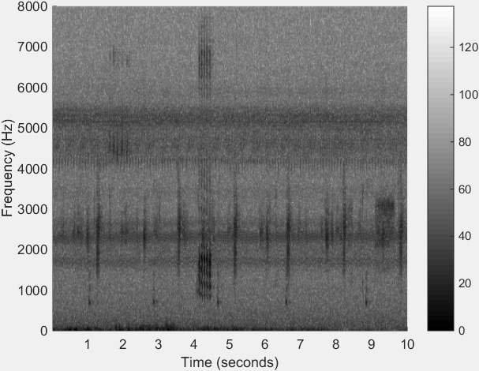

1. Spectrogram.

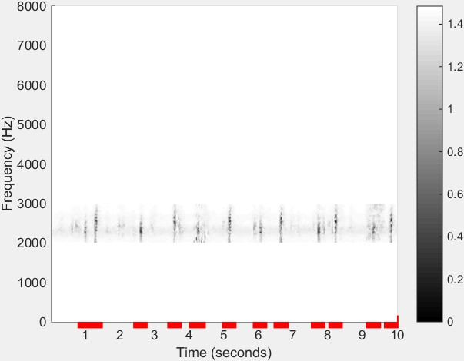

1. Segmentation results with marked red lines.

**Figure 4.3**: Segmentation results for *Uperolela mimula* using bandpass filtering, noise reduction and H*a*¨rm*a*¨’s method. The red line in (b) indicates the start and stop location of each segmented syllable.

* + 1. Spectral peak track extraction

Spectral peak tracks (SPT) (also called frequency tracks) have been explored for studying birds [Heller and Pinezich, 2008,](#_bookmark208) [Jancovic and Kokuer, 2015] and whales [Roch et al., 2011]. In this chapter, the spectral peak track is used to represent the trace of a frog advertisement call, because frogs that are genetically related share more similar advertisement calls than distantly related frogs [Gingras and Fitch, 2013]. The reasons for using SPT are (1) to isolate the desired frog calls from the background noise; (2) to extract corresponding SPT features. Here, the SPT method is reported in Xie et al.  [2015b].

For the SPT extraction algorithm, seven parameters need to be set (Table 4.3). The process for determining those parameters is explained in Section 3.

*4.2. METHOD* 57

**Table 4.3**: Parameters used for spectral peak extraction

**Parameter Description**

*I* (dB) Minimum intensity threshold for peak selection

*Tc* (s) Maximum time domain interval for peak connection

*Ts* (s) Minimum time interval for stopping growing tracks

*fc* (Hz) Maximum frequency domain interval for peak connection

*dmin* (s) Minimum track duration

*dmax* (s) Maximum track duration

*β*(0*∼*1) Minimum density value

Before applying the SPT extraction algorithm, each syllable is transformed to a spectrogram with the following parameter settings (Hamming window, frame size is 128 samples, and window overlap is 90%). For the generated spectrogram, the maximum intensity (real peak) is selected from each frame with a minimum required intensity, *I*. Then, the time and frequency domain intervals between two successive peaks are calculated. If the time and frequency intervals are smaller than *Tc* and *fc* respectively, one initial track (SPT1) will be generated.

After that, linear regression is applied to the generated track for calculating the position of the

next predicted peak. Based on peaks *p*1(*t*1*, f*1) and *p*2(*t*2*, f*2) within the initial track (SPT1), *a*

and *b* in Equation (4.2) can be solved.

*f* = *at* + *b* (4.2)

Based on *a* and *b*, the predicted peak *p*ˆ*n* of the following frame *tn* can be calculated. Next, the time and frequency domain intervals between predicted peak (*p*ˆ*n*) and the real peak of the successive frame are recalculated. If the time and frequency intervals are smaller than *Tc* and *fc* respectively, the real peak will be added to the initial track. After each peak is added to the initial track, linear regression is repeated to recalculate the next predicted peak, using at most the last 10 included peaks. This iterative process continues until *Ts* is no longer satisfied. When no more peaks will be added to one track, the next step is to compare the duration and density of the track with *dmin*, *dmax*, and *β*. If all conditions are satisfied, then the track will be saved to the track list. The SPT results for *Neobatrachus sudelli* are shown in Figure 4.4. During the process of track extraction, time domain gaps are generated where the intensity threshold *I* is not reached. These gaps can be filled by predicting the correct frequency bin using linear

*CHAPTER 4. ADAPTIVE FREQUENCY SCALED WAVELET PACKET DECOMPOSITION*

58 *FOR FROG CALL CLASSIFICATION*

regression, as illustrated in Figure. 4.4.

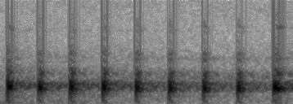

Frequency (kHz)

|  |  |  |  |  |  |  |
| --- | --- | --- | --- | --- | --- | --- |
| 16 |  | | | | | |
| 14 |
| 12 |
| 10 |
| 8 |
| 6 |
| 4 |
| 2 |
| 0 |
| 0 | 0.24 | 0.47 | 0.71 | 0.95 1.18 | 0 | 0.24 |
| Time (seconds)  (a) selected peaks below the intensity threshold *I* are | | | | | | |
| 16 |  |  |  |  |  |  |
| 14 |  |  |  |  |  |  |
| 12 |  |  |  |  |  |  |
| 10 |  |  |  |  |  |  |
| 8 |  |  |  |  |  |  |
| 6 |  |  |  |  |  |  |
| 4 |  |  |  |  |  |  |
| 2 |  |  |  |  |  |  |
| 0 |  |  |  |  |  |  |
| 0 | 0.24 | 0.47 | 0.71 | 0.95 1.18 | 0 | 0.24 |
| Time (seconds)  (b) spectral peak track with predicted peaks using | | | | | | |

linear regression.

set to zero.

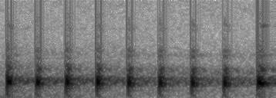

Frequency (kHz)

**Figure 4.4**: Spectral peak track extraction results for *Neobatrachus sudelli*. By filling the gaps within the track, the dominant frequency can be more accurately calculated.

* + 1. Syllable SPT features

After SPT extraction, each SPT is expressed in the following format: (1) track start time *ts*; (2) track stop time *te*; (3) frequency bin index for each of the peaks within the track *ft* (*ts ≤ t ≤ te*). Then, syllable features including track duration, dominant frequency, and oscillation rate are calculated based on the SPT.

1. Track duration (second): Track duration (*Dt*) is directly obtained from the bounds of the

*4.2. METHOD* 59

track.

*Dt* = (*te − ts*) *∗ rx* (4.3)

where *rx* is the time domain resolution in unit second per frame.

1. Dominant frequency (Hz): Dominant frequency (*f*¯) is calculated by averaging the frequency of all peaks within one track

*te*

*f*¯ = X *ft/*(*te − ts* + 1) *∗ ry* (4.4)

*t*=*ts*

where *ry* is the frequency domain resolution with unit frequency per bin, *ft* is the frequency bin index of peak *t*.

1. Oscillation rate (Hz): Oscillation rate (*Or* ) represents the number of pulses per second. The algorithm for extracting oscillation rate is introduced and summarised as follows. First, the frequency domain boundary is defined based on the dominant frequency, and the power within the boundary is calculated. Then, the power vector is normalised, and the first and last 20% part of the vector is discarded, because of the uncertainty in the start and end of the syllables. Next, the autocorrelation with the length of the vector is calculated. Furthermore, a discrete cosine transform (DCT) is applied to the vector after subtracting the mean, and the position of the highest frequency (*Pf* ) is achieved. Finally, the oscillation rate is defined as

*O* = *Pf*

*L*

*r*

*dct*

*∗ rx ∗ γ* (4.5)

where *Pf* is the position of the highest frequency values of the DCT result, *Ldct* is the length for applying DCT to the power vector, and is experientially set as 0.2 second in this chapter.

* + 1. Wavelet packet decomposition

Wavelet packet decomposition (WPD) is a powerful tool for the analysis of non-stationary signals, which includes multiple bases and different basis [Selin et al., 2007]. With WPD, an original acoustic signal can be split into two frequency bands such as lower and higher frequency band. Then, both lower and higher frequency bands can be further continuously decomposed into two sub-bands, which produce a complete wavelet packet tree F[arooq and](#_bookmark199) [Datta, 2001]. Due to its ability for analysing a non-stationary signal, WPD has been used to

*CHAPTER 4. ADAPTIVE FREQUENCY SCALED WAVELET PACKET DECOMPOSITION*

60 *FOR FROG CALL CLASSIFICATION*

analyse acoustic signals [Ren et al., 2008,](#_bookmark233) [Selin et al., 2007]. Here, WPD is used to obtain features for frog call classification.

* + 1. WPD based on an adaptive frequency scale

To obtain robust features for frog call classification, the frequency scale used for WPD is crucial. In prior work [Biswas et al., 2014,](#_bookmark178) [Litvin and Cohen, 2011,](#_bookmark223) [Zhang and Li, 2015], different frequency scales have already been proposed for WPD. Bark-scaled WPD was proposed by Litvin and Cohen to separate blind source from a single channel audio source [Litvin and](#_bookmark223) [Cohen, 2011]. Biswas et al. [2014] used features based on ERB-scaled (Equivalent Rectangular Bandwidth) WPD for Hindi consonant recognition. Zhang and Li [2015] developed a method based on Mel-scaled WPD for bird sound detection with the SVMs classifier. However, most frequency scales used for WPD are developed for studying speech rather than frogs. Therefore, finding a suitable frequency scale for frogs to perform the WPD is important for obtaining features with strong discriminatory power. In this chapter, an adaptive frequency scale for WPD for frog calls is proposed, based on the dominant frequency of frog species to be classified. Specifically, the k-means clustering algorithm is used to cluster the dominant frequency of all syllables. Then, the centroids of the clustering result are used to generate the frequency scale. Here, the value of *k* for the k-means clustering algorithm is the same as the number of frog species to be classified; the distance function used is *city block* [Melter, 1987].

Based on the obtained frequency scale, an adaptive frequency scaled WPD method is pro- posed, which is described in Algorithm 1. The wavelet packet tree used for classifying 18 frog species is shown in Figure 4.5.

* + 1. Feature extraction based on adaptive frequency scaled WPD

In previous studies [Bedoya et al., 2014,](#_bookmark177) [Xie et al., 2015b], Mel-frequency cepstral coeffi- cients (MFCCs) have been used for studying bioacoustic data, and used as the baseline for feature comparison in this chapter. Besides MFCCs, another feature set called Mel-scaled wavelet packet decomposition sub-band cepstral coefficients (MWSCCs) is also included in the comparison experiment [Zhang and Li, 2015], because it shows better performance than MFCCs for bird detection in a complex environment. In this chapter, we propose a novel feature set named *adaptive frequency scale wavelet packet decomposition sub-band cepstral*

* 1. *METHOD* 61

**Algorithm 1:** Adaptive frequency scale for WPD

**Data**: *ci*(*i* = 1*,* 2*, ..., K*), *fs*, where *K* is the number of frog species to be classified, *ci* is the centroid of the clustering results, *fs* = *sr/*2 where *sr* is the sample rate of the audio recordings, which is 16 kHz here.

**Result**: Adaptive wavelet packet tree

begin

**Step 1**: Sort the centroid *ci*(*i* = 1*,* 2*, ..., K*), and calculate the difference between the consecutive vectors of *c*, sort the difference and save it as *dj* (*j* = 1*,* 2*, ..., K −* 1)

**Step 2**: Calculate the decomposition level *L* based on the following rule

*fs/min*(*d*) *≤* 2*L−*1

where L is the minimum integer that satisfies that equation.

**Step 3**: Perform the wavelet packet decomposition

**for** *l* = 1 : *L* **do**

* + 1. Calculate the frequency resolution of level l

**for** *i* = 1 : *K* **do**

**1**: Put the *ci* into the right frequency band

**2**: Count the number of *ci* in each band (*n*)

**if** *n ≥* 2 **then**

perform further decomposition to that particular node

else

stop decomposition

*coefficients* (AWSCCs) for frog call classification. The extraction procedure of AWSCCs is similar to MWSCCs. However, the frequency scale used for our AWSCCs is based on an adaptive frequency scale rather than the Mel-scale for MWSCCs. Meanwhile, after performing DCT, temporal feature integration is used for calculating the statistics of feature vectors, which generates different statistical types of AWSCCs (see in Figure. 4.6).

After syllable segmentation, the signal of one syllable is represented as *y*(*n*)*, n* = 1*, ..., N* , where *N* is the length of one syllable of frog calls. Based on the *y*(*n*), steps for AWSCCs extraction are described as follows.

**1)**. Add Hamming window to the signal *y*(*n*).

*x*(*n*) = *w*(*n*)*y*(*n*) (4.6)

where *w*(*L*) is the Hamming window function and defined as *w*(*n*) = 0*.*54 0*.*46*cos*( 2*nπ* ), *L*

*−*

*L−*1

is the length of Hamming window and set as 128 samples here.

**2)**. Perform wavelet packet decomposition spaced in adaptive frequency scale as described in

*CHAPTER 4. ADAPTIVE FREQUENCY SCALED WAVELET PACKET DECOMPOSITION*

62 *FOR FROG CALL CLASSIFICATION*

**Level 1**

**Level 2**

**Level 3**

**Level 4**

**Level 5**

**Level 6**

**Level 7**

**Level 8**

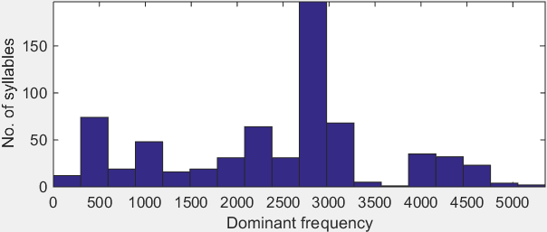

**Figure 4.5**: Adaptive wavelet packet tree for classifying twenty frog species. The upper image is the wavelet packet tree; the lower image is the histogram of dominant frequency for twenty frog species.

Hamming window

FFT Mel filter

band

Log + DCT

MFCCs

Syllable of

frog calls

Hamming

window

Mel-scaled

WPD

Sub-band

energy

Normalizat

ion

Log + DCT

MWSCCs

Hamming

window

AF-scaled

WPD

Sub-band

energy

Normalizat

ion

Log + DCT

**Temporal feature integration**

Different

AWSCCs

Adaptive frequency scale

**Figure 4.6**: Description of three feature extraction methods including MFCCs, MWSCCs, and different statistical types of AWSCCs.

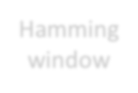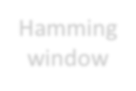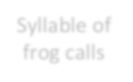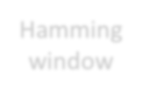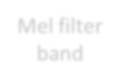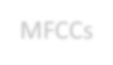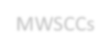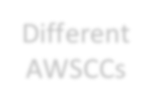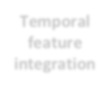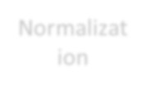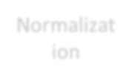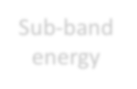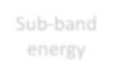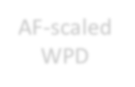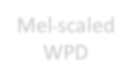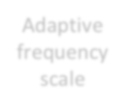

Section 2.7.

*M*

*W P* (*i, j*) = X *x*(*n*)*ψ*(*a,b*)(*n*) (4.7)

*i*=1

where *W P* (*i, j*) is the wavelet coefficients of the decomposition, *i* is the sub-band index, *j*

* 1. *METHOD* 63

is the index of wavelet coefficients, *ψ*(*a,b*)(*n*) is the wavelet base function, and we use ’Db 4’ experimentally. Here, *a* and *b* are the scale and shift parameters, respectively. ’Db 4’ represents the Daubechies wavelet transform, which has four scaling and wavelet function coefficients.

**3)**. Calculate the total energy of each sub-band,

*Mi*

*W Pi* = X[*W P* (*i, j*)]2 (4.8)

*j*=1

where *i* = 1*,* 2*, ..., T* , and *T* is the total number of sub-band, and *j* = 1*,* 2*, ..., Mi*, *Mi* is the total number of wavelet coefficients.

**4)**. Normalise the energy of each sub-band.

*SEi* =

*W Pi Mi*

(4.9)

where *i* = 1*,* 2*, ..., T* .

**5)**. Perform DCT on the logarithm sub-band energy for dimension reduction and obtain the feature AWSCCs.

*T*

*AW SCCs*(*d*) = X *logSEicos*(

*i*=1

*d*(*i −* 0*.*5)

*T*

*π*) (4.10)

where *d* = 1*,* 2*, ..., d0* , 1 *≤ d0 ≤ T* , here *d0* is the dimension of AWSCCs, and set as 12 here. To

keep the feature dimension consistency, the dimensions for MFCCs and MWSCCs are also set as 12 in this chapter, and the detailed steps for extraction can be found in [Bedoya et al., 2014] and [Zhang and Li, 2015].

**6)**. Temporal feature integration

Here, the statistics of all feature vectors over each windowed signal are calculated, which in- clude sum, average, standard deviation, and skewness. With randomly selected five instances for each frog species, the classification accuracy of averaged AWSCCs is higher than other statistics of AWSCCs. Therefore, only averaged AWSCCs are used in the subsequent experiment. To capture the dynamic information of the frog calls, the delta-AWSCCs are also calculated based on the averaged AWSCCs.

*CHAPTER 4. ADAPTIVE FREQUENCY SCALED WAVELET PACKET DECOMPOSITION*

64 *FOR FROG CALL CLASSIFICATION*

* + 1. Classification

In this chapter, the k-nearest neighbour (k-NN) and support vector machine (SVM) classifica- tion algorithms are used for frog call classification. The input parameters for each classifier are syllable features (SFs), MFCCs, MWSCCs, and different AWSCCs, and the output is the frog species.

k-nearest neighbours

For the k-NN classifier, an object is classified to the class of the majority of its k nearest neighbours [Huang et al., 2009]. Specifically, frog feature vectors are stored with species labels in the training phase. For the test phase, the distances between an input frog feature vector and all stored vectors are calculated. Then, k closest vectors are used for selecting the most frequent vector as the label. For example, the Euclidean distance between an input feature vector *fi,c* and one stored feature vector *fj,c* is calculated as

v

u *n*

*d*(*i, j*) = uX(*fi,c − fj,c*)2

t

*c*=1

(4.11)

where *i* and *j* are indices of the feature vector, *n* means the dimension of the feature vector. Next, k nearest neighbours of the feature vector *i* are selected based on the Euclidean distance for selecting the most frequent vector as the label. If the following equation is satisfied

1 X *d*(*i, j*(*s* )) *≤* 1

1 *k*

*k*1 *j∈s*1 2

X *d*(*i, j*(*s*2)) (4.12)

*j∈s*2

where *k* = *k*1 + *k*2, *k*1 is the number of frog species *s*1, *k*2 is the number of frog species *s*2. Here, the input feature vector *i* will be classified as frog species *s*2.

Support vector machines

Due to the high accuracy and superior generalisation properties, support vector machines have been widely used for classifying animal sounds [Acevedo et al., 2009,](#_bookmark173) [Huang et al., 2009]. In this chapter, the feature set obtained is first selected as training data. Then, the pairs (*vn, Ln*)*, l* =

*l l*

1*,* 2*, ..., Cl* are constructed using the selected training data, where *Cl* is the number of frog

* 1. *EXPERIMENT RESULT AND DISCUSSION* 65

instances in the training data, *vn*

*l*

is the feature vector obtained from the *l*-*th* frog instance

in the training data, *Ln* is the frog species label. Furthermore, the decision function for the classification problem based on SVM [Cortes and Vapnik, 1995] is defined by the training data as follows:

*l*

*f* (*v*) = *sgn*(X *αnLnK*(*v, vn*) + *bn*) (4.13)

*l l l l*

*sv*

where *K*(*., .*) is the kernel function, *αn* is the Lagrange multiplier, and *bn* is the constant

*l l*

value.

## Experiment result and discussion

Several experiments are described for evaluating our proposed frog call classification system. First, the parameter tuning is discussed based on the reference data set. Then, the comparisons between all proposed features are studied. Finally, the classification results under different SNR are described.

* + 1. Parameter tuning

There are five modules for parameter tuning: syllable segmentation, spectral peak track, feature extraction, and classification (Figure. 5.1).

For syllable segmentation, the window size and overlap are 512 samples and 25%, however, the intensity threshold is 10 dB and 5 dB for the commercial recordings and the JCU recordings respectively.

In the spectral peak track determination, there are seven parameters (see in Table 4.3). The parameter settings are shown in Table 4.4.

With a random parameter setting start, an iterative loop is performed for a fixed range of each parameter base on Table 4.1 to optimise those parameters.

For feature extraction, the window size and overlap are the same for MFCCs, MWSCCs, and AWSCCs using Hamming window, which are 128 samples and 90%, respectively. The dimensions of MFCCs, MWSCCs and AWSCCs are 12. For SFs and delta-AWSCCs, the dimensions are 3 and 24, respectively.

*CHAPTER 4. ADAPTIVE FREQUENCY SCALED WAVELET PACKET DECOMPOSITION*

66 *FOR FROG CALL CLASSIFICATION*

**Table 4.4**: Parameter setting for calculating spectral peak track.

|  |  |  |
| --- | --- | --- |
| **Parameter** | **Commercial recordings** | **JCU recordings** |
| *I* (dB) | 3 | 3 |
| *Tc* (s) | 0.005 | 0.1 |
| *Ts* (s) | 0.05 | 0.2 |
| *fc* (Hz) | 800 | 800 |
| *dmin* (s) | 0.01 | 0.05 |
| *dmax* (s) | 2 | 2 |

*β*(0*∼*1) 0.8 0.6

Following prior work [Han et al., 2011,](#_bookmark205) [Huang et al., 2009,](#_bookmark211) [Xie et al., 2015b], the distance function used for k-NN is the Euclidean distance, and *k* is set as 3. As for the SVM classifier, the Gaussian kernel is used. Parameters *α* and *v* are selected independently for each feature set by grid-search using cross validation [Hsu et al., 2003].

* + 1. Feature evaluation

All experiments are carried out in Matlab R2014b. Performance statistics are estimated with ten-fold cross validation. Totally, five feature sets including SFs, MFCCs, MWSCCs, and averaged AWSCCs, and delta-AWSCCs, are fed to two classifiers, which are the k-NN and SVM classifiers. Both k-NN and SVM classifiers are run ten times for evaluating the feature robustness. Due to the non-uniform distribution of the number of syllables for different frog species in the commercial recordings, a weighted classification accuracy is defined as follows

*N*

* *n*

*weighted Acc* = X *Acc*(*i*) *i*

*N*

(4.14)

*i*=1

where *ni* is the number of syllables for frog species *i*, *N* is the number of syllables for all frog species, *Acc* is the classification accuracy for that particular frog species.

* + 1. Comparison between different feature sets

The classification accuracy comparison for 18 frog species using five feature sets and two classifiers is shown in Table 4.5.

*4.3. EXPERIMENT RESULT AND DISCUSSION* 67

**Table 4.5**: Weighted classification accuracy (mean and standard deviation) comparison for five feature sets with two classifiers.

**Feature set**

**Classification accuracy (%) k-NN SVM**

#### SFs 82.2 *±* 11.2 84.2 *±* 10.5

MFCCs 90.8 *±* 8.6 92.8 *±* 11.0

MWSCCs 95.0 *±* 7.7 97.6 *±* 5.7

Averaged AWSCCs 98.8 *±* 4.2 99.0 *±* 3.6

Delta-AWSCCs 99.2 *±*2.1 **99.6** *±***1.8**

In this experiment, the best classification accuracy is 99.6%, which is achieved by the delta- AWSCCs with the SVM classifier. Compared with the average AWSCCs, the delta-AWSCCs achieved a slightly better performance. One may conjecture that the delta-AWSCCs can capture the dynamic information of the frog calls. For MWSCCs, the averaged classification accuracy of both classifiers is about 2% lower than that of averaged AWSCCs and delta-AWSCCs with 96.3%. The improvement shows that the proposed adaptive frequency scale can capture more information about frog calls than the Mel-scale (Figure. 4.7).

As for SFs and MFCCs, the averaged classification accuracy is much lower than AWSCCs, which is 83.2% and 91.8%, respectively. To explore the reason for the improvement of the proposed feature, the frog call classification accuracy of all frog species is shown in Table 4.6. However, only the features that use the SVM classifier are shown, because averaged accuracy of the k-NN classifier (93.2%) is lower than the SVM classifier (94.64%).

Table 4.6 lists the classification accuracy of all 18 frog species with five features. It can be seen from the table that delta-AWSCCs have an accuracy greater than 95% for all frog species. Compared with averaged AWSCCs, the classification accuracy of *Pseudophryne cori- acea* (PCA) and *Litoria verreauxii verreauxii* (LVV) are improved to 100%; it might be that the delta-AWSCCs include the dynamic information of frog calls. For *Litoria revelata* (LRA), both the classification accuracy of averaged AWSCCs and delta-AWSCCs are lower than 100%; this is because the dominant frequency is quite similar with multiple frog species including *Assa darlingtoni* (ADI), *Litoria nasuta* (LNA) and *Litoria verreauxii verreauxii* (LVV). However, the classification of *Litoria revelata* (LRA) is 100% using Mel-scale based techniques, because the Mel-scale has a better frequency resolution for *Litoria chloris* (LCS) within its dominant

*CHAPTER 4. ADAPTIVE FREQUENCY SCALED WAVELET PACKET DECOMPOSITION*

68 *FOR FROG CALL CLASSIFICATION*

1 4.5

0.9

0.8

0.7

0.6

0.5

0.4

0.3

0.2

0.1

4

3.5

3

2.5

2

1.5

1

0.5

0

0 2 4 6 8 10 12

(a) MFCCs

0

0 2 4 6 8 10 12

3.5

3.5

3 3

2.5

2.5

2

1.5

2

1.5

1

1

0.5

0.5 0

0

0 2 4 6 8 10 12

1. Averaged AWSCCs

-0.5

0 5 10 15 20 25

1. Delta-AWSCCs

(b) MWSCCs

**Figure 4.7**: The feature vectors for 31 syllables of the single species, *Assa darlingtoni*. The x-axis is the feature index and y-axis is the feature value. Note that the feature vectors for averaged AWSCCs

(c) and delta-AWSCCs (d) are more highly correlated than for the other two methods (a) and (b).

frequency range. In Table 4.8, the classification accuracy of SFs and MFCCs is lower than the other three features, at only 84.2% and 92.8%, respectively.

The statistical significance of the results is shown in Table 4.7. The classification accuracy of average AWSCCs is not significantly lower than the delta-AWSCCs. However, the classification accuracy of MWSCCs, MFCCs and SFs is significantly lower than delta-AWSCCs.

Since our wavelet packet tree for feature extraction is obtained based on the frog species to be classified, two more experiments are used for further evaluation. The first experiment is to classify the first ten frog species (No.1-10); the second is to classify the first fourteen frog species (No.1-14) (see Table 4.1). The wavelet packet tree for classifying ten and fourteen frog species

*4.3. EXPERIMENT RESULT AND DISCUSSION* 69

**Table 4.6**: Classification accuracy of five features for the classification of twenty-four frog species using the SVM classifier. Here, Avg AWSCCs means the averaged AWSCCs.

**Classification accuracy (%)**

**Code**

|  |  |  |  |  |  |
| --- | --- | --- | --- | --- | --- |
|  | **SFs** | **MFCCs** | **MelCCs** | **Avg AWSCCs** | **Delta-AWSCCs** |
| ADI | 76.7 *±* 15.3 | 80.0 *±* 22.1 | 83.3 *±* 16.7 | 100.0 *±* 0.0 | 100.0 *±* 0.0 |
| CPA | 86.7 *±* 16.3 | 100.0 *±* 0.0 | 93.3 *±* 13.3 | 100.0 *±* 0.0 | 100.0 *±* 0.0 |
| LCA | 93.3 *±* 15.3 | 100.0 *±* 0.0 | 100.0 *±* 0.0 | 100.0 *±* 0.0 | 100.0 *±* 0.0 |
| LCS | 70.0 *±* 23.3 | 63.3 *±* 27.7 | 96.7 *±* 10.0 | 93.3 *±* 13.3 | 96.7 *±* 10.0 |
| LFX | 91.7 *±* 8.3 | 93.3 *±* 8.2 | 93.3 *±* 8.2 | 100.0 *±* 0.0 | 100.0 *±* 0.0 |
| LGA | 30.0 *±* 45.8 | 100.0 *±* 0.0 | 100.0 *±* 0.0 | 100.0 *±* 0.0 | 100.0 *±* 0.0 |
| LLA | 92.7 *±* 8.1 | 98.7 *±* 2.7 | 98.0 *±* 4.3 | 100.0 *±* 0.0 | 100.0 *±* 0.0 |
| LNA | 78.6 *±* 14.6 | 94.3 *±* 9.5 | 95.7 *±* 9.1 | 100.0 *±* 0.0 | 100.0 *±* 0.0 |
| LRA | 40.0 *±* 30.0 | 10.0 *±* 20.0 | 100.0 *±* 0.0 | 90.0 *±* 20.0 | 98.2 *±* 6.5 |
| LUA | 60.0 *±* 20.0 | 100.0 *±* 0.0 | 86.7 *±* 22.1 | 100.0 *±* 0.0 | 100.0 *±* 0.0 |
| LVV | 100.0 *±* 0.0 | 96.7 *±* 10.0 | 80.0 *±* 22.1 | 93.3 *±* 13.3 | 100.0 *±* 0.0 |
| MFS | 90.0 *±* 15.3 | 76.7 *±* 21.3 | 90.0 *±* 15.3 | 100.0 *±* 0.0 | 100.0 *±* 0.0 |
| MFI | 90.0 *±* 30.0 | 100.0 *±* 0.0 | 100.0 *±* 0.0 | 100.0 *±* 0.0 | 100.0 *±* 0.0 |
| PKN | 90.0 *±* 20.0 | 100.0 *±* 0.0 | 100.0 *±* 0.0 | 100.0 *±* 0.0 | 100.0 *±* 0.0 |
| PCA | 72.5 *±* 20.8 | 77.5 *±* 20.8 | 95.0 *±* 10.0 | 92.5 *±* 11.5 | 100.0 *±* 0.0 |
| PRI | 45.0 *±* 35.0 | 80.0 *±* 33.2 | 100.0 *±* 0.0 | 100.0 *±* 0.0 | 100.0 *±* 0.0 |
| RSS | 50.0 *±* 50.0 | 100.0 *±* 0.0 | 100.0 *±* 0.0 | 100.0 *±* 0.0 | 100.0 *±* 0.0 |

ULA 93.3 *±*13.3 100.0 *±*0.0 100.0 *±*0.0 100.0 *±*0.0 100.0 *±*0.0

**Table 4.7**: Paired statistical analysis of the results in Table 4.6. For the classification accuracy of each frog species, the paired Student t-test was conducted T[anton, 2005].

Pairs t-test results

Delta-AWSCCs - Avg AWSCCs t=1.95 (not significant)

Delta-AWSCCs - MWSCCs t=3.41 (significant at p *<*0.01, df =17) Delta-AWSCCs - MFCCs t=2.91 (significant at p *<*0.01, df =17) Delta-AWSCCs - SFs t=5.52 (significant at p *<*0.001, df =17)

is shown in Figure. 4.8, which is different from the tree for classifying eighteen frog species. However, the Mel-scaled wavelet packet tree is the same for all experiments (see Figure. 4.9). The classification results are shown in Table 4.8. Since the classification accuracy with averaged AWSCCs is very high for classifying ten and fourteen frog species, the delta-AWSCCs is not included in this experiment. Table 4.8 shows that averaged AWSCCs can achieve the highest classification accuracy for classifying different numbers of frog species. Since the averaged AWSCCs are adaptively extracted based on the data, more frog species do not cause a large decrease in the classification accuracy.

*CHAPTER 4. ADAPTIVE FREQUENCY SCALED WAVELET PACKET DECOMPOSITION*

70 *FOR FROG CALL CLASSIFICATION*

|  |  |  |  |
| --- | --- | --- | --- |
|  |  | | |
|  | |  | |
|  |  | |  |

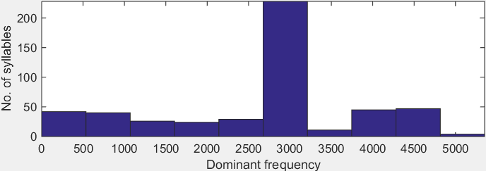

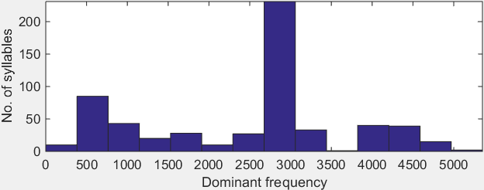**Figure 4.8**: Wavelet packet tree based on adaptive frequency scale for classifying ten and fifteen frog species.

**Figure 4.9**: Mel-scaled wavelet packet tree for frog call classification.

**Table 4.8**: Classification accuracy (%) for classifying different number of frog species with four feature sets.

|  |  |  |  |  |
| --- | --- | --- | --- | --- |
| **Features** | **SFs** | **MFCCs** | **MWSCCs** | **Averaged AWSCCs** |
| 18 frog species  14 frog species | 84.2 *±* 10.5  89.6 *±* 9.7 | 92.8 *±* 11.0  94.4 *±* 8.5 | 97.6 *±* 5.7  99.2 *±* 2.6 | 99.0 *±* 4.6  100.0 *±* 0.0 |

10 frog species 94.6 *±*8.7 95.8 *±*8.6 100.0 *±*0.0 100.0 *±*0.0

* + 1. Comparison under different SNRs

To further evaluate the robustness of the proposed feature, a Gaussian noise signal, with SNR of 40 dB, 30 dB, 20 dB, and 10 dB, is added to the original signal. The noise is added after syllable

* 1. *EXPERIMENT RESULT AND DISCUSSION* 71

segmentation, because this chapter focuses on the development of novel features for classifica- tion rather than the segmentation method. The classification accuracy with five features under different SNRs is shown in Figure. 4.10. Compared with MFCCs and MWSCCs, SFs have a stronger anti-noise performance, because the dominant frequency of SFs has a small variation under low SNR. Correspondingly, the adaptive frequency scale also has a small variation, because it is generated by means of applying the k-means clustering algorithm to the dominant frequency. Therefore, our proposed feature has a stronger anti-noise performance than other cepstral features (MFCCs and MWSCCs).

120

100

Weighted classification accuracy

80

60

40 Delta ASWCC

Averaged AWSCC

MWSCC MFCC

20 SF

0

SNR 40 SNR 30 SNR 20 SNR 10

Different SNRs (dB)

**Figure 4.10**: Sensitivity of five features for different levels of noise contamination.

* + 1. Feature evaluation using the real world recordings

Table 4.9 shows the classification accuracy comparison using our proposed feature to classify eight frog species obtained from the JCU recordings. Since calls of some frog species in the JCU recordings do not have oscillation structure, SFs are not included for the comparison. Compared with other referred features, our proposed feature also achieves the best classification performance. Since the JCU recordings often have multiple calls from different frog species, spectral peak track occasionally cannot capture the specific frog species (labelled species for that syllable), but other frog species to be classified; however, applying k-mean clustering to the dominant frequency calculated from the spectral peak track can reduce this deviation. Therefore, the frequency scale used for the WPD can be accurately achieved, which still leads to a high classification accuracy with the proposed feature.

*CHAPTER 4. ADAPTIVE FREQUENCY SCALED WAVELET PACKET DECOMPOSITION*

72 *FOR FROG CALL CLASSIFICATION*

**Table 4.9**: Classification accuracy using the JCU recordings.

Classification accuracy (%)

**Feature set**

**k-NN SVM**

MFCCs 67.5 *±* 13.2 70.8 *±* 14.1

MWSCCs 90.4 *±* 9.2 91.6 *±* 8.7

Averaged AWSCCs 94.1 *±* 6.3 94.5 *±* 5.8

Delta-AWSCCs 97.0 *±*5.2 **97.4** *±***5.4**

## 4.4 Summary and limitations

In this chapter, a novel feature extraction method for frog call classification is developed using the adaptive frequency scaled wavelet packet decomposition. With segmented syllables, spec- tral peak track is first extracted from each syllable. Then, track duration, dominant frequency, and oscillation rate are calculated based on each track. Next, a k-means clustering algorithm is applied to the dominant frequency, which generates the frequency scale for WPD. Finally, a new feature set, AWSCCs, is calculated. Since the feature extraction method is developed based on the data itself, the wavelet packet tree varies according to the frog species to be classified. Compared with the Mel-scaled WPD tree, the proposed adaptive wavelet packet tree can better fit the dominant frequency distribution of the frog species to be classified. With the proposed frequency scale, the call characteristics of those frog species to be classified can be enhanced, while the background noise and calls from other animals will be suppressed. Therefore, the proposed feature sets can achieve a higher accuracy for the classification of frog calls than others. Meanwhile, since the frequency scale is calculated based on the dominant frequency of those frog species to be classified, our proposed wavelet tree structure is more accurate and efficient in classifying the frog calls when compared with Mel-scale (Figure. 4.8 and Figure. 4.9).

The feature extraction algorithm is designed for classifying frog calls. For frog calls, the typical structure in a spectrogram is frequency contour (named spectral peak track in this chapter), which is within a given frequency range starting at a given time [Mellinger et al.,](#_bookmark227) [2011]. For other organisms that have similar frequency contour structures, such as the whistles of dolphins, and chirps of birds [Chen and Maher, 2006], spectral peak tracks can also be extracted from the spectrograms of their calls. Based on those spectral peak tracks, dominant frequency can be calculated. For the subsequent analysis, the features can be calculated using the same

* 1. *SUMMARY AND LIMITATIONS* 73

process as described in this chapter. For those organisms without a clear frequency contour structure, this proposed method can also be used by enhancing the frequency contour structure, which can be realised by applying a small window size and a large window overlap to the recording waveform.

The oscillation rate is calculated based on the spectrogram, which is generated by applying STFT to the waveform. However, when the temporal gap is smaller than the window size used for STFT, the oscillation structure will disappear. Therefore, finding new techniques for trans- lating the 1-D signal to 2-D signal is our future direction. Since the frequency scale is generated based on the dominant frequency, this technique can be applied to other organisms that have clear frequency contour structures. Modifying this algorithm to those organisms without a clear frequency contour structure needs to be solved. This research also plans to include additional experiments that test a wider variety of audio data from different geographical and environment conditions. Other animal calls such as birds, insects, and whales can also be studied. Furthermore, the idea of developing new features based on the data itself will be explored.

*CHAPTER 4. ADAPTIVE FREQUENCY SCALED WAVELET PACKET DECOMPOSITION*

74 *FOR FROG CALL CLASSIFICATION*

# Chapter 5

**Multiple-instance multiple-label learning for the classification of frog calls with acoustic event detection**

## Overview

This chapter presents a method for the classification of simultaneously vocalising frog species in low signal-to-noise ratio (SNR) recordings. In Chapters 3 and 4, frog call classification is solved using a signal-instance single-label (SISL) framework, which cannot reflect the nature of automatically collected environmental recordings. Most automatically collected field record- ings have low SNR and consist of multiple simultaneous animal vocal activities including frogs, birds, crickets, and so on. This character of environmental acoustic recordings makes the multiple-instance, multiple-label (MIML) learning a suitable classification framework. To be specific, individual frog syllables in one audio clip are regarded as *multiple instance*, and the frog species included in that audio clip denote *multiple labels*. The key part of this MIML classification framework for studying frog calls is to detect individual syllables in environmental recordings with multiple simultaneously vocalising frog species. After syllable detection, stan- dard acoustic features and MIML classifiers can be used to perform the MIML classification.

To evaluate our proposed MIML classification framework, a representative sample of 342 10-second recordings was exported from the database and split into training and testing sets. The performance is evaluated based on the MIML learning measures. Experimental results

75

*CHAPTER 5. MULTIPLE-INSTANCE MULTIPLE-LABEL LEARNING FOR THE*

76 *CLASSIFICATION OF FROG CALLS WITH ACOUSTIC EVENT DETECTION*

Demonstrate that the MIML classification framework can be successfully adopted to classify multi- ple simultaneously vocalising frog species in low SNR recordings.

## Materials and methods

Our frog call classification system consists of four steps: signal processing, acoustic event detection, feature extraction, and classification (Fig. 5.1). Detailed description of each step is listed in the following parts.



Mask descriptors (MD)

MIML-SVM

Spectrogram

Acoustic event

detection

Profile statistics

(PS)

MIML-RBF Frog species

Combination of

MD and PS

MIML-kNN

Signal

processing Feature

Segmentation

extraction

Classification

**Figure 5.1**: Flowchart of a frog call classification system using MIML learning.

* + 1. Materials

Digital recordings in this chapter were obtained with a battery-powered, weatherproof Song Meter (SM2) box (Wildlife Acoustics, <http://www.wildlifeacoustics.com/products/song-meter-> sm2-birds). Recordings were two-channel, sampled at 22.05 kHz and saved in WAC4 format. In this chapter, a representative sample of 342 10-s recordings was selected to train and evaluate our proposed algorithm for predicting which frog species are present in a recording. All those examples were collected between 02/2014 to 03/2014, because it is the frog breeding season with high calling activity. All the species that are present in each 10-s recording were manually labelled by an ecologist who studies frog calls. There are totally eight frog species in the recordings: Canetoad (CAD) (*F*0=560 Hz), Cyclorana novaehollandiae (CNE) (*F*0=610 Hz), Limnodynastes terraereginae (LTE) (*F*0=610 Hz), Litoria fallax (LFX) (*F*0=4000 Hz), Litoria nasuta (LNA) (*F*0=2800 Hz), Litoria rothii (LRI) (*F*0=1800 Hz), Litoria rubella (LRA) (*F*0=2300 Hz), and Uperolela mimula (UMA) (*F*0=2400 Hz). Here, *F*0 is the averaged dominant frequency for each frog species. Each recording contains between 1 and 5 species. Following

*5.2. MATERIALS AND METHODS* 77

the prior work of Briggs et al. [2012], we assume that recordings without any frog calls can be filtered during acoustic event detection.

* + 1. Signal processing

All the recordings were first re-sampled at 16 kHz and mixed to mono. A spectrogram was then generated by applying short-time Fourier transform (STFT) to each recording. Specifi- cally, each recording was divided into frames of 512 samples with 50% frame overlap. A fast Fourier transform was then performed on each frame with a Hamming window, which yielded amplitude values for 256 frequency bins, each spanning 31.25 Hz. The final decibel values (S) were generated using

*Stf* = 20 *∗ log*10(*Atf* ) (5.1)

where A is the amplitude value, *t* = 0*, ..., T −* 1 and *f* = 0*, ..., F −* 1 represent time and frequency index, *T* and *F* are 256 frequency bins and 625 frames, respectively.

* + 1. Acoustic event detection for syllable segmentation

Acoustic event detection (AED) aims to detect a specified acoustic event in audio data. In this chapter, we use AED for frog syllable segmentation. Since all the recordings are collected from the field, there is much overlapping vocal activity from different sources. Traditional methods for frog syllable segmentation are based on time domain information (Huang et al. [2009], Somervuo et al. [2004]), which cannot address those recordings. Here, we modified the AED method developed by Towsey et al. [2012] to segment syllables in those recordings with overlapping activity. The detail of our AED method is described as follows: **Step 1:** Wiener filtering

To de-noise and smooth the spectrogram, a 2-D Wiener filter is applied to the spectrogram image over a 5 *×* 5 time-frequency grid, where the filter size is selected after consideration of trade-off between removing the background graininess and blurring the acoustic events.

*S*ˆ*tf* = *µ* +

(*σ*2 *− ν*2)

*σ*2

(*Stf − ν*) (5.2)

where *µ* and *σ*2 are local mean and variance, respectively; *ν*2 is the noise variance estimated by

*CHAPTER 5. MULTIPLE-INSTANCE MULTIPLE-LABEL LEARNING FOR THE*

78 *CLASSIFICATION OF FROG CALLS WITH ACOUSTIC EVENT DETECTION*

averaging all local variances.

**Step 2:** Spectral subtraction

After Wiener filtering, the graininess has been removed. However, some noises such as wind, insect and motor engine that cover the whole recording cannot be removed. Here, a modified spectral subtraction method is employed for dealing with those noises.

**Algorithm 2:** Modified Spectral Subtraction

**Data**: *S*ˆ*tf* , spectrogram after Wiener filtering.

**Result**: *S*ˆ*0*

*tf*

= *S*ˆ*tf* , noise reduced spectrogram.

begin

**Construct** an array of the modal noise values for all frequency bins;

**for** *f ∈ F* **do**

1. calculate the histogram of the intensity value over each frequency bin
2. smooth the histogram array with a moving average window of size 7
3. regard the modal noise intensity at the position of maximal bin in the left-side of the histogram

**Smooth** the array with a moving average filter with window of size 5;

**for** *f ∈ F* **do**

1. subtract the modal noise intensity
2. truncated negative decibel values to zero

**Step 3:** Adaptive thresholding

After noise reduction, the next step is to convert a noise reduced spectrogram *S*ˆ*0*

*tf*

into the

binary spectrogram *Sb*

*tf*

for events detection. Here, an adaptive thresholding method named

*Otsu thresholding* Otsu [1975] is employed to find an optimal threshold.

*b* (*k*) = *w*1(*k*)*w*2(*k*)[*µ*1(*k*) *− µ*2(*k*)]2

*φ*2

(5.3)

where *w*1(*k*) = P*k p*(*j*) is calculated from the histogram as *k*, *p*(*j*) = *n*(*j*)*/N* are the values

0

of the normalised gray level histogram, *n*(*j*) is the number of values in level *j*, *N* is the total number of values over the whole spectrogram image, *µ*1(*k*) = [P*k p*(*j*)*x*(*j*)]*/w*1, *x*(*j*) is the value at the center of the *j*th histogram bin. Then, the threshold, *T*0, is calculated as

0

*T*0 = (*φ*2 (*k*) + *φ*2 (*k*))*/*2 (5.4)

*b*1 *b*2

**Step 4:** Events filtering using dominant frequency and event area

Since not all detected events correspond to frog vocalisations, to further remove those events

* 1. *MATERIALS AND METHODS* 79

that are not from the listed frog species in section 5.2.1, dominant frequency (*F*0) and area within the event boundary (*Ar*) are used for filtering.

**Algorithm 3:** Event filtering based on dominant frequency and event area

**Data**: *Sb* , spectrogram; *ts*(*n*), *te*(*n*), *fl*(*n*), *fh*(*n*), location of each acoustic event *n*; *F*0(*i*), dominant frequency of frog species *i*.

*tf*

Result: begin

*S*˜*tf* , spectrogram after events filtering.

**Calculate** the area of each acoustic event *n*. *Area*(*n*) = (*te*(*n*) *− ts*(*n*)) *∗* (*fh*(*n*) *− fl*(*n*)) **for** *n ∈ Ne*1 **do**

**if** *Ar*(*n*) *≥ Arl* **then**

split event *n* into small events

where *Arl* is set as 3000 pixels.

**Filter** events using dominant frequency *fd*(*n*) = P*te*(*n*)

*t*=*ts*(*n*)

*F* (*t*)*/te*(*n*) *− ts*(*n*)

where *F* (*t*) is the peak frequency of each frame within the event area

**for** *n ∈ Ne*2 **do for** *i ∈ I* **do**

**if** *fd*(*n*) *≥ F*0(*i*) + *θ; fd*(*n*) *≤ F*0(*i*) *− θ* **then**

*fd*(*n*) = 0;

where *θ* is frequency range and set as 300 Hz.

**Remove** small acoustic events except frequency band between *θl* and *θh*

**for** *n ∈ Ne*2 **do**

**if** *Ar*(*n*) *≤ Ars* **then**

remove event *n*

where *Ars* is set at 300 pixels, *θl* and *θh* are set as 300 Hz and 800 Hz, respectively. Because the area of LTE is smaller than *Ars*.

**Step 5:** Region growing

A region growing algorithm is utilised to obtain the contour of the particular acoustic event [[Mallawaarachchi et al., 2008]].](#_bookmark225) To get the accurate boundary of each acoustic event and improve the discrimination of extracted features, a 2-D region growing algorithm is applied to obtain the accurate event shape within each segmented event. First, a maximal intensity value within the event area is selected as the seed point. Then, the neighbourhood pixels of the seed(s) above the threshold are located and assigned to the output image, and the new added pixels are used as seeds for further processing. Finally, when all the pixels that satisfy the criteria are added to the output image, the recursive algorithm will stop and get the final results (Fig. 5.3). Here, the threshold value is empirically set as 5 dB.

*CHAPTER 5. MULTIPLE-INSTANCE MULTIPLE-LABEL LEARNING FOR THE*

80 *CLASSIFICATION OF FROG CALLS WITH ACOUSTIC EVENT DETECTION*

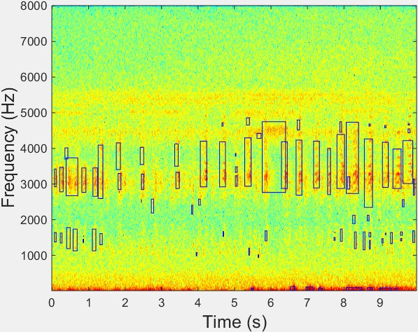

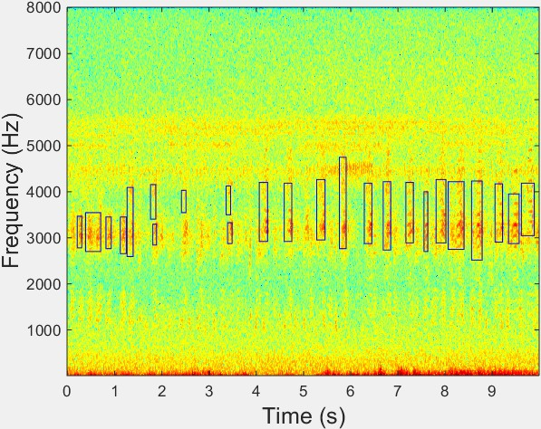**Figure 5.2**: Acoustic event detection results before (Left) and after (Right) event filtering based on dominant frequency. Here, blue rectangle means the time and frequency boundary of each detected event.

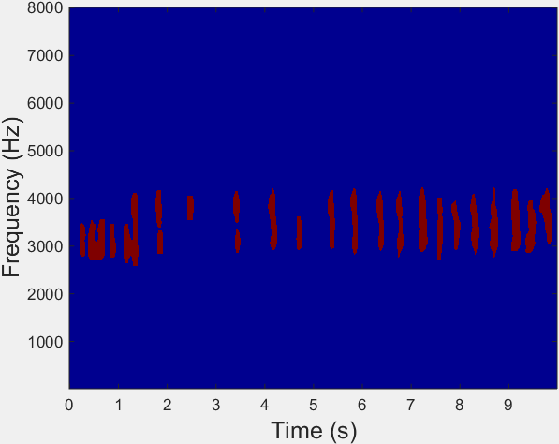

**Figure 5.3**: Acoustic event detection results after region growing. Left: binary segmentation results; Right: segmented frog syllables.

* + 1. Feature extraction

Based on acoustic event detection results, two feature representations are first calculated to describe each event (syllable): mask descriptors and profile statistics [Briggs et al., 2012]. Here, we exclude a histogram of orientation from our feature set, because the previous studies have already demonstrated its lowest classification accuracy [Briggs et al., 2012;](#_bookmark181) [Ruiz-Munoz](#_bookmark236) [et al., 2015]. For mask descriptors, it is used to describe the syllable shape including mini- mum frequency, maximum frequency, bandwidth, duration, area, perimeter, non-compactness, rectangularity. For profile statistics, there are time-Gini, frequency-Gini, frequency-mean, frequency-variance, frequency-skewness, frequency-kurtosis, frequency-max, time-max, mask- mean, and mask standard deviation. The third feature set consists of all features.

* 1. *EXPERIMENT RESULTS* 81
     1. Multiple-instance multiple-label classifiers

After feature extraction, three MIML algorithms are evaluated for the classification of multiple simultaneous vocalising frog species: MIML-SVM, MIML-RBF, and MIML-kNN. With some form of event-level distance measure, the MIML problem has been reduced to a single-instance multiple-label problem by associating each event with an event-level feature [Briggs et al., 2012]. Here, the maximal and average Hausdorff distances between two syllables are used by MIML- SVM and MIML-RBF, separately. For MIML-kNN, the nearest neighbour is used to assign syllable-level features.

## Experiment results

* + 1. Parameter tuning

There are three modules, the parameters of which need to be discussed: signal processing, acous- tic event detection, and classification. For signal processing, the window size and overlap are 512 samples and 50%, respectively. During the process of acoustic event detection, four thresholds for event filtering need to be determined, which are small and large area threshold, and frequency boundary for events filtering. All those thresholds were determined empirically by applying various combinations of thresholds to a small number of randomly selected 10s clips. For MIML-SVM classifiers, the parameters used are (*C, γ, r*) and set as (0.1, 0.6, 0.2) experimentally. For MIML-RBF, the parameters are (*r, µ*) and set as (0.1,0.6). For MIML-kNN, the number of references (k) and citers (*k0* ) are 10 and 20, respectively.

* + 1. Classification

In this chapter, all the algorithms were programmed in Matlab 2014b. Each MIML algorithm is evaluated with five-fold cross-validation on the collection of 342 species-labelled recordings. Five evaluation rules are used for comparing the performance with the combination of three feature representations and three ML algorithms: Hamming loss, Rank loss, Average precision, One error, Exampled based F1, and Micro F1 [Madjarov et al., 2012,](#_bookmark224) [Zhou et al., 2008]. The value range of all five evaluation rules is between 0 to 1. The definition of each evaluation rule is described as follows:

*CHAPTER 5. MULTIPLE-INSTANCE MULTIPLE-LABEL LEARNING FOR THE*

82 *CLASSIFICATION OF FROG CALLS WITH ACOUSTIC EVENT DETECTION*

1. Hamming loss directly measures the fraction of labels that are incorrectly predicted. A smaller value of hamming loss indicates a better classification performance.
2. Rank loss indicates the number of label pairs that are incorrectly ordered by the scores of ML classifier. A smaller value of rank loss indicates a better classification performance.
3. Average precision is the average fraction of labels that are ranked higher than an actual label belonging to an example. A higher value of average precision indicates a better classification performance.
4. One error is the fraction of bags whose top scoring label is not in the true label set. A smaller value of one error indicates a better classification performance.
5. Exampled based F1 is the average of the harmonic mean of example-precision and example- recall for every example. The example-precision is defined for an example as the size of the intersection of the set of its predicted labels and the set of its ground truth labels divided by the size of the set of its predicted labels. The example-recall is defined for an example as the size of the intersection of the set of its predicted labels and the set of its ground truth labels divided by the size of the set of its ground truth labels. A higher value of exampled based F1 indicates a better classification performance.
6. Micro F1 is the harmonic mean of micro-precision and micro-recall where micro-precision and micro-recall are the precision and the recall, which are averaged over all example and label pairs. A higher value of micro F1 indicates a better classification performance.

The positive/negative is 1*−*Hamming loss and it is 0.818 for MIML-RBF with Mask de- scriptors (MD). MD and profile statistical (PS), and all features (AF) are put into the three classifiers, respectively. The accuracy measure for each MIML classifier is shown in Table

5.1. Here, the best classification accuracy is achieved by MIML-RBF using MD. For each classifier, the classification accuracy of MD is higher than PS and AF, which shows that the event shape has higher discrimination power than the event content. To give a concrete view of predictions, the results of five randomly selected recordings using MIML-RBF are shown in Table 5.2. Recordings of No.1 and No.3 are accurately predicted.

*5.4. DISCUSSION* 83

**Table 5.1**: Accuracy measure for MIML classifiers with different feature representations. Here,

*↓* indicates the smaller the better, while *↑* indicates the bigger the better.

**Feature Algorithm Hamming loss** *↓* **Rank loss** *↓* **One-error** *↓* **Coverage** *↓* **Micro-AUC** *↑*

|  |  |  |  |  |  |  |
| --- | --- | --- | --- | --- | --- | --- |
| MD | MIML-SVM | 0.253 | 0.186 | 0.308 | 3.147 | 0.745 |
| MD | MIML-kNN | 0.205 | 0.153 | 0.298 | 2.647 | 0.771 |
| MD | MIML-RBF | **0.182** | **0.132** | **0.223** | **2.352** | **0.828** |
| PS | MIML-SVM | 0.239 | 0.208 | 0.323 | 3.544 | 0.728 |
| PS | MIML-kNN | 0.211 | 0.153 | 0.298 | 2.647 | 0.777 |
| PS | MIML-RBF | 0.186 | 0.161 | 0.338 | 3.161 | 0.746 |
| AF (MD+PS) | MIML-SVM | 0.261 | 0.199 | 0.279 | 3.588 | 0.761 |
| AF (MD+PS) | MIML-kNN | 0.205 | 0.160 | 0.264 | 2.735 | 0.787 |
| AF (MD+PS) | MIML-RBF | 0.191 | 0.142 | 0.220 | 2.632 | 0.821 |

**Table 5.2**: Example predictions with MIML-RBF.

|  |  |  |
| --- | --- | --- |
| **No.** | **Ground truth** | **Predicted labels** |
| 1 | UMA | UMA |
| 2 | LNA, LRI, UMA | LNA, LRA, UMA |
| 3 | LNA, UMA | LNA, UMA |
| 4 | LNA, LFX, LRA | LNA, LFX, LRI, LRA |
| 5 | LNA, LFX, LRA | LNA, LRA |

## Discussion

Since most recordings used in this chapter consist of multiple simultaneously vocalising frog species, the traditional single-instance, single-label classification framework is no longer suit- able. A novel framework for the classification of multiple simultaneous vocalising frog species in environmental recordings is proposed, which is adapted from Briggs et al. [2012], a study on birds. Differently from that work, this research designed a new acoustic event detection method for syllable segmentation rather than using a supervised learning algorithm. This was because there is a lack of lots of annotated frog recordings. As for the classification results, our proposed framework can achieve an acceptable classification accuracy. However, the classification results are highly affected by the AED results.

## Summary and limitations

In this chapter, we propose a novel framework for the classification of multiple simultaneous vo- calising frog species in environmental recordings. To the best of our knowledge, this is the first

*CHAPTER 5. MULTIPLE-INSTANCE MULTIPLE-LABEL LEARNING FOR THE*

84 *CLASSIFICATION OF FROG CALLS WITH ACOUSTIC EVENT DETECTION*

study that applies the MIML algorithm to frog calls. Since frogs tend to call simultaneously, the MIML algorithm is more suitable for dealing with those recordings than single-instance single- label classification. After applying an acoustic event detection algorithm to each 10s recording, each frog syllable is segmented. Then, three feature representations are calculated, based on those segmented syllables. Finally, three MIML classifiers are used for the classification of frog calls with the best accuracy (81.8% true positive/negatives). Future work will focus on the study of novel features and MIML classifiers for further improving the classification performance. Since current classification results are highly affected by the syllable segmentation results, to further improve the classification performance, one solution is to prepare an annotated dataset and change to using a supervised learning algorithm. Another is to use a different classification framework, which does not need the AED process.

# Chapter 6

**Detecting frog calling activity based on acoustic event detection and multi-label learning**

## Overview

This chapter describes the research conducted for detecting frog calling activity (frog abundance and frog species richness). Compared with Chapter 5, acoustic event detection is used to predict the present or absence of eight specific frog species. Here, frog abundance is calculated based on the area and content of each segmented event. In Chapter 5, acoustic features are calculated based on the results of acoustic event detection (AED) to predict frog species richness, but the accuracy of AED results directly affect the multiple-label, multiple-instance (MIML) classifica- tion performance. To reduce the bias introduced by AED, this research presents a global feature representation for the classification of recordings with simultaneous vocalising frog species. This feature representation regards all the frog species in each individual recording as a whole. Therefore, the classification process can be framed as multiple-label (ML) learning.

Compared with that described in Chapter 5, three global feature representations are cal- culated to classify each segmented recording: linear predictive coding (LPC), MFCCs and wavelet-based features. The wavelet-based features are similar with the features used in Chapter

4. The difference is that we divide *adaptive WPD sub-band ceptral coefficients* into three equal stages to capture more temporal information.

Furthermore, this proposed classification framework is conducted for a long-term analysis. The frog calling activity during the breeding season is calculated. Also, the correlation between

85

*CHAPTER 6. DETECTING FROG CALLING ACTIVITY BASED ON ACOUSTIC EVENT*

86 *DETECTION AND MULTI-LABEL LEARNING*

the frog calling activity and weather variables is studied for finding the relationship between frog calls and environments.

## Materials and methods

The architecture of this frog calling activity detection system is shown in Figure 6.1. The system consists of three parts: frog abundance detection, frog species richness detection, and correlation analysis. Each part is discussed in detail in the following subsections.

Audio data

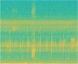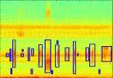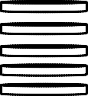

|  |  |
| --- | --- |
| AED results | |
|  |  |

Weather variables

Correlation analysis

**Include frogs**

No END

Yes

Multi-label learning

* + 1. MFCCs, 2. LPCs,

3. Wavelet feature

**Figure 6.1**: Flowchart of a frog call classification system using multi-label learning.

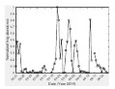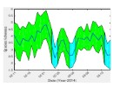

* + 1. Acquisition of frog call recordings

All recordings selected for this chapter were obtained from three sites in Queensland, Australia: *Kiyomi dam*, *Stony creek dam* and *BG creek dam*, using a battery-powered acoustic sensor (stored in a weather proof metal box) with an external microphone. The recordings were stored on 16 GB SD cards in 64 kbps MP3 mono format. All recordings were collected from February, 2014 to April, 2014, because it is the breeding season in Queensland when male frogs make calls to attract females for the purpose of reproducing. All recordings started around sunset, finished around sunrise every day and have 12 hour duration. The study sampled 10-second recordings every 10 minutes for those continuous recordings. There are 4170, 4908, and 1544 10-second recordings for *Kiyomi dam*, *Stony Creek dam* and *BG Creek dam* respectively, because of data loss. A representative

*6.2. MATERIALS AND METHODS* 87

sample of 342 10-second recordings was selected to train and evaluate the proposed method. The ground truth of those 342 10-second recordings is generated by a frog expert, who manually tagged each recording with frog species.

We first manually inspected spectrograms of ten randomly selected call examples for each frog species. Two parameters, dominant frequency and syllable duration, were then measured and averaged, as listed in Table 6.1, which are used as prior information for subsequent analysis.

**Table 6.1**: Dominant frequency (*F*0) and syllable duration (*Ts*) of eight frog species averaged for ten randomly selected syllables.

|  |  |  |  |
| --- | --- | --- | --- |
| **Frog species** | **Code** | **Dominant frequency (Hz)** | **Syllable duration(ms)** |
| *Canetoad* | CAD | 560 | NA |
| *Cyclorana novaehollandiae* | CNE | 610 | 400 |
| *Limnodynastes terraereginae* | LTE | 610 | 100 |
| *Litoria fallax* | LFX | 4000 | 280 |
| *Litoria nasuta* | LNA | 2800 | 160 |
| *Litoria rothii* | LRI | 1800 | 500 |
| *Litoria rubella* | LRA | 2300 | 580 |
| *Uperolela mimula* | UMA | 2400 | 120 |

* + 1. Frog abundance monitoring

Frog abundance is monitored through the detection of acoustic events in a spectrogram image. Here, the spectrogram was generated by applying short-time Fourier transform (STFT) to each 10-second recording. Acoustic event detection, which consists of multiple image processing steps, is modified from our previous study [Xie et al., 2015d] and summarised as follows. **Step 1:** Wiener filter

To de-noise and smooth the spectrogram, a 2-dimensional Wiener filter is applied to the spec- trogram image over a 5 *×* 5 time-frequency grid, where the filter size is selected after the consideration of trade-off between removing the background graininess and blurring acoustic events.

*S*ˆ*tf* = *µ* +

(*σ*2 *− ν*2)

*σ*2

(*Stf − ν*) (6.1)

where *µ* and *σ*2 are local mean and variance, respectively; *ν*2 is the noise variance estimated by averaging all local variances.

**Step 2:** Spectral subtraction

After Wiener filtering, the graininess has been removed. However, some noises such as wind,

*CHAPTER 6. DETECTING FROG CALLING ACTIVITY BASED ON ACOUSTIC EVENT*

88 *DETECTION AND MULTI-LABEL LEARNING*

Insect and motor engine, which cover the whole recording, still remained. Here, a modified spectral subtraction is employed for dealing with those noises. Description of this algorithm can be found in our previous study [Xie et al., 2016].

**Step 3:** Adaptive thresholding

Following noise reduction, the next step is to convert the noise reduced spectrogram *S*ˆ*0*

*tf*

into

the binary spectrogram *Sb*

*tf*

for events detection. Here, an adaptive thresholding method named

*Otsu thresholding* [Otsu, 1975] is employed to find an optimal threshold.

*b* (*k*) = *w*1(*k*)*w*2(*k*)[*µ*1(*k*) *− µ*2(*k*)]2

*φ*2

(6.2)

where *w*1(*k*) = P*k p*(*j*) is calculated from the histogram, as *k*, *p*(*j*) = *n*(*j*)*/N* are the values

0

of the normalised gray level histogram, *n*(*j*) is the number of values in level *j*, *N* is the total number of values over the whole spectrogram image, *µ*1(*k*) = [P*k p*(*j*)*x*(*j*)]*/w*1, *x*(*j*) is the value at the centre of the *j*th histogram bin. Then, the threshold, *T*0, is calculated as

0

*T*0 = (*φ*2 (*k*) + *φ*2 (*k*))*/*2 (6.3)

*b*1 *b*2

**Step 4:** Events filtering using dominant frequency and event area

To further remove those events that do not belong to the frog species shown in Table 6.1, dominant frequency (*F*0) and area (number of pixels) within the event boundary (*Ar*) are used for filtering. First, large acoustic events, whose area is larger than *Alarge*, are separated into small events, because the area of frog calls to be classified in Table 6.1 is empirically smaller than *Alarge*. Then, dominant frequency is used to filter the events. First, the averaged frequency is calculated by averaging the peak frequency within each acoustic event. Then, the event, the averaged frequency of which is not within allowed fluctuation in both sides of dominant frequency, is discarded. Finally, small acoustic events, the area of which are smaller than *Asmall*, are filtered. Those events, with average frequency of between 300 Hz and 800 Hz, are not filtered out using *Asmall*, because the area of LTE (averaged frequency is between 300 Hz and 800 Hz) is smaller than *Asmall*. Figure 6.2 shows the acoustic event detection results.

To calculate frog abundance of each segmented recording, the frog abundance is calculated as follows.

*6.2. MATERIALS AND METHODS* 89

*N*

*Fabun* = X *Ai,j* (*n*)2 (6.4)

*n*=1

Here, *Ai,j* represents the decibel value of location (*i, j*) within each acoustic event *n* in the spectrogram.

* + 1. Wavelet-based feature extraction for species richness analysis

Frog species richness is calculated by tagging each segmented recording. Since many seg- mented recordings consist of multiple frog species, one direct solution is to assign each record- ing with a set of labels (frog species) for explicitly expressing its semantics [Zhang and Zhou](#_bookmark258), [2014]. Therefore, multi-label learning is adopted to tag each segmented recording.

Extracting discriminating features, which maximise between-group (inter-specie) dissimi- larity and minimise within-group (intra-specie) dissimilarity, is very important for achieving high classification performance [Bedoya et al., 2014;](#_bookmark177) [Huang et al., 2009]. In this chapter, feature extraction is performed based on wavelet packet decomposition using a modified version of the method introduced in Chapter 4 and detailed below.

For feature extraction, constructing a suitable frequency scale for a wavelet packet (WP) tree based on the dominant frequency of each frog species is the first step, because different frog species tend to have different dominant frequencies Gingras and Fitch [2013]. In Chapter 4, k-means clustering was first applied to the extracted dominant frequencies of training data. Then, the frequency scale was built by sorting clustering centroids to construct the WP tree. In this chapter, the prior information on dominant frequency (*F*0) obtained from Table 6.1 is directly used to construct the WP tree. We iteratively detect each WP tree sub-band node until the frequency range of each node includes more than one dominant frequency *F*0. Then, the WP tree of that particular sub-band node will be further split until each sub-band node has only one dominant frequency value or none. After constructing the frequency scale, adaptive frequency scaled wavelet packet decomposition is applied to each segmented recording for feature extraction.

For each 10-second recording, it is represented as *y*(*n*)*, n* = 1*, ..., N* , where *N* is the length of each recording. Based on the *y*(*n*), detailed description for WP-based feature extraction is listed as follows:

*CHAPTER 6. DETECTING FROG CALLING ACTIVITY BASED ON ACOUSTIC EVENT*

90 *DETECTION AND MULTI-LABEL LEARNING*

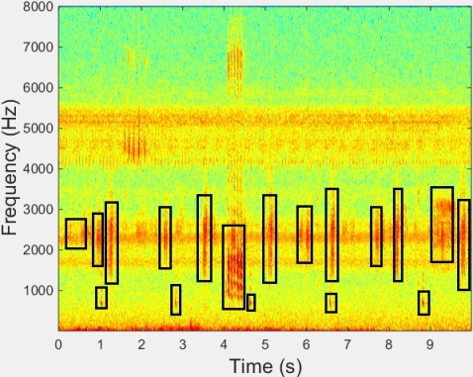

8000

1. 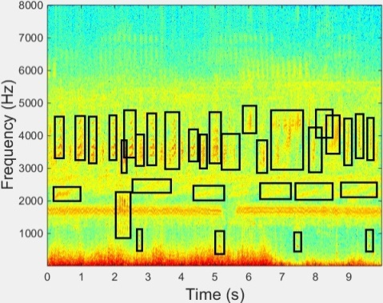Baseline (b) Baseline

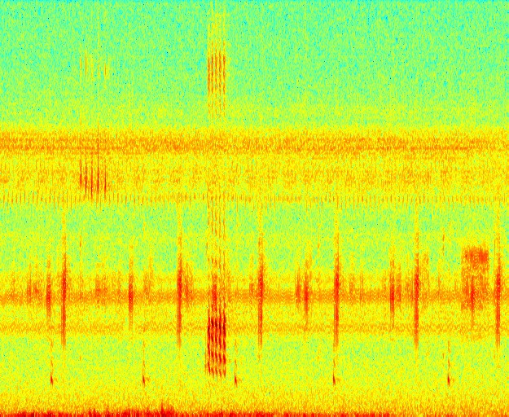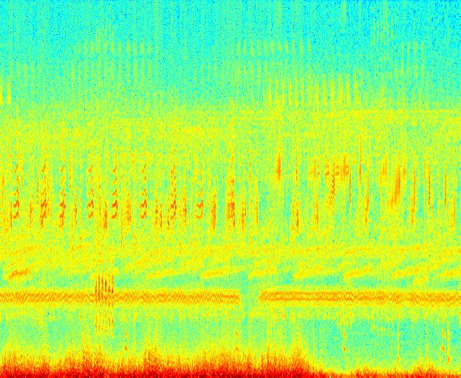

8000

7000

7000

6000

6000

5000

Frequency (Hz)

5000

Frequency (Hz)

4000

4000

3000

3000

2000

2000

1000

1000

8000

0 1 2 3 4 5 6 7 8 9

Time (s)

1. Method of Fodor [2013]



0 1 2 3 4 5 6 7 8 9

Time (s)

1. Method of Fodor [2013]

8000

7000

7000

6000

6000

5000

|  |  |  |  |
| --- | --- | --- | --- |
|  |  |  |  |
|  |  |  |  |
|  |

Frequency (Hz)

5000

Frequency (Hz)

4000

4000

3000

3000

2000

2000

1000

1000

0 1 2 3 4 5 6 7 8 9

Time (s)

1. Method of Towsey and Planitz [2011]



8000

0 1 2 3 4 5 6 7 8 9

Time (s)

1. Method of Towsey and Planitz [2011]

8000

7000

7000

6000

6000

5000

Frequency (Hz)

5000

Frequency (Hz)

4000

4000

3000

3000

|  |
| --- |
|  |
|  |
|  |

2000

2000

1000

1000

0 1 2 3 4 5 6 7 8 9

Time (s)

1. Proposed method

0 1 2 3 4 5 6 7 8 9

Time (s)

1. Proposed method

**Figure 6.2**: Acoustic event detection for frog abundance monitoring using different methods. For each row, different methods are applied to the same recordings. The baseline of the detection results is shown in the first row; detected frog calls are drawn using a blue rectangle. For each column, different methods are used for the same recording.

* 1. *MATERIALS AND METHODS* 91

**Step 1**: Add a Hamming window to the signal y(n) and perform wavelet packet decomposition spaced in adaptive frequency scale as described in Xie et al., 2016.

*M*

*W P* (*i, j*) = X *y*(*n*)*w*(*n*)*ψ*(*a,b*)(*n*) (6.5)

*i*=1

where *w*(*L*) is the Hamming window function, *W P* (*i, j*) is the wavelet coefficients of the decomposition, *i* is the sub-band index, *j* is the index of wavelet coefficients, *ψ*(*a,b*)(*n*) is the wavelet base function, and ’db4’ is used experimentally. Here, *a* and *b* are the scale and shift parameters, respectively.

**Step 2**: Calculate the total energy of each sub-band.

*Mi*

*W Pi* = X[*W P* (*i, j*)]2 (6.6)

*j*=1

where *i* = 1*,* 2*, ..., T* , and *T* is the total number of sub-band, and *j* = 1*,* 2*, ..., Mi*, *Mi* is the total number of wavelet coefficients.

**Step 3**: Normalise the energy of each sub-band.

*SEi* =

*W Pi Mi*

(6.7)

where *i* = 1*,* 2*, ..., T* .

**Step 4**: Perform discrete cosine transform on the logarithm sub-band energy for dimension reduction and obtain the WP-based feature.

*T*

*W Pbase*(*d*) = X *logSEicos*(

*i*=1

*d*(*i −* 0*.*5)

*T*

*π*) (6.8)

where *d* = 1*,* 2*, ..., d0* , 1 *≤ d0 ≤ T* , here *d0* is the dimension of WP-based feature, and set as 12.

Differently from that described in Chapter 4, the recording is first segmented into frames using a Hamming window. Then, all frames are divided into three equal parts, and the WP-feature within each part is averaged, respectively, because different frog species within similar frequency bands may exist in one 10-second recording; segmenting each recording into small parts might be able to keep the information of different frog species in the same frequency band. Besides the WP-based feature, two other acoustic features, linear predictive coefficients (LPCs) and Mel-frequency Cepstral

*CHAPTER 6. DETECTING FROG CALLING ACTIVITY BASED ON ACOUSTIC EVENT*

92 *DETECTION AND MULTI-LABEL LEARNING*

coefficients (MFCCs), are calculated for the comparison.

* + 1. Multi-label classification for species richness analysis

Since many segmented recordings consist of calls from multiple frog species, frog call classifi- cation can be framed as a multi-label classification problem. However, previous studies have not adopted multi-label learning to classify frog calls. Therefore, it is worth investigating different multi-label learning algorithms for the classification of multiple vocalising frog species. In this chapter, four multi-label learning algorithms, whose base classifier is a C4.5 decision tree, are employed: binary relevance (BR), classifier chains (CC), random k-labEL Pruned Sets (RAKEL and RAKEL1) [Zhang and Zhou, 2014]. The default parameter settings of those four multi- label learning algorithms are used. The trained classifier, which achieves the best classification performance, is then used to tag rest recordings. After tagging each 10-second recording, frog species richness is lastly calculated as follows.

*Frich* =

P*K*

*k*=1

*frich*(*k*) *K*

(6.9)

where *frich*(*k*) is the number of frog species of each tagged 10-second recording, *K* is the number of 10-second recording for each day.

## Experiment results

* + 1. Experiment setup

Each 10-second recording is divided into frames of 512 samples and 50% frame overlap for STFT. *Alarge* and *Asmall*, which are used for area filtering in acoustic event detection, are empirically set at 3000 pixels and 300 pixels, respectively. Allowed fluctuations in both sides of dominant frequency are 300 Hz for dominant frequency filtering. For WP-based feature, window size and overlap are 512 samples and 50%, the window function is a Hamming window. All algorithms were programmed in Matlab 2014b except multi-label learning, which was implemented in Meka 1.7.74.

4<http://meka.sourceforge.net/>

* 1. *EXPERIMENT RESULTS* 93
     1. Frog abundance detection

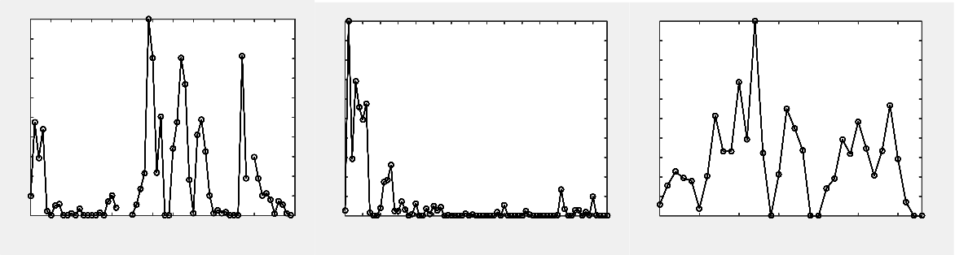Figure 6.3 shows the frog abundance result of three selected sites through the whole frog breeding season. It can be found that the frog abundance of the same site changes a great deal over time. In the *Kiyomi dam*, frog abundance is relatively high from February 21 to February 25. However, frog abundance is quite low in two periods, which are February 26 to March 11 and April 07 to April 12. The highest abundance of this site is achieved on March 22. However, the highest abundance for *Stony Creek dam* and *BG Creek dam* is obtained in February, which shows that frog abundance of different sites often varies a lot for different environments. Recordings of 47 days of all three sites have no frog calls. In the subsequent analysis, only those recordings that consist of frog calls are used for frog species richness analysis.

Normalized frog abundance

Normalized frog abundance

Normalized frog abundance

|  |  |  |  |  |  |
| --- | --- | --- | --- | --- | --- |
| 1 |  | 1 |  | 1 |  |
| 0.9 |  | 0.9 |  | 0.9 |
| 0.8 |  | 0.8 |  | 0.8 |
| 0.7 |  | 0.7 |  | 0.7 |
| 0.6 |  | 0.6 |  | 0.6 |
| 0.5 |  | 0.5 |  | 0.5 |
| 0.4 |  | 0.4 |  | 0.4 |
| 0.3 |  | 0.3 |  | 0.3 |
| 0.2 |  | 0.2 |  | 0.2 |
| 0.1 |  | 0.1 |  | 0.1 |
| 0 |  | 0 |  | 0 |
|  | Date (Year-2014) |  | Date (Year-2014) |  | Date (Year-2014) |
|  | (a) *Kiyomi dam* |  | (b) *Stony creek dam* |  | (c) *BG creek dam* |

**Figure 6.3**: Frog abundance detection of different sites: *Kiyomi dam*, *Stony Creek dam* and *BG Creek dam*. For *Kiyomi dam*, three days do not record any acoustic data and then there is no value in those particular days. All the frog abundance value is normalised to [0 1].

* + 1. Frog species richness analysis

Different multi-label learning algorithms are applied on 342 selected recordings to compare dif- ferent feature sets. Then, six evaluation rules are used to compare the performance with the combination of four feature sets and four multi-label algorithms: Hamming loss, Rank loss, Average precision, One error, Exampled based F1, and Micro F1 Madjarov et al. [2012], Zhang and Zhou [2014]. Experiment results are shown in Table 6.2.

The combination of multi-stage WP-based feature+LPCs and the RAKEL1 method achieves the best performance. Therefore, this combination is used for the testing data. Figure 6.4 shows the frog species richness of the three selected sites. For all the three sites, the variation of species richness is not high, which shows that species richness of the same area is relatively

*CHAPTER 6. DETECTING FROG CALLING ACTIVITY BASED ON ACOUSTIC EVENT*

94 *DETECTION AND MULTI-LABEL LEARNING*

**Table 6.2**: Classification results based on four feature sets and four multi-label learning algorithms. Here the methods for multi-label algorithms are in accordance to the name in the Meka software. The base classifier of all methods is decision tree. For a metric, the best value

is in bold. Here, *↓*indicates the smaller the better, while *↑*indicates the bigger the better.

**Features Method Hamming loss** *↓* **Rank loss** *↓* **Average precision** *↑* **One error** *↓* **Exampled based F1** *↑* **Micro F1** *↑*

|  |  |  |  |  |  |  |  |
| --- | --- | --- | --- | --- | --- | --- | --- |
| MFCCs+LPCs | BR | 0.155 *±* 0.015 | 0.171 *±* 0.037 | **0.446** *±* **0.061** | 0.246 *±* 0.063 | 0.699 *±* 0.03 | 0.749 *±* 0.024 |
|  | CC | 0.147 *±* 0.018 | 0.147 *±* 0.02 | 0.35 *±* 0.016 | 0.199 *±* 0.042 | 0.722 *±* 0.035 | 0.756 *±* 0.029 |
|  | RAKEL | 0.167 *±* 0.038 | 0.122 *±* 0.026 | 0.333 *±* 0.017 | 0.194 *±* 0.063 | 0.721 *±* 0.044 | 0.752 *±* 0.041 |
|  | RAKEL1 | 0.134 *±* 0.012 | 0.099 *±* 0.025 | 0.342 *±* 0.023 | **0.147** *±* **0.056** | 0.74 *±* 0.044 | 0.783 *±* 0.022 |
| Multi-stage MFCCs + LPCs | BR | 0.155 *±* 0.016 | 0.169 *±* 0.035 | 0.445 *±* 0.062 | 0.249 *±* 0.064 | 0.7 *±* 0.03 | 0.75 *±* 0.024 |
|  | CC | 0.147 *±* 0.018 | 0.147 *±* 0.021 | 0.35 *±* 0.016 | 0.199 *±* 0.042 | 0.722 *±* 0.034 | 0.756 *±* 0.028 |
|  | RAKEL | 0.166 *±* 0.035 | 0.124 *±* 0.027 | 0.334 *±* 0.018 | 0.194 *±* 0.069 | 0.724 *±* 0.048 | 0.754 *±* 0.04 |
|  | RAKEL1 | 0.134 *±* 0.013 | 0.101 *±* 0.026 | 0.342 *±* 0.02 | 0.15 *±* 0.063 | 0.737 *±* 0.05 | 0.783 *±* 0.023 |
| WP-based feature + LPCs | BR | 0.148 *±* 0.025 | 0.139 *±* 0.033 | 0.356 *±* 0.065 | 0.254 *±* 0.063 | 0.708 *±* 0.046 | 0.762 *±* 0.036 |
|  | CC | 0.168 *±* 0.031 | 0.168 *±* 0.045 | 0.341 *±* 0.027 | 0.272 *±* 0.061 | 0.684 *±* 0.054 | 0.723 *±* 0.048 |
|  | RAKEL | 0.155 *±* 0.023 | 0.103 *±* 0.022 | 0.324 *±* 0.018 | 0.178 *±* 0.031 | 0.729 *±* 0.032 | 0.763 *±* 0.030 |
|  | RAKEL1 | 0.14 *±* 0.027 | 0.094 *±* 0.018 | 0.333 *±* 0.028 | 0.193 *±* 0.063 | 0.727 *±* 0.053 | 0.773 *±* 0.042 |
| Multi-stage WP-based feature + LPCs | BR | 0.153 *±* 0.014 | 0.147 *±* 0.022 | 0.364 *±* 0.056 | 0.266 *±* 0.037 | 0.689 *±* 0.035 | 0.75 *±* 0.025 |
|  | CC | 0.142 *±* 0.029 | 0.146 *±* 0.023 | 0.345 *±* 0.019 | 0.254 *±* 0.094 | 0.714 *±* 0042 | 0.764 *±* 0.045 |
|  | RAKEL | 0.154 *±* 0.022 | 0.11 *±* 0.012 | 0.33 *±* 0.027 | 0.196 *±* 0.062 | 0.739 *±* 0.022 | 0.768 *±* 0.025 |

RAKEL1 **0.131** *±***0.012 0.09** *±***0.014** 0.33 *±*0.026 0.173 *±*0.03 **0.743** *±***0.026 0.787** *±***0.018**

stable. However, frog species richness of *BG Creek dam* has a smaller variation over the time than *Kiyomi dam* and *Stony Creek dam*. The comparison of the species richness for the three sites is shown in Figure 6.5. In contrast to other sites, the species richness in *BG Creek dam* is the highest. This might be that *BG Creek dam* is closer to a river and farther away from the human community.

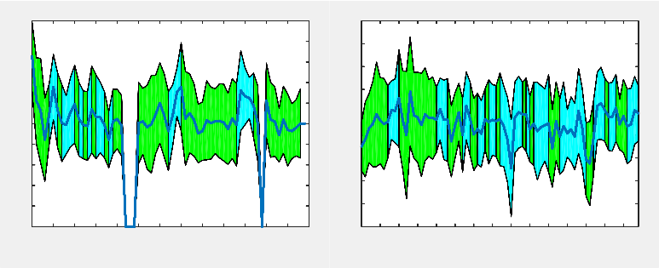

5 5 6

4.5

4

3.5

Species richeness

3

2.5

2

1.5

1

0.5

4.5

4

3.5

Species richeness

3

2.5

2

1.5

1

5.5

5

4.5

Species richeness

4

3.5

3

2.5

2

0 0.5

1.5

Date (Year-2014)

1. *Kiyomi dam*

Date (Year-2014)

1. *Stony creek dam*

Date (Year-2014)

1. *BG creek dam*

**Figure 6.4**: Frog species richness distribution of three selected sites. Here green bar represents the species variation, blue bar means there is no frog calls, zero value denotes the data loss of those particular days.

* + 1. Statistical analysis

Multiple regression analysis is used to explore frog calling activity (frog abundance and frog species richness) along weather variables (mean temperature and rainfall)5. Frog calling activity is found to be highly correlated with mean temperature (F=5.18, P*<*0.05 for abundance, and

5<http://www.bom.gov.au/?ref=hdr>

* 1. *SUMMARY AND LIMITATIONS* 95

5

4.5

4

Frog species richness

3.5

3

2.5

2

Kiyomi dam Stony creek dam BG creek dam

Sites for collecting recordings

**Figure 6.5**: Averaged frog species richness of different sites.

F=10.7, P*<*0.01 for species richness). To calculate the correlation between rainfall and frog calling activity, we first set the rainfall value as the dummy variable. Then, the correlation be- tween frog calling activity and rainfall is also studied with multiple regression analysis (F=4.63, P*<*0.05 for abundance, and F=4.64, P*<*0.05 for species richness). The statistical analysis results indicate that frogs tend to make calls in the warm and humid environment, which is in accordance to previous studies [Akmentins et al., 2015;](#_bookmark174) [Canavero et al., 2008].

## 6.4 Summary and limitations

Acoustic sensors are more widely used to monitor frog calling activity than the traditional field survey method. However, the use of acoustic sensors generates large volumes of audio data, which makes it necessary to develop automated methods. This paper proposes a novel method for detecting frog calling activity based on acoustic event detection and multi-label learning. Specifically, acoustic event detection is the first step to calculate frog abundance. Meanwhile, each 10-second recording is analysed to decide whether it contains frog calls or not. For those recordings with frog calls, multi-label learning is further used for calculating frog species richness with multi-stage WP-based features and LPCs. Finally, statistical analysis is utilised to reflect the relationship between frog calling activity (frog abundance and frog species richness) and weather variables (mean temperature and rainfall). Experiment results show that our proposed method can accurately detect frog calling activity and reflect its relationship with weather variables. Future work will focus on a wider frog call database, including a larger

*CHAPTER 6. DETECTING FROG CALLING ACTIVITY BASED ON ACOUSTIC EVENT*

96 *DETECTION AND MULTI-LABEL LEARNING*

number of frog species, and frog calls collected over a longer period.

# Chapter 7

**Conclusion and future work**

This thesis has addressed frog call classification, using both high and low SNR recordings. For high SNR recordings, both feature extraction methods and classification frameworks for frog call classification are investigated. For feature extraction, enhanced feature representations and a novel feature representation based on wavelet packet decomposition are proposed. To study multiple simultaneously vocalising frog species in low SNR recordings, a spectrum of machine learning algorithms were explored, including single-instance single-label classification, multiple-instance multiple-label classification, and multiple-label classification.

Many challenges of this thesis lie in the designing and identifying the effective feature ex- traction algorithms and adopting novel classification frameworks that can successfully classify low SNR recordings with multiple simultaneously vocalising frog species. In this chapter, key contributions of this research to the challenges will be summarised. Furthermore, useful avenues of inquiry for improving the methods described in this thesis will be explored.

## Summary of contributions

The contributions of this research are mainly twofold.

* + 1. Feature representation: Identifying characteristics of Australian frog vocalisations and developing corresponding novel feature representations.
    2. System integration: Designing a new framework that combines multiple signal processing and machine learning techniques into a unified and effective system to classify frogs using

97

acoustics.

Below is the summary of the contributions of this thesis:

* + - 1. *Enhanced acoustic feature representation for frog call classification in high SNR record- ings.*

A systematic scheme was developed towards the goal of automatic classification of frog calls. The performances of various classification methods such as LDA, K-NN, SVM, RF, MLP were evaluated, together with different feature representations. The experience gained and experi- mental results demonstrate that: 1) Compared with previous feature representation, an enhanced feature representation including temporal, perceptual, and cepstral features can achieve the best classification performance. 2) The best classification performance is achieved by SVM and RF, in comparison with LDA, K-NN, and MLP. 3) The cepstral features are very sensitive to the background noise, but can achieve good classification accuracy in the high SNR recordings.

* + - 1. *A novel feature representation via adaptive wavelet packet decomposition for frog call classification in both high and low SNR recordings.*

To improve the anti-noise ability of cepstral features, wavelet packet decomposition is utilised to design a novel cepstral feature representation. Compared with other cepstral features such as MFCCs, Mel-scale wavelet packet decomposition coefficients, our proposed feature represen- tation shows both good classification performance and excellent anti-noise ability.

* + - 1. *Design a MIML classification framework for frog call classification in low SNR record- ings.*

Since most frog field recordings consist of multiple simultaneously vocalising frog species, both MIML and ML classification frameworks are first introduced to study frog calls. For MIML learning, a novel acoustic event detection algorithm is designed to segment acoustic events by using event filtering. Then, different MIML classifiers are evaluated, together with various acoustic features based on the content and shape of the segmented events. The results show that MIML-RBF achieves the best classification results.

* + - 1. *Design a ML classification framework for frog call classification in low SNR recordings.* For an ML classification framework, acoustic event detection is first used to filter all the record- ings to find those that have frog calls. Meanwhile, frog abundance is detected based on the shape and content of segmented acoustic events. Then, those recordings with frog calls are classified via ML learning. The feature representation used is a modified adaptive WPD sub-band cepstral

coefficients. Compared with MIML learning, ML learning can achieve a better classification performance, because the MIML learning results are greatly affected by the syllable segmenta- tion results. Lastly, the correlation between the frog calling activity (frog abundance and frog species richness) and weather variables (mean temperature and rainfall) are studied.

## Limitations and future work

Although our proposed frog call classification system shows promising classification perfor- mance, there is still much work that can be done to help scientists and researchers in data collection and analysis in the bioacoustics communities.

* One of the most important issues when dealing with frog recordings is the need for the standardised species-specific data with behavioural labels. Therefore, the algorithms we developed for frog call classification can be evaluated on a larger dataset. Consequently, researchers can use the outcomes of such automatic call classification methods for field studies, effectively and precisely. However, it is very time-consuming to perform manual labelling. It is necessary to develop automatic or semi-automatic methods to perform the labelling.
* Another aspect that requires tremendous improvement is the need for an advanced frog syllable segmentation method for the field recordings, so as to extract more accurate event- based features and conduct more thorough analysis on frog vocalisations. The problem of syllable segmentation is very complicated, because there are many simultaneous, over- lapping calling activities from birds, frogs, insects, and many other sources.
* Since collected low SNR recordings often contain much background noise, it is important to develop effective noise reduction algorithms to improve the classification performance.
* In addition, the *adaptive WPD sub-band cepstral coefficients* feature has been success- fully used for frog call classification, which is used to capture the frequency domain information. The time-varying information has been attempted heuristically but there is still a lack of systematic exploration.
* Our developed frog call classification system aims to help ecologists to study frogs over larger spatial and temporal scales. However, there is still no a generic platform for running

the frog calls recordings. It is necessary to develop a toolbox with an easy user interface for frog call classification, and then ecologists can conduct the analysis on their own.

We focus on efficacy in this research, however efficiency is also very important in big data analysis. For this purpose, the MATLAB code corresponding to feature extractors and classifiers needs to be optimised to perform real-time frog call classification in the field.

# Appendix A

**Waveform, spectrogram and SNR of frog species from David Stewart’s CD**

**Table A.1**: Waveform, spectrogram, and SNR of selected six frog species from David Stewart’s

P*m*+*L S*2

CD. The SNR is calculated as *SN R* = 10 *∗ log*10(

*i*=*m*

P*n*+*L*

*i* ) where *L* is the length of the signal

*j*=*n N* 2

*j*

and noise used for calculating SNR, and set at 6000 samples here, *n* and *m* are manual selected

start location in the waveform for noise and signal, respectively.

❍❍

❍

❍❍

Frog

Waveform Spectrogram SNR (dB)

species ❍❍

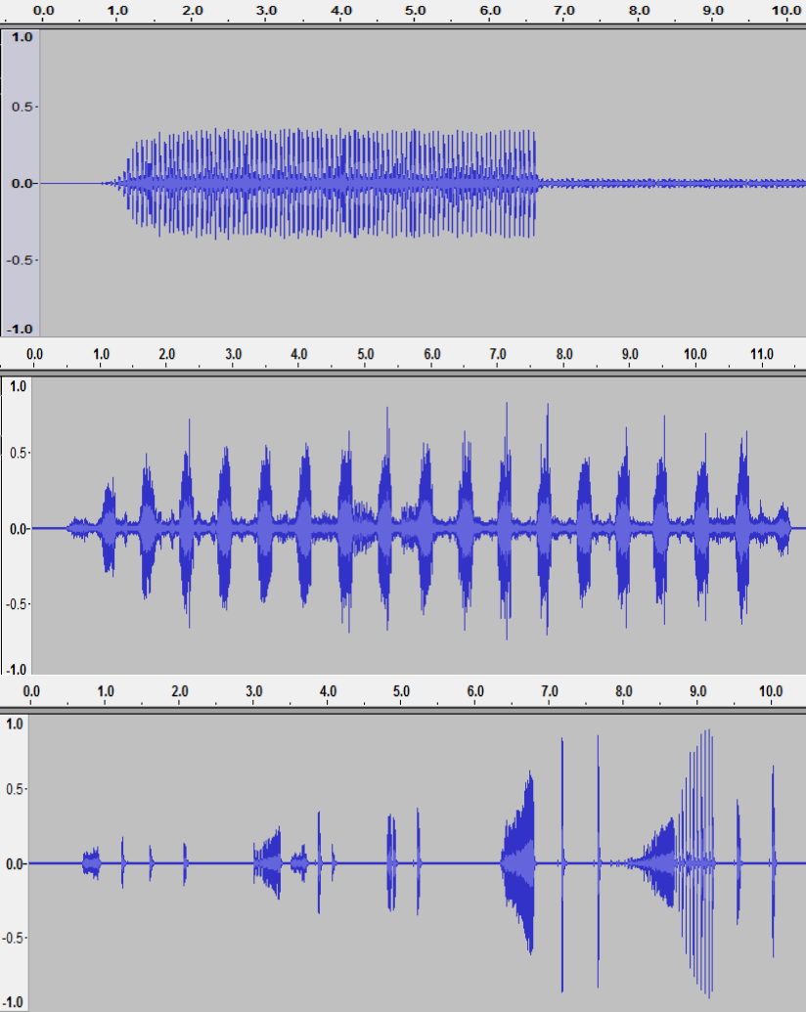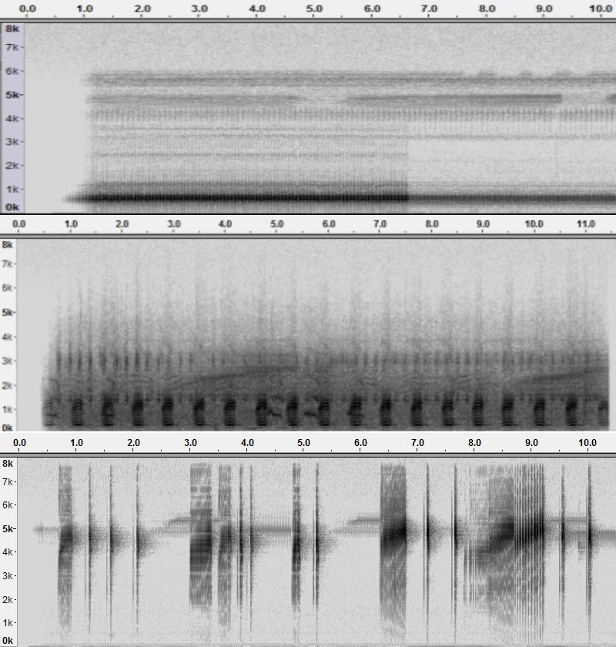

❍

❍

*Bufo marinus* 19.35

*Litoria caerulea* 15.78

*Litoria fallax* 43.7

101

102

*APPENDIX A. WAVEFORM, SPECTROGRAM AND SNR OF FROG SPECIES FROM*

*DAVID STEWART’S CD*

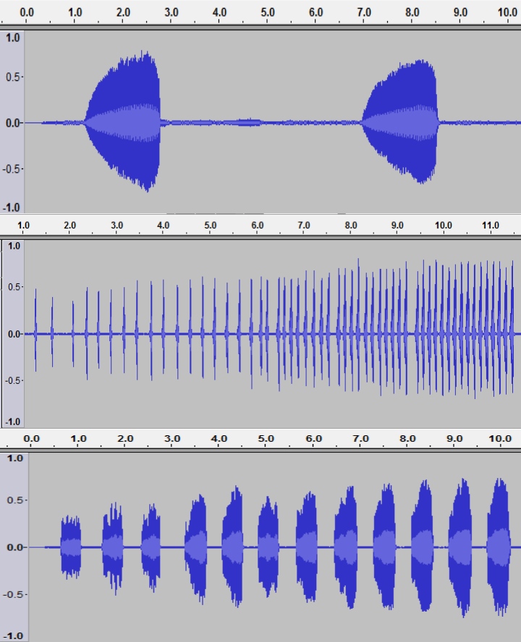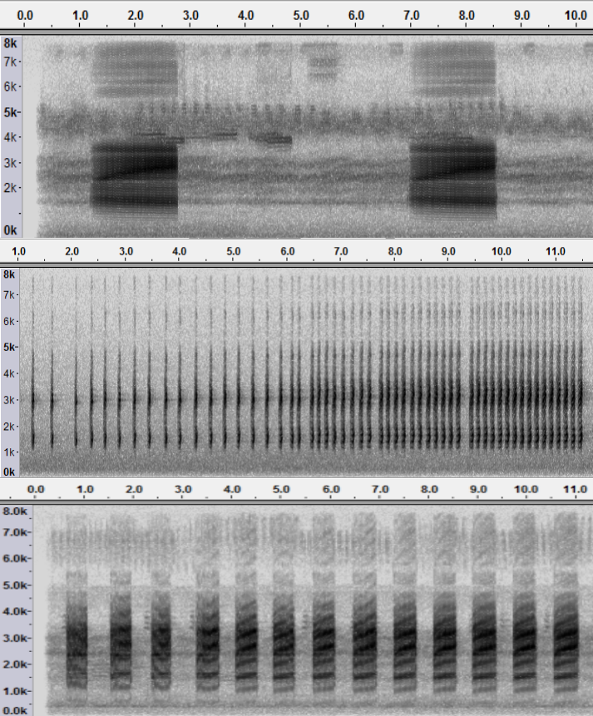

*Litoria gracillenta* 25.8

*Litoria latopalmata* 35.85

*Litoria rubella* 36.2

# Appendix B

**Waveform, spectrogram and SNR of six frog species from JCU recordings**

**Table B.1**: Waveform, spectrogram, and SNR of eight frog species (recordings from JCU)

Waveform Spectrogram SNR (dB)

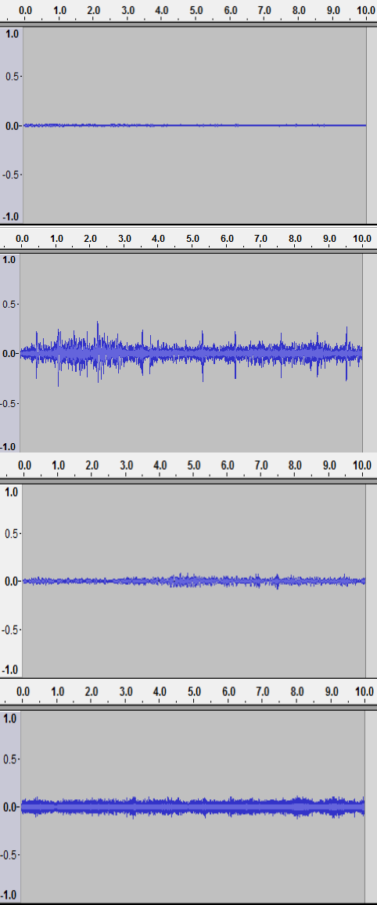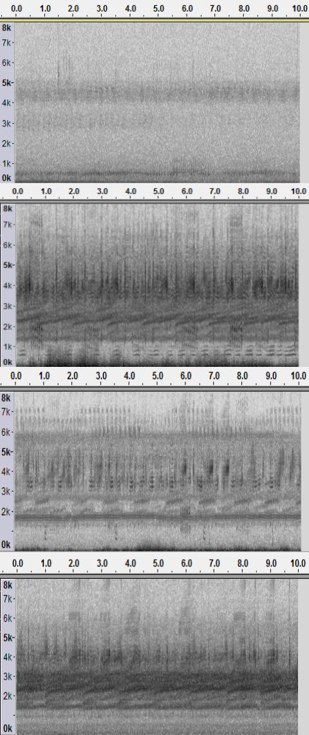

*Bufo marinus* 1.86

*Cyclorana novaehollandiae* -0.13

*Limnodynastes terraereginae* -2.88

*Litoria fallax* 1.52

103

104

*APPENDIX B. WAVEFORM, SPECTROGRAM AND SNR OF EIGHT FROG SPECIES*

*FROM JCU RECORDINGS*

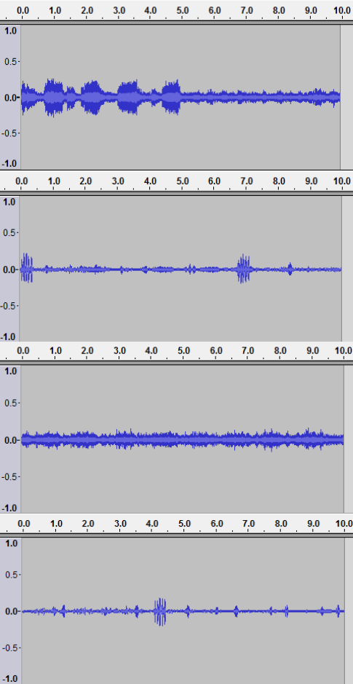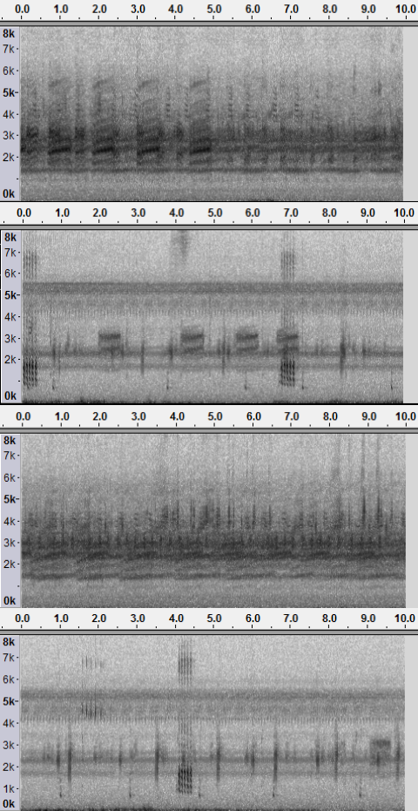

*Litoria nasuta* 2.14

*Litoria rothii* 10.24

*Litoria rubella* 1.08

*Uperolela mimula* 10.28

# Appendix C

**Power spectral density (PSD) estimate of signal and noise (JCU recordings)**

**Table C.1**: Power spectral density (PSD) estimate of signal and noise (JCU recordings); for some frog species, the PSD difference between the signal and background noise is marked with the red rectangle, which indicates the frequency location of specific frog species; for others, the PSD of signal and noise is very similar, which means that some sources have similar frequency information with frog species

PPP

##### Frog

PPP

##### Parameters

PPPP

##### Welch PSD (Signal) Welch PSD estimate (Noise)

species PP

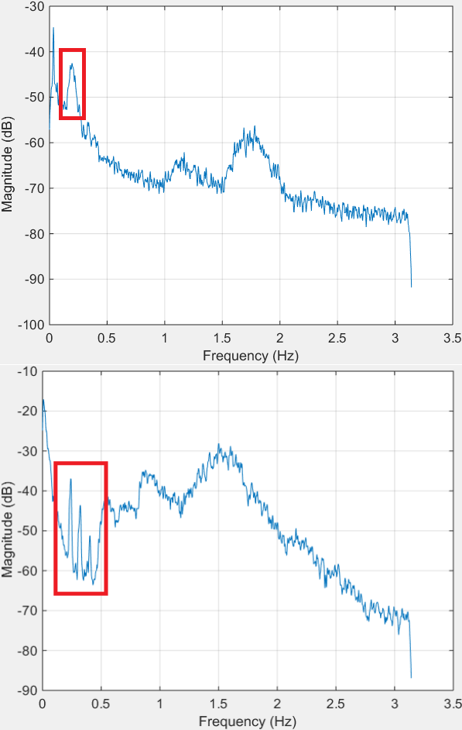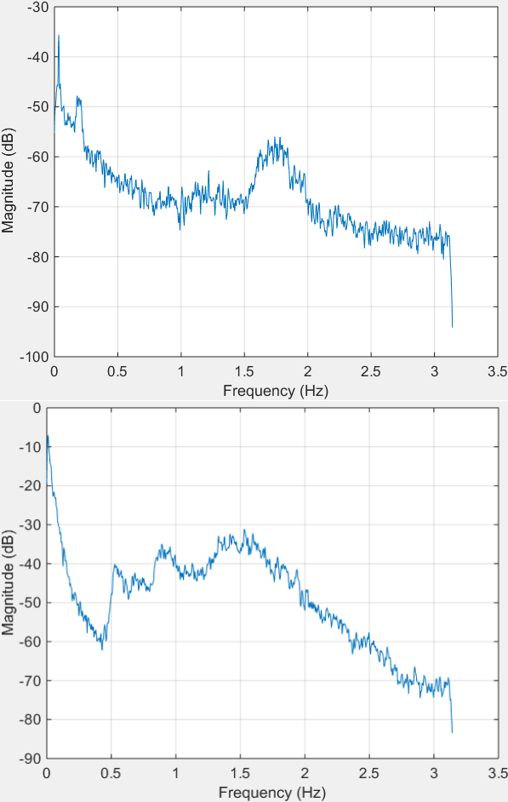

###### Bufo marinus

*Cyclorana novaehollandiae*

105

*APPENDIX C. POWER SPECTRAL DENSITY (PSD) ESTIMATE OF SIGNAL AND NOISE*

106

*(JCU RECORDINGS)*

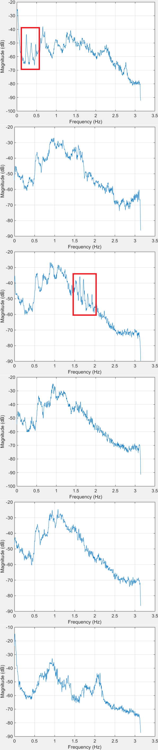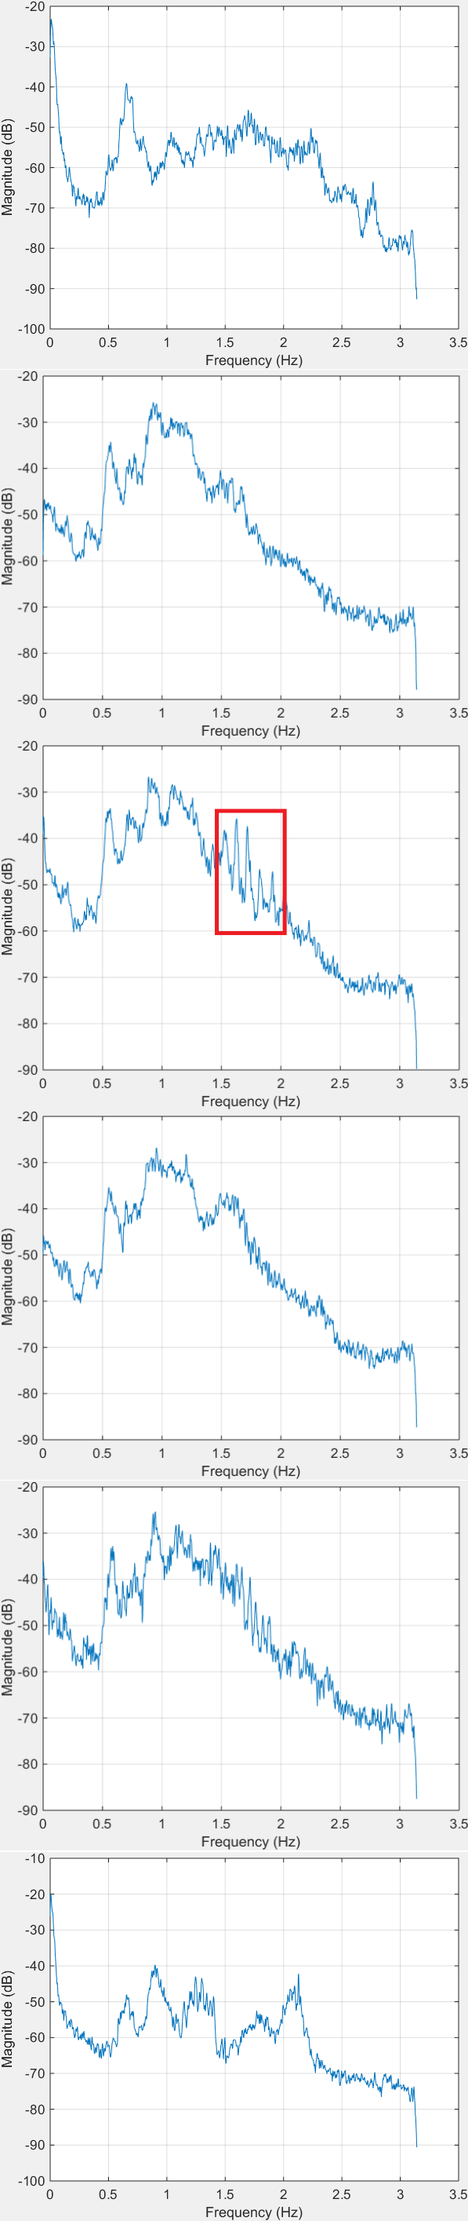

*Limnodynastes terraereginae*

*Litoria fallax*

*Litoria nasuta*

*Litoria rothii*

*Litoria rubella*

*Uperolela mimula*

**Appendix D**

**Confidence interval of signal and noise**

**Table D.1**: Confidence interval of signal and noise (David Stewart’s CD). The calculation of

confidence interval is defined as *CI* = *µ ± Z ∗ σ*

*√L*

,where *µ* and *σ* are the mean and standard

deviation, respectively, *Z* is the upper (1*−C*) critical value for the standard normal distribution,

2

*C* is the confidence level, and set at 0.95.

PPPP

Frog

P Parameters

P

P

Confidence intervals of signal Confidence intervals of noise

species

PPP

P

P

*Bufo marinus* -9.27*10*−*6 *±* 2.10*10*−*3 -2.67*10*−*5 *±* 2.26*10*−*4

*Litoria caerulea* -6.73*10*−*5 *±* 2.40*10*−*3 -6.89*10*−*5 *±* 3.90*10*−*4

*Litoria fallax* -5.85*10*−*6 *±* 1.50*10*−*3 -2.73*10*−*5 *±* 9.62*10*−*6

*Litoria gracillenta* -7.12*10*−*5 *±* 2.00*10*−*3 -7.70* 10*−*5 *±* 1.00*10*−*4

*Litoria latopalmata* -6.58*10*−*5 *±* 2.70*10*−*3 -1.02*10*−*4 *±* 4.36*10*−*5

*Litoria rubella* -3.13*10*−*5 *±* 3.00*10*−*3 -9.87*10*−*5 *±* 4.70*10*−*5

PPPP

**Table D.2**: Confidence interval of signal and noise for JCU recordings Parameters

Frog

PPP

PPP

Confidence intervals of signal Confidence intervals of noise

species PP

*Bufo marinus* -1.36*10*−*5 *±* 6.00*10*−*5 -3.22*10*−*5 *±* 4.80*10*−*5

*Cyclorana novaehollandiae* 1.30*10*−*3 *±* 8.70*10*−*4 1.30*10*−*3 *±* 8.90*10*−*4

*Limnodynastes terraereginae* 6.43*10*−*5 *±* 1.30*10*−*4 1.86*10*−*4 *±* 1.89*10*−*4

*Litoria fallax* 2.31*10*−*5 *±* 5.00*10*−*4 5.75*10*−*6 *±* 4.22*10*−*4

*Litoria nasuta* -1.55*10*−*4 *±* 4.90* 10*−*4 6.25* 10*−*6 *±* 3.85*10*−*4

*Litoria rothii* -3.32*10*−*4 *±* 9.2*10*−*4 1.61* 10*−*4 *±* 2.84*10*−*4

*Litoria rubella* -8.15*10*−*5 *±* 5.52*10*−*4 -2.69* 10*−*5 *±* 4.87*10*−*4

*Uperolela mimula* -1.20*10*−*3 *±* 1.10*10*−*3 -9.36*10*−*4 *±* 3.35*10*−*4

107

108 *APPENDIX D. CONFIDENCE INTERVAL OF SIGNAL AND NOISE*

# References

Acevedo, M. A., Corrada-Bravo, C. J., Corrada-Bravo, H., Villanueva-Rivera, L. J., and Aide,

T. M. (2009). Automated classification of bird and amphibian calls using machine learning: A comparison of methods. *Ecological Informatics*, 4(4):206–214.

Akmentins, M., Pereyra, L., Sanabria, E., and Vaira, M. (2015). Patterns of daily and seasonal calling activity of a direct-developing frog of the subtropical andean forests of Argentina. *Bioacoustics*, 24(2):89–99.

Allen, J. (1997). Short term spectral analysis, synthesis, and modification by discrete fourier transform. In *IEEE Trans. on Acoust., Speech, and Sig. Proc.*, volume 4, pages 21–24.

Bao, L. and Cui, Y. (2005). Prediction of the phenotypic effects of non-synonymous single nucleotide polymorphisms using structural and evolutionary information. *Bioinformatics*, 21(10):2185–2190.

Bedoya, C., Isaza, C., Daza, J. M., and Lo´pez, J. D. (2014). Automatic recognition of anuran species based on syllable identification. *Ecological Informatics*, 24:200–209.

Biswas, A., Sahu, P., and Chandra, M. (2014). Admissible wavelet packet features based on human inner ear frequency response for Hindi consonant recognition. *Computers & Electrical Engineering*, 40(4):1111 – 1122.

Brandes, T. S. (2008). Feature vector selection and use with hidden markov models to identify frequency-modulated bioacoustic signals amidst noise. *Audio, Speech, and Language Processing, IEEE Transactions on*, 16(6):1173–1180.

Brandes, T. S., Naskrecki, P., and Figueroa, H. K. (2006). Using image processing to detect and classify narrow-band cricket and frog calls. *The Journal of the Acoustical Society of America*, 120(5):2950–2957.

109

Briggs, F., Lakshminarayanan, B., Neal, L., Fern, X. Z., Raich, R., Hadley, S. J., Hadley,

A. S., and Betts, M. G. (2012). Acoustic classification of multiple simultaneous bird species: A multi-instance multi-label approach. *The Journal of the Acoustical Society of America*, 131(6):4640–4650.

Camacho, A., Garc´ıa-Rodr´ıguez, A., and Bolan˜os, F. (2011). Automatic detection of vocalizations of the frog diasporus hylaeformis in audio recordings. In *Proceedings of Meetings on Acoustics*, volume 14, page 010003. Acoustical Society of America.

Canavero, A., Arim, M., Naya, D. E., Camargo, A., Da Rosa, I., and Maneyro, R. (2008).

Calling activity patterns in an anuran assemblage: the role of seasonal trends and weather determinants. *North-Western Journal of Zoology*, 4(1):29–41.

Chen, W., Zhao, G., and Li, X. (2013). A novel approach based on ensemble learning to nips4b challenge. In *proc. of int. symp. Neural Information Scaled for Bioacoustics, sabiod. org/nips4b, joint to NIPS, Nevada*.

Chen, W.-P., Chen, S.-S., Lin, C.-C., Chen, Y.-Z., and Lin, W.-C. (2012). Automatic recognition of frog calls using a multi-stage average spectrum. *Computers & Mathematics with Applications*, 64(5):1270–1281.

Chen, Z. and Maher, R. C. (2006). Semi-automatic classification of bird vocalizations using spectral peak tracks. *The Journal of the Acoustical Society of America*, 120(5):2974–2984.

Colombia, C. and del Cauca, V. (2009). Frogs species classification using lpc and classification algorithms on wireless sensor network platform.

Colonna, J., Ribas, A., dos Santos, E., and Nakamura, E. (2012a). Feature subset selection for automatically classifying anuran calls using sensor networks. In *Neural Networks (IJCNN), The 2012 International Joint Conference on*, pages 1–8.

Colonna, J. G., Cristo, M., Junior, M. S., and Nakamura, E. F. (2015). An incremental technique for real-time bioacoustic signal segmentation. *Expert Systems with Applications*, 42(21):7367

– 7374.

Colonna, J. G., Ribas, A. D., dos Santos, E. M., and Nakamura, E. F. (2012b). Feature subset selection for automatically classifying anuran calls using sensor networks. In *Neural Networks (IJCNN), The 2012 International Joint Conference on*, pages 1–8. IEEE.

Cortes, C. and Vapnik, V. (1995). Support-vector networks. *Machine learning*, 20(3):273–297.

Croker, B. and Kottege, N. (2012). Using feature vectors to detect frog calls in wireless sensor networks. *The Journal of the Acoustical Society of America*, 131(5):EL400–EL405.

Dang, T., Bulusu, N., and Hu, W. (2008). Lightweight acoustic classification for cane-toad monitoring. In *Signals, Systems and Computers, 2008 42nd Asilomar Conference on*, pages 1601–1605. IEEE.

Dayou, J., Han, N. C., Mun, H. C., Ahmad, A. H., Muniandy, S. V., and Dalimin, M. N. (2011).

Classification and identification of frog sound based on entropy approach. In *International Conference on Life Science and Technology*, volume 3, pages 184–187.

Deng, L. and O’Shaughnessy, D. (2003). *Speech processing: a dynamic and optimization- oriented approach*. CRC Press.

Dorcas, M. E., Price, S. J., Walls, S. C., and Barichivich, W. J. (2009). Auditory monitoring of anuran populations. *Amphibian ecology and conservation: a hand book of techniques. Oxford University Press, Oxford*, pages 281–298.

Dudgeon, D., Arthington, A. H., Gessner, M. O., Kawabata, Z.-I., Knowler, D. J., Le´veˆque, C., Naiman, R. J., Prieur-Richard, A.-H., Soto, D., Stiassny, M. L., et al. (2006). Freshwater biodiversity: importance, threats, status and conservation challenges. *Biological reviews*, 81(02):163–182.

Dufour, O., Glotin, H., Artires, T., Bas, Y., and Giraudet, P. (2013). Multi-instance multi-label acoustic classification of plurality of animals: birds, insects & amphibian. *Workshop on Neural Information Processing Scaled for Bioacoustics*, pages 164–174.

Farooq, O. and Datta, S. (2001). Mel filter-like admissible wavelet packet structure for speech recognition. *IEEE Signal Processing Letters*, 8(7):196–198.

Fodor, G. (2013). The ninth annual mlsp competition: first place. In *Machine Learning for Signal Processing (MLSP), 2013 IEEE International Workshop on*, pages 1–2. IEEE.

Fox, E. J. (2008). A new perspective on acoustic individual recognition in animals with limited call sharing or changing repertoires. *Animal Behaviour*, 75(3):1187 – 1194.

Gingras, B. and Fitch, W. T. (2013). A three-parameter model for classifying anurans into four genera based on advertisement calls. *The Journal of the Acoustical Society of America*, 133(1):547–559.

Gordon, L., Chervonenkis, A. Y., Gammerman, A. J., Shahmuradov, I. A., and Solovyev, V. V. (2003). Sequence alignment kernel for recognition of promoter regions. *Bioinformatics*, 19(15):1964–1971.

Grigg, G., Taylor, A., Mc Callum, H., and Watson, G. (1996). Monitoring frog communities: an application of machine learning. In *Proceedings of Eighth Innovative Applications of Artificial Intelligence Conference, Portland Oregon*, pages 1564–1569.

Han, N. C., Muniandy, S. V., and Dayou, J. (2011). Acoustic classification of Australian anurans based on hybrid spectral-entropy approach. *Applied Acoustics*, 72(9):639–645.

Han, W., Chan, C.-F., Choy, C.-S., and Pun, K.-P. (2006). An efficient mfcc extraction method in speech recognition. In *Circuits and Systems, 2006. ISCAS 2006. Proceedings. 2006 IEEE International Symposium on*, pages 4–pp. IEEE.

Harma, A. (2003). Automatic identification of bird species based on sinusoidal modeling of syllables. In *Acoustics, Speech, and Signal Processing, 2003. Proceedings.(ICASSP’03). 2003 IEEE International Conference on*, volume 5, pages V–545. IEEE.

Heller, J. R. and Pinezich, J. D. (2008). Automatic recognition of harmonic bird sounds using a frequency track extraction algorithm. *The Journal of the Acoustical Society of America*, 124(3):1830–1837.

Hsu, C.-W., Chang, C.-C., Lin, C.-J., et al. (2003). A practical guide to support vector classification.

Huang, C.-J., Chen, Y.-J., Chen, H.-M., Jian, J.-J., Tseng, S.-C., Yang, Y.-J., and Hsu, P.-A. (2014). Intelligent feature extraction and classification of anuran vocalizations. *Applied Soft Computing*, 19(0):1 – 7.

Huang, C.-J., Yang, Y.-J., Yang, D.-X., and Chen, Y.-J. (2009). Frog classification using machine learning techniques. *Expert Systems with Applications*, 36(2):3737–3743.

Huang, C.-J., Yang, Y.-J., Yang, D.-X., Chen, Y.-J., and Wei, H.-Y. (2008). Realization of an intelligent frog call identification agent. In *Agent and Multi-Agent Systems: Technologies and Applications*, pages 93–102. Springer.

Jaafar, H. and Ramli, D. (2013a). Automatic syllables segmentation for frog identification system. In *Signal Processing and its Applications (CSPA), 2013 IEEE 9th International Colloquium on*, pages 224–228.

Jaafar, H. and Ramli, D. A. (2013b). Automatic syllables segmentation for frog identification system. In *Signal Processing and its Applications (CSPA), 2013 IEEE 9th International Colloquium on*, pages 224–228. IEEE.

Jaafar, H., Ramli, D. A., and Shahrudin, S. (2013a). A comparative study of classification algorithms and feature extractions for frog identification system.

Jaafar, H., Ramli, D. A., and Shahrudin, S. (2013b). Mfcc based frog identification system in noisy environment. In *Signal and Image Processing Applications (ICSIPA), 2013 IEEE International Conference on*, pages 123–127. IEEE.

Jancovic, P. and Kokuer, M. (2015). Acoustic recognition of multiple bird species based on penalized maximum likelihood. *Signal Processing Letters, IEEE*, 22(10):1585–1589.

Jang, Y., Hahm, E. H., Lee, H.-J., Park, S., Won, Y.-J., and Choe, J. C. (2011). Geographic variation in advertisement calls in a tree frog species: gene flow and selection hypotheses. *PloS one*, 6(8):e23297.

Juan Mayor, L. M. M. (2009). Frogs species classification using lpc and classification algorithms on wireless sensor network platform. In *XVII General Assembly, Ibero-American Conference on Trends in Engineering Education and Collaboration, ISTEC, 2009*.

Kular, D., Hollowood, K., Ommojaro, O., Smart, K., Bush, M., and Ribeiro, E. (2015).

Classifying frog calls using Gaussian mixture models. In *Advances in Visual Computing*, pages 347–354. Springer.

Lasseck, M. (2013.). Bird song classification in field recordings: winning solution for nips4b 2013 competition. In *Proc. of int. symp. Neural Information Scaled for Bioacoustics, sabiod. org/nips4b, joint to NIPS, Nevada.*

Lee, C.-H., Chou, C.-H., Han, C.-C., and Huang, R.-Z. (2006). Automatic recognition of animal vocalizations using averaged mfcc and linear discriminant analysis. *Pattern Recognition Letters*, 27(2):93–101.

Litvin, Y. and Cohen, I. (2011). Single-channel source separation of audio signals using bark scale wavelet packet decomposition. *Journal of Signal Processing Systems*, 65(3):339–350.

Madjarov, G., Kocev, D., Gjorgjevikj, D., and D?eroski, S. (2012). An extensive experimental comparison of methods for multi-label learning. *Pattern Recognition*, 45(9):3084 – 3104.

Mallawaarachchi, A., Ong, S., Chitre, M., and Taylor, E. (2008). Spectrogram denoising and automated extraction of the fundamental frequency variation of dolphin whistles. *The Journal of the Acoustical Society of America*, 124(2):1159–1170.

Massaron, L. (2013). Ensemble logistic regression and gradient boosting classifiers for multilabel bird song classification in noise (nips4b challenge). *Proc of Neural Information Processing Scaled for Bioacoustics, joint to NIPS*.

Mellinger, D. K., Martin, S. W., Morrissey, R. P., Thomas, L., and Yosco, J. J. (2011). A method for detecting whistles, moans, and other frequency contour sounds. *The Journal of the Acoustical Society of America*, 129(6):4055–4061.

Melter, R. A. (1987). Some characterizations of city block distance. *Pattern Recognition Letters*, 6(4):235 – 240.

Mencıa, E. L., Nam, J., and Lee, D.-H. (2013). Learning multi-labeled bioacoustic samples with an unsupervised feature learning approach. *Proc of Neural Information Processing Scaled for Bioacoustics, joint to NIPS*, 2013:184–189.

Noda, J. J., Travieso, C. M., and S?nchez-Rodr?guez, D. (2016). Methodology for automatic bioacoustic classification of anurans based on feature fusion. *Expert Systems with Applications*, 50:100 – 106.

Otsu, N. (1975). A threshold selection method from gray-level histograms. *Automatica*, 11(285- 296):23–27.

Potamitis, I. (2015). Unsupervised dictionary extraction of bird vocalisations and new tools on assessing and visualising bird activity. *Ecological Informatics*, 26:6–17.

Ren, Y., Johnson, M. T., and Tao, J. (2008). Perceptually motivated wavelet packet transform for bioacoustic signal enhancement. *The Journal of the Acoustical Society of America*, 124(1):316–327.

Rocchesso, D. (2003). *Introduction to sound processing*. Mondo estremo.

Roch, M. A., Brandes, T. S., Patel, B., Barkley, Y., Baumann-Pickering, S., and Soldevilla, M. S. (2011). Automated extraction of odontocete whistle contours. *The Journal of the Acoustical Society of America*, 130(4):2212–2223.

Ruiz-Munoz, J., Orozco-Alzate, M., and Castellanos-Dominguez, G. (2015). Multiple instance learning-based birdsong classification using unsupervised recording segmentation. *Proceedings of the Twenty-Fourth International Joint Conference On Artificial Intelligence (IJCAI 2015)*.

Selin, A., Turunen, J., and Tanttu, J. T. (2007). Wavelets in recognition of bird sounds.

*EURASIP Journal on Applied Signal Processing*, 2007(1):141–141.

Somervuo, P. et al. (2004). Classification of the harmonic structure in bird vocalization.

In *Acoustics, Speech, and Signal Processing, 2004. Proceedings.(ICASSP’04). IEEE International Conference on*, volume 5, pages V–701. IEEE.

Somervuo, P., Ha¨rma¨, A., and Fagerlund, S. (2006). Parametric representations of bird sounds for automatic species recognition. *Audio, Speech, and Language Processing, IEEE Transactions on*, 14(6):2252–2263.

Stewart, D. (1999). Australian frog calls: subtropical east. Audio CD.

Stowell, D. and Plumbley, M. D. (2013). Feature design for multilabel bird song classification in noise (nips4b challenge). *Proceedings of NIPS4b: neural information processing scaled for bioacoustics, from neurons to big data*.

Tan, W., Jaafar, H., Ramli, D., Rosdi, B., and Shahrudin, S. (2014). Intelligent frog species identification on android operating system. *International journal of circuits, systems and signal processing*.

Tanton, J. S. (2005). *Encyclopedia of mathematics*. Facts On File.

Tjahja, T. V., Fern, X. Z., Raich, R., and Pham, A. T. (2015). Supervised hierarchical segmentation for bird song recording. In *Acoustics, Speech and Signal Processing (ICASSP), 2015 IEEE International Conference on*, pages 763–767. IEEE.

Towsey, M., Planitz, B., Nantes, A., Wimmer, J., and Roe, P. (2012). A toolbox for animal call recognition. *Bioacoustics*, 21(2):107–125.

Towsey, M. W. and Planitz, B. (2011). Technical report : acoustic analysis of the natural environment. 2011.

Vaca-Castano, G. and Rodriguez, D. (2010). Using syllabic mel cepstrum features and k-nearest neighbors to identify anurans and birds species. In *Signal Processing Systems (SIPS), 2010 IEEE Workshop on*, pages 466–471. IEEE.

Wei, B., Yang, M., Rana, R. K., Chou, C. T., and Hu, W. (2012). Distributed sparse approximation for frog sound classification. In *Proceedings of the 11th international conference on Information Processing in Sensor Networks*, pages 105–106. ACM.

Wimmer, J., Towsey, M., Planitz, B., Williamson, I., and Roe, P. (2013). Analysing environmental acoustic data through collaboration and automation. *Future Generation Computer Systems*, 29(2):560–568.

Xie, J. (2016). Widelife acoustic. [*http://www.wildlifeacoustics.com/products/song-meter-sm2-*](http://www.wildlifeacoustics.com/products/song-meter-sm2-) *birds*.

Xie, J., Towsey, M., Eichinski, P., Zhang, J., and Roe, P. (2015a). Acoustic feature extraction using perceptual wavelet packet decomposition for frog call classification. *11th IEEE International Conference on eScience*.

Xie, J., Towsey, M., Truskinger, A., Eichinski, P., Zhang, J., and Roe, P. (2015b). Acoustic classification of australian anurans using syllable features. In *2015 IEEE Tenth International Conference on Intelligent Sensors, Sensor Networks and Information Processing (IEEE ISSNIP 2015)*, Singapore, Singapore.

Xie, J., Towsey, M., Zhang, J., Dong, X., and Roe, P. (2015c). Application of image processing techniques for frog call classification. *International Conference on Image Processing*.

Xie, J., Towsey, M., Zhang, J., and Roe, P. (2015d). Image processing and classification procedure for the analysis of Australian frog vocalisations. In *Proceedings of the 2Nd International Workshop on Environmental Multimedia Retrieval*, EMR ’15, pages 15–20, Shanghai, China. ACM.

Xie, J., Towsey, M., Zhang, J., and Roe, P. (2016). Adaptive frequency scaled wavelet packet decomposition for frog call classification. *Ecological Informatics*, pages –.

Yen, G. G. and Fu, Q. (2002). Automatic frog call monitoring system: a machine learning approach. In *AeroSense 2002*, pages 188–199. International Society for Optics and Photonics.

Yuan, C. L. T. and Ramli, D. A. (2012). Frog sound identification system for frog species recognition. In *Context-Aware Systems and Applications*, pages 41–50. Springer.

Zhang, M.-L. and Zhou, Z.-H. (2014). A review on multi-label learning algorithms. *Knowledge and Data Engineering, IEEE Transactions on*, 26(8):1819–1837.

Zhang, X. and Li, Y. (2015). Adaptive energy detection for bird sound detection in complex environments. *Neurocomputing*, 155(0):108 – 116.

Zhou, Z.-H., Zhang, M.-L., Huang, S.-J., and Li, Y.-F. (2008). Miml: a framework for learning with ambiguous objects. *CORR abs/0808.3231*.

118 *REFERENCES*